**AEEC General Session Agenda Item 7C**

**Airport Mapping Database Subcommittee**

**Change 1 to ARINC Specification 816-2: *Embedded Interchange Format For Airport Mapping Database***

**AEEC Letter: 16‐035/ADB‐039**

**Comments Received:**

Submitted by Bryan Bender, Christian Pschierer, and Brian Gilbert

Company: Jeppesen, Boeing

Nature of Changes: Technical

In the electronic support files two errors were discovered:

1. The Arresting System Location Element does not indicate inheritance of the Feature Base and
2. A Duplicate Aeronautical Database element was included in the schema definition

In the pdf, one error was discovered:

3.) The ApronTypType coding is incorrectly defined with a value range of 0-2 while it should be 1-3 to agree with the range specified in DO-291B and the xsd.

**Course of Action:** The following changes to the electronic support files must be made:

**For error 1:**

1. In the Enterprise Architect Project file, the diagram which illustrates this will be modified as follows:

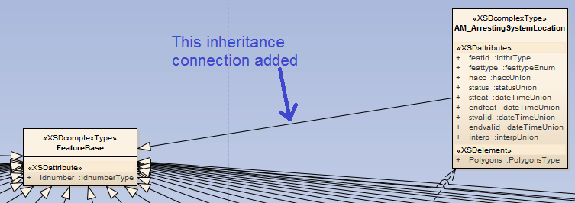

1. In the XML Schema Definition file, the following blue text will be added:

<xsd:complexType name="AM_ArrestingSystemLocation">

                        <xsd:complexContent>

                                    <xsd:extension base="adb:FeatureBase">

                                                <xsd:sequence>

                                                ….

                                                </xsd:attribute>

                                    </xsd:extension>

                        </xsd:complexContent>

            </xsd:complexType>

1. In the XML Meta Data Interchange file, the following blue text will be added:

<UML:Generalization subtype="EAID_D76C961A_E677_4e6f_BD04_3F6D43879B1A" supertype="EAID_D12008F0_5AC8_4cb1_A5AD_DC9CEB03F6B5" xmi.id="EAID_40B968E2_E63D_44b5_AAD9_2EE0BC1FEF3A" visibility="public">

<UML:ModelElement.taggedValue>

<UML:TaggedValue tag="style" value="3"/>

                        <UML:TaggedValue tag="ea_type" value="Generalization"/>

                        <UML:TaggedValue tag="direction" value="Source -&gt; Destination"/>

                        <UML:TaggedValue tag="linemode" value="3"/>

                        <UML:TaggedValue tag="linecolor" value="-1"/>

                        <UML:TaggedValue tag="linewidth" value="0"/>

                        <UML:TaggedValue tag="seqno" value="0"/>

                        <UML:TaggedValue tag="headStyle" value="0"/>

                        <UML:TaggedValue tag="lineStyle" value="0"/>

                        <UML:TaggedValue tag="ea_localid" value="828"/>

<UML:TaggedValue tag="ea_sourceName" value="AM_ArrestingSystemLocation"/>

                        <UML:TaggedValue tag="ea_targetName" value="FeatureBase"/>

                        <UML:TaggedValue tag="ea_sourceType" value="Class"/>

                        <UML:TaggedValue tag="ea_targetType" value="Class"/>

                        <UML:TaggedValue tag="ea_sourceID" value="62"/>

                        <UML:TaggedValue tag="ea_targetID" value="111"/>

                        <UML:TaggedValue tag="src_visibility" value="Public"/>

                        <UML:TaggedValue tag="src_aggregation" value="0"/>

                        <UML:TaggedValue tag="src_isOrdered" value="false"/>

                        <UML:TaggedValue tag="src_targetScope" value="instance"/>

                        <UML:TaggedValue tag="src_changeable" value="none"/>

                        <UML:TaggedValue tag="src_isNavigable" value="false"/>

                        <UML:TaggedValue tag="src_containment" value="Unspecified"/>

<UML:TaggedValue tag="src_style" value="Union=0;Derived=0;AllowDuplicates=0;"/>

                        <UML:TaggedValue tag="dst_visibility" value="Public"/>

                        <UML:TaggedValue tag="dst_aggregation" value="0"/>

                        <UML:TaggedValue tag="dst_isOrdered" value="false"/>

                        <UML:TaggedValue tag="dst_targetScope" value="instance"/>

                        <UML:TaggedValue tag="dst_changeable" value="none"/>

                        <UML:TaggedValue tag="dst_isNavigable" value="true"/>

                        <UML:TaggedValue tag="dst_containment" value="Unspecified"/>

<UML:TaggedValue tag="dst_style" value="Union=0;Derived=0;AllowDuplicates=0;"/>

                        <UML:TaggedValue tag="virtualInheritance" value="0"/>

            </UML:ModelElement.taggedValue>

</UML:Generalization>

**For error 2:** In the XML Schema Definition file, the following red text will be removed:

<xsd:simpleType name="aprontypUnion">

                        <xsd:union memberTypes="adb:aprontypBase adb:defaultIntEnum"/>

            </xsd:simpleType>

~~<xsd:element name="ADB">~~

~~<xsd:complexType>~~

~~<xsd:sequence/>~~

~~</xsd:complexType>~~

~~</xsd:element>~~

            <xsd:simpleType name="bridgeUnion">

                        <xsd:union memberTypes="adb:bridgeBase adb:defaultIntEnum"/>

            </xsd:simpleType>

**For error 3:** In the pdf, the ApronTypType enumeration table will be revised as follows:

|  |  |
| --- | --- |
| **<<enumeration>>**  **ApronTypType** | |
| **Literal Value** | **Numeric Value** |
| Reserved | 0 |
| General | 1 |
| Penalty Box/Hold Pad | 2 |
| Turnaround | 3 |
| Reserved | 4-99 |
| Not Entered | -32764 |
| Not Applicable | -32765 |
| Unknown | -32767 |
| Null | -32768 |