Stellar Solutions

Interoffice Correspondence

Date: Sep 26, 2017

Subject: ATN/OSI and ATN/IPS Cockpit Data SATCOM Interfaces DRAFT

To: José Godoy From: Rainer J Koll
AGCS Special Committee Organization: Stellar Solutions
for Air-Ground Technologies Email: rkoll@stellaraerospace.co.uk
Telephone: +44 7976 123 185
CC: Brent Phillips (FAA)
Brent.Phillips@faa.gov
Dave Robinson (FAA)
david.w.robinson@faa.gov
Ann Heinke (Stellar Solutions)
aheinke@stellarsolutions.com
Alan Schuster Bruce (Inmarsat)
alan.schuster-bruce@inmarsat.com
Gary Colledge
Gary.Colledge@inmarsat.com
Mike Hooper
michael.hooper@iridium.com
AGCS Email Distribution

The AEEC AGCS Special Committee for Air-Ground Technologies met on Sep. 20/21/22 in Montreal to progress characteristic A771 D3S1 for Iridium SATCOM. At that meeting Ann Heinke, Dave Robinson and Rainer Koll accepted the action to develop sections 3.2.2.x and 4.3.x with regard to ATN/OSI and ATN/IPS cockpit data interfaces. These interfaces are also not yet developed for A781 D1S7 Inmarsat SB-Safety, so it should be assumed that the action is relevant for both characteristics.
1) Why ATN/OSI and ATN/IPS cockpit data interfaces
The airlines and FAA are seeking cost-effective air-ground (wireless) data links to provide an increasing level of information exchange at higher data rate, lower latency, and higher availability while supporting communications security. Emerging SATCOM technologies such as Inmarsat SwiftBroadband Safety (SB-S) and IridiumNext (Certus) are expected to meet that objective over several evolutionary steps, and deliver high performance data links on aircraft to support sharing of communications, navigation, and surveillance information under Air Traffic Management (ATM) modernization programs such as the FAA’s NextGen program.
Next Generation Satellite Systems (NGSS) in conjunction with the Aeronautical Telecommunication Network (ATN) Open Systems Interconnection (OSI) and the ATN Network Internet Protocol Suite (IPS) are being proposed and are in development as a way to offer SATCOM systems with adequate performance for the exchange of safety critical data and flight information between aircraft and ground systems in domestic and oceanic airspace. In essence, the long-term objective of NGSS is to support 4D trajectory ATM and future air traffic growth projections in domestic and oceanic airspace.
During the evolutionary steps that SATCOM is undergoing, significant differences will exist between the network and applications used within the SESAR domain in Europe and the NextGen domain in the US. This means in practicality, that the advanced applications of NextGen datalink conforming aircraft cannot be fully supported in Europe. Vice versa, the advanced applications of SESAR datalink conforming aircraft cannot be fully supported in the US NAS. Based on current intentions, these harmonization gap years are going to exist at least until 2025, and very likely beyond until the harmonized SATCOM technology based on the ATN IPS network and the Baseline 2 (B2) application has worked its way through linefit and retrofit aircraft populations.
To achieve the NGSS goal of a globally harmonized, supported and fully performing SATCOM Datalink, further SATCOM definition and standardization work is required in terms of physical link, network and applications.
The goal is therefore to standardize and harmonize the applicable transition paths so that a converged state can be reached, taking into account:
- The different starting points and legacy infrastructure
- The different needs and urgencies for local implementation of data communication services
- The necessary accommodation of existing SATCOM technology and aircraft/ground installations
- Opportunities for shorting the harmonization gap years and earlier introduction of SATCOM Datalinks conforming to ATN IPS network protocols and the B2 set of applications that can support the full message set for 4D Trajectory ATM.
- Risk/Opportunity assessment of potential dual protocol stack equipage and/or dual industrial developments, including e.g. the economic impact.
- System Security Considerations
Although the AGCS Special committee and A781/A771 focus on SATCOM avionics and its interfaces, considerations have to be given as to which protocols and technologies ANSPs can use (and when) that will ensure they can support in a given airspace links such as VDL Mode O/A or Mode 2, as well as ATN OSI and/or ATN IPS SATCOM systems. Backward compatibility is necessary with traditional ACARS air traffic services, e.g. FANS and Aeronautical Operational Control (AOC), such as ARINC 702A flight plans, the Link 2000+ (Aeronautical Telecommunication Network B1) and ATN B2 applications.
The principal SATCOM elements are:
- Applications
- Networks
- Physical links
In order to have interoperable end-to-end communications, the aircraft and the ground infrastructure and systems must share a common/compatible combination of these elements, and respective ground infrastructure and system elements of the various international airspaces must support the avionics capabilities of flights operating in/out, or overflying both respective Airspaces. The SESAR and NextGen data communication roadmaps for continental and oceanic areas are aiming in the long term to a harmonized environment based on:
- ATN/IPS for the network
- Baseline 2 (B2) for the ATM service applications
- VDL Mode 2 and high bandwidth SATCOM.
2) SATCOM Cockpit Data Interface Combinations
Table 1 provides an overview of the various SATCOM cockpit data interfaces that either exist at present, or are under consideration. The table offers a naming convention that is currently under review by the ICAO CP DCIWG PT-S Working Group, making a distinction between the various SATCOM Performance Classes (and sub-classes) based on performance and function, and showing the relationship between RCP and the applicable airspace category.
In order to achieve the Network/Application combinations listed in Table 1, the AES must implement the corresponding ACARS, ATN OSI and/or ATN IPS Airborne Gateway functions and support the corresponding communication protocols. The Airborne Gateway must automatically register with the corresponding Ground Gateway in accordance with the actual Network/Application AES configuration.

DEFINITION  NAME | Network /  Application | Interoperability  Specification | Performance specification | Required Com. Perf. | Airspace  Category
Performance Class C | ACARS / FANS/1A | DO-258A/ED-100A | DO-306/ED-122 | RCP 240 RSP 180 | Oceanic
Performance Class B (α) | ACARS / FANS/1A | DO-258A/ED-100A | DO-306/ED-122 | RCP 130  RSP 160 | Oceanic and Domestic
Performance Class B (β) | ACARS / FANS/1A ATN / OSI – B1 | DO-258A/ED-100A  DO-280B/ED-112B | DO-306/ED-122  DO-290/ED-120 | RCP 130  RSP 160 | Oceanic and Domestic
Performance Class B (γ) | ACARS / FANS/1A ATN / OSI – B1  ATN / IPS – B2 | DO-258A/ED-100A  DO-280B/ED-112B  DO-351A/ED-229A | DO-306/ED-122  DO-290/ED-120 | RCP 130  RSP 160 | Oceanic and Domestic
Performance Class B (δ) | ACARS / FANS/1A  ATN / IPS – B2 | DO-258A/ED-100A  DO-351A/ED-229A | DO-306/ED-122  DO-350A/ED-228A | RCP 130  RSP 160 | Oceanic and Domestic
Performance Class A | ATN / IPS – B3 | t.b.d. | t.b.d. | RCP 60  RSP 60 | Oceanic and Domestic
Table 1 - SATCOM Naming Convention (under review)
Notes for Table 1:
- Higher SATCOM Performance Classes include compliance with lesser Performance Classes, e.g. RCP 130 /RSP 160 SATCOM Performance also meets RCP 240 / RSP 180.
- SATCOM Performance Class B (α) has been PARC validated at RCP 130 / RSP160 for FANS-over-SBB. FAA ratification is pending.
- No schedule has yet been agreed for SATCOM Performance Class A developments.
- The Airspace Category column refers to SATCOM capability only. For achieving overall operational capability implementation of the corresponding ground networks and applications is necessary.
3. DRAFT Proposal for A781 and A771 sections 3.2.2.x and 4.3.x
Considerations:
The ACARS data protocol is defined in ARINC Specification 618. The function of the protocol is to provide character-based data connectivity between an aircraft and any number of ground-based service providers with whom the aircraft operator has subscription relationships. ACARS messages are normally sent to and from the aircraft avionics through an ARINC 429 physical interface, using the ARINC 620 protocol. Ethernet ports are typically used to interface IP data to the SATCOM equipment.
The ATN/OSI data service is a high availability data service with priority and pre-emption, intended to support ATS ATN applications using the ATN/OSI network protocol (ICAO 9880). The groundside interface to ANSPs and CNPs is the same as for VDL Mode 2 and is defined in the ICAO ATN manual. The airside interface to the CMU is an evolution of the equivalent ACARS CMU to SDU interface. ATN/OSI is primarily designed to carry operational traffic representing safety and regularity of flight. The ATN operational traffic type consists of data communications services to air traffic service (ATS), Aeronautical Operational Control (AOC) and Aeronautical Administrative Communication (AAC). The ATN/OSI data service must be delivered via a VPN or equivalent between the ground and aircraft to provide adequate protection of message integrity. AES supporting ATN/OSI (including AES supporting both ATN/OSI and ACARS) are required to use the VPN. The VPN terminates within the AES on the aircraft and within a security gateway within the ground aero rack, which also houses the gateways for ATN/OSI and ACARS. The VPN ensure mutual authentication of the endpoints and integrity of data using IPSec. Access to ATN/OSI and ACARS services is controlled using a PKI system.
ATN/IPS is an ICAO Aeronautical Telecommunication Network (ATN) implementation, based on the Internet Protocol Suite (IPS). ATN/IPS has adopted the same four layer model as defined in the Internet Society (ISOC) internet standard STD003, which is a combination of Internet Engineering Task Force (IETF) RFC 1122 and RFC 1123. The ICAO Manual for the ATN using IPS Standards and Protocols (Doc 9896) includes convergence mechanisms and application services that allow the operation of legacy ATN/OSI applications over the ATN/IPS transport layer. The ATN/IPS Internetwork is specifically and exclusively intended to provide data communications services to air traffic service (ATS) provider organizations and aircraft operating agencies supporting ATS Communication (ATSC), AOC and AAC. The IPS systems support all existing systems/applications which are being deployed using ACARS and ATN OSI protocol. The IPS also supports future capabilities such as ATN B2 applications and beyond.
The allocation of the IPS function to the avionics systems will have differences in terms of avionics architecture. Two main architecture options are considered:
- A429 legacy architecture (interfaces between equipment based only on A429 point-to-point buses),
- A664 based architecture (AFDX and Ethernet interfaces) , which may also include some A429 interfaces
ARINC 429 based ATN/IPS Avionics architectures:
The central element of the traditional ARINC 429 data bus IPS architecture is the CMU/ATSU equipment, which includes the following functions:
- ACARS routing function,
- ATN/OSI routing function,
- ATS applications, including CPDLC,
- Hosted AOC applications.
Note: ATSU units are installed on Airbus Single Aisle and Long Range commercial aircrafts
families (A32x and A330/340).

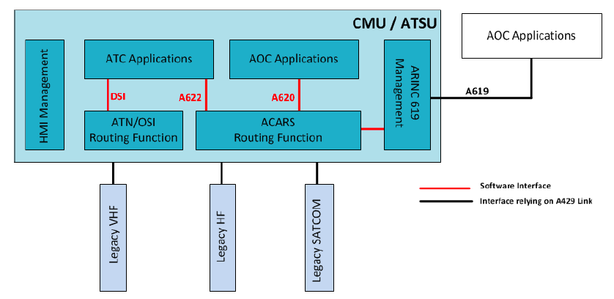
Figure 1 - Architecture Based on ARINC 429, ref. Project Paper 658
Functions are implemented as software products hosted on CMU/ATSU equipment, based on ARINC 758 standard concepts. Interfaces between functions are also software-based. The ATSU has the capability to provide ACARS communication to AOC applications located outside the ATSU, through an ARINC 619 interface supported by ARINC 429 links. This capability is for instance provided to the FMS AOC on existing Airbus aircraft. ATS applications can be hosted in the CMU/ATSU equipment, but also outside (e.g. FMS).
Usually each ATS application is dedicated to one routing function (ACARS or ATN). On Continental Airspace configurations, ATN B1 applications are connected to the ATN/OSI routing function, and optionally ARINC 623 applications (DCL, ATIS) are connected to the ACARS routing function. On Remote or Oceanic Airspace configurations, FANS 1/A applications and optionally ARINC 623 applications (OCL, DCL, ATIS) are connected to the ACARS routing function. Dual configurations are possible. ARINC 429 digital buses connecting LRU’s are still installed on most Airbus commercial transport aircraft including A319/A320/A321 series and A330/A340, A380 and A350.
A429 buses are limited in bandwidth (100 kbps).
New ATN/IPS Avionics architectures:
ARINC Specification 664 is the guidance document that establishes the architecture framework for IP-based aircraft. It contains detailed implementation specification for AFDX, and the Ethernet physical layer. ARINC 664 architectures are based on Integrated Modular Avionics (IMA), as defined in ARINC 651, and rely on the AFDX network and switches defined in ARINC 664 Part 7. The ARINC 664 standards defines a number of elements of a generic aircraft architecture which may support functions relying on an AFDX switched network, but also a domain based on “standard” Ethernet network.
ATN/IPS system could be hosted either in the ATSU/CMU or in dedicated equipment, taking into account that segregation is likely required for providing a layered security solution. Due to limited growing capability and complexity to implement segregation inside ATSU/CMU, the dedicated equipment option is preferred. Even if integrated in a different way depending on the aircraft type, it is suitable that the ATN/IPS router is common to all aircraft types.

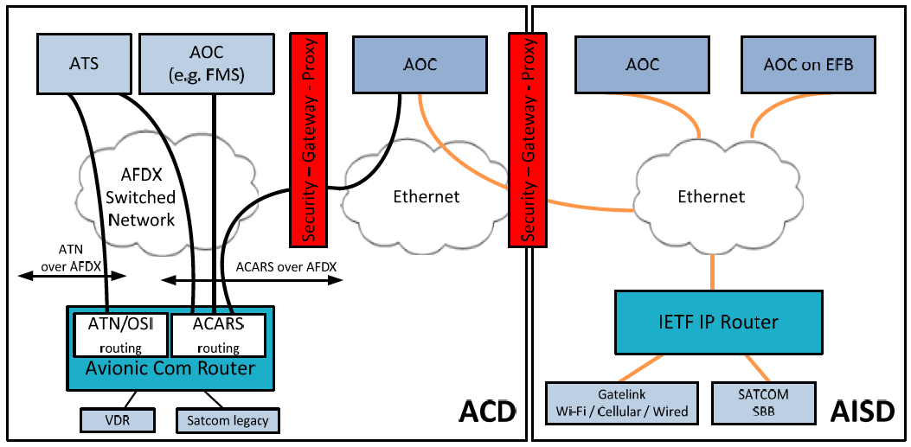
Figure 2 - High-level view of ARINC 664 based architecture
Required inputs for A781 and A771 sections 3.2.2.x and 4.3.x:
- Interfaces and type of interfaces required by the Inmarsat SB-Safety and IridiumNext (Certus) IPS system to be defined.
- A781 SB-Safety logical architecture diagram to be updated (shown next page)
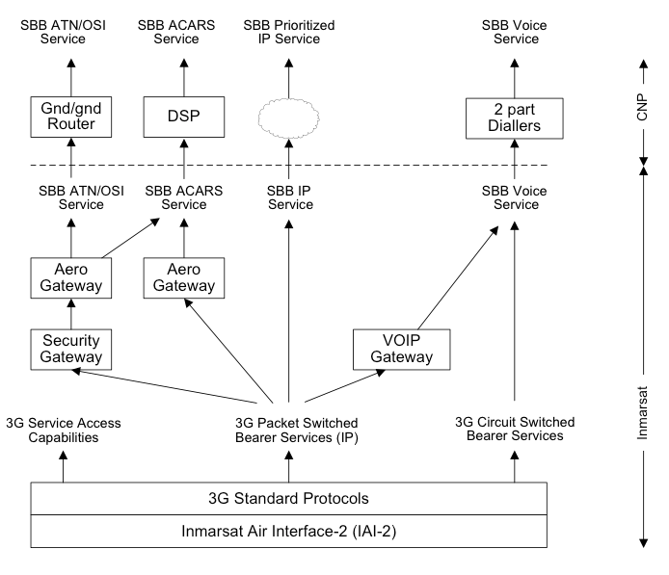
- A781 ACARS and ATN/OSI Data Service End-To-End Architecture to be updated
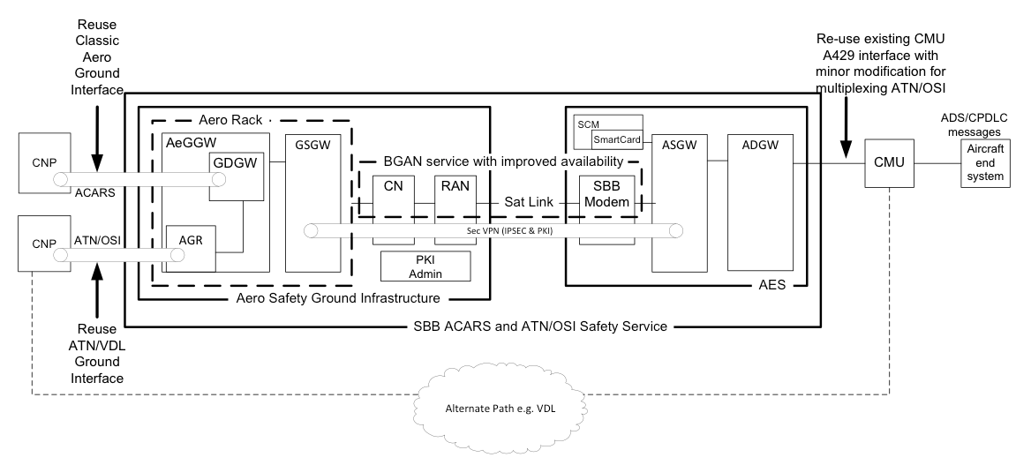
- A771 Iridium End-To-End Architecture to be updated for ATN/OSI and ATN /IPS Data Service (shown next page)
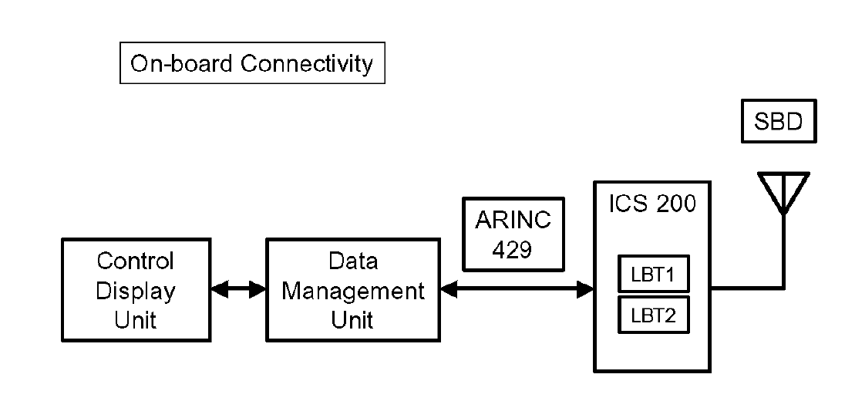
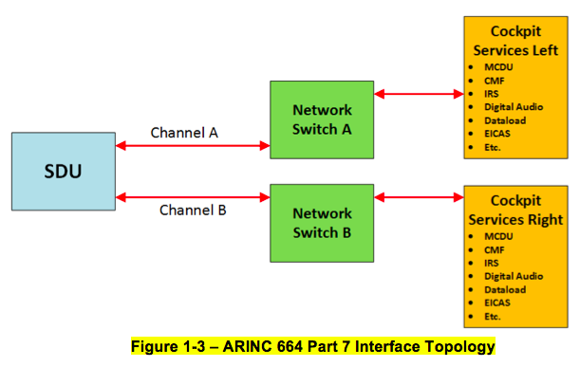
- Common issues for A781 and A771 sections 3.2.2.x and 4.3.x that need to be resolved:
  - A suitable method to map IPV6 packets from the CMU onto the Inmarsat (IPV4) network, extract them at a ground gateway, then pass them to ground ATN/IPS routers.
  - Evaluation whether a similar issue will exist for IridiumNext (Certus)T the same interface to the CMU will be required, regardless of the SATCOM type.
  - The SDU/SBU should not have to manage IPV6 addressing, nor security, since both of these functions can reside in the on-board router (CMU), and the ground ATN/IPS router.
  - A tunneling scheme, or equivalent, appears the most appropriate solution.
The appropriate text needs to be developed to populate sections 3.2.2.x and 4.3.x, taking into account prior inputs and discussions.

