ARINC Project Initiation/Modification (APIM)

Name of Proposed Project APIM 20-002 ___________
Size 4 ARINC 600 Connector, Rack and Panel (960 pins)

Name of Originator and/or Organization
AIRBUS

Subcommittee Assignment and Project Support

Suggested AEEC Group and Chairman
ARINC 600 Connector Working Group
Chairman TBD

Support for the Activity (as verified)
Airlines: TBD
Airframe Manufacturers: AIRBUS
Suppliers: RADIALL / SOURIAU / TE
Others: to add system suppliers AIRBUS AVIONICS (internal suppliers)

Commitment for Drafting and Meeting Participation (as verified)
Airlines: TBD
Airframe Manufacturers: AIRBUS
Suppliers: RADIALL / SOURIAU / TE
Others: to add system suppliers AIRBUS AVIONICS (internal suppliers)

Recommended Coordination with other groups
Cabin Systems Subcommittee
SAI Subcommittee

Project Scope (why and when standard is needed)

Description
The aim is to increase:
- New connector size with 3 additional cavities
- Shell number available
- Pins number

See attached presentation.
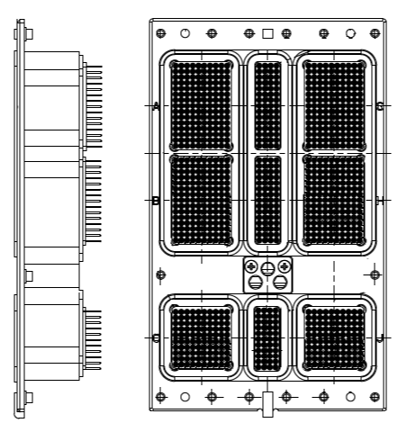
Receptacle connector

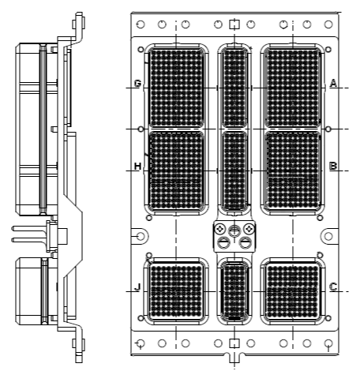

Plug connector

ARINC 600 performance expected to be defined, both electrical and mechanical.

Planned usage of the ARINC Standard
Note: New airplane programs must be confirmed by the aircraft manufacturer prior to completing this section.

New aircraft developments planned to use this specification yes ☐ no ☒
Airbus: (aircraft & date)
Boeing: (aircraft & date)
Other: (manufacturer, aircraft & date)
Modification/retrofit requirement yes ☒ no ☐
Specify: (A320 & 2023 for testing)
Needed for airframe manufacturer or airline project yes ☒ no ☐
Specify: (A320 & 2023 for testing)
Mandate/regulatory requirement yes ☐ no ☒
Program and date: (program & date)
Is the activity defining/changing an infrastructure standard? yes ☒ no ☐
Specify: ARINC 600 standard
When is the ARINC standard required? Dec 2021
What is driving this date? to secure system architecture new development with buy strategy
Are 18 months (min) available for standardization work? yes ☒ no ☐
If NO please specify solution: _________________
Are Patent(s) involved? yes ☐ no ☒
If YES please describe, identify patent holder: _________________

Issues to be Worked
(Describe the major issues to be addressed.)
Additional cavities with existing ARINC 600 shells (cf. drawing).

Security Scope
Is Cyber Security Impacted (if yes, check box(es) below) yes ☐ no ☒
Aircraft Control Domain yes ☐ no ☒
Airline Information Services Domain yes ☐ no ☒
PAX Information and Entertainment Systems yes ☐ no ☒
Other _________________________________ yes ☐ no ☒

Benefits

Basic Benefits
Operational enhancements yes ☐ no ☒
For equipment standards:
        - Is this a hardware characteristic? yes ☒ no ☐
        - Is this a software characteristic? yes ☐ no ☒
        - Interchangeable interface definition? yes ☐ no ☒
        - Interchangeable function definition? yes ☐ no ☒
If not fully interchangeable, please explain: _________________
Is this a software interface and protocol standard? yes ☐ no ☒
Specify: _________________
Product offered by more than one supplier yes ☒ no ☐
Identify: RADIALL / SOURIAU / TE

Specific Project Benefits

Offer more PIN contact per avionics equipment to system.

Benefits for Airlines
Enabler for more integrated systems (e.g. Reduce number of avionics S/N)

Benefits for Airframe Manufacturers
Offer more PIN contact per avionics equipment to system,

Benefits for Avionics Equipment Suppliers
Foster an ecosystem around a new standardized connector.

Documents to be Produced and Date of Expected Result
ARINC 600 Standard update for December 2021.

Meetings and Expected Document Completion
6 meetings to be anticipated during the 18 months
The following table identifies the number of meetings and proposed meeting days needed to produce the documents described above.

Activity | Mtgs | Mtg-Days  (Total) | Expected Start Date | Expected Completion Date
ARINC 600 | 6 | 18 | 06/2020 | 12/2021

Please note the number of in-person meetings and the number of meeting days to be supported by the ARINC IA Staff.
Please add a statement describing the frequency of web conferences.

Comments
None

Expiration Date for the APIM
December 2022

Completed forms should be submitted to Paul Prisaznuk (pjp@sae-itc.org)
AEEC Executive Secretary & Program Director

