ARINC Project Initiation/Modification (APIM)

Name of Proposed Project APIM 16-015A
Ground System Definition for e-Enabled Aircraft

Name of Originator and/or Organization
Maurice Ingle, American Airlines

Subcommittee Assignment and Project Support

Suggested AEEC Group and Chairman
Software Distribution and Loading (SDL) Subcommittee
Chairman: Ted Patmore, Delta Air Lines

Support for the activity (as verified)
Airlines: American Airlines, Cathay Pacific, Delta Air Lines, El Al Israel Airlines, Lufthansa, Qatar Airways, Southwest, TAP Portugal, United Airlines, UPS, Virgin America, WestJet
Airframe Manufacturers: Airbus, Boeing
Suppliers: Collins, Esterline, Honeywell, Teledyne

Commitment for Drafting and Meeting Participation (as verified)
Airlines: American Airlines, Delta Air Lines, Lufthansa
Airframe Manufacturers:
Suppliers: Teledyne
Others:

Recommended Coordination with other groups
RTCA SC-216, EASA WG-72, NIS and SAI Subcommittees

Project Scope (why and when standard is needed)

Description
e-Enabled aircraft and their e-Operations Ground Systems are proprietary, and only operational with aircraft built by that respective airframer. Airlines that operate aircraft from more than one airframer are faced with building and maintaining more than one entire ground system.
The project has a grand objective, potentially involving almost all facets of airborne software management. Given unlimited power, time, resources, and business approval the project would simply provide airlines a single Software management system. This system would span from LSAP receiving, storage, distribution, PKI, installation, and verification, to include configuration reporting. It would cover all airframes, all fleets, and all systems.
The reality of the industry does not allow for such a simple system to be available today for airlines.
This APIM proposes a phased approach to achieving an acceptable outcome for all stakeholders. Initially, industry will draft a document defining an API to allow access between an airline’s ground software management tools to any aircraft manufacturer’s airplane software distribution mechanisms. This is represented in the Figure 1 as API-1. This phase provides value to the airlines by simplifying a portion of their ground infrastructure requirements
It was originally envisioned that API-2 (see Figure 1) would later be developed to standardize the Air to Ground Module (AGM) communication to the aircraft.

Figure 1 – Old Concept - Modular e-Enabled Ground Support System

However, there has been significant reluctance from the major aircraft manufacturers in sharing the AGM to aircraft interface information with outside parties. Among other reasons for their position, they consider this information to be proprietary and essential to maintaining aircraft security. Additionally, standardizing the AGM affects TC aircraft components and restricts future development to keep up with the latest technology.
The SDL Subcommittee began working on an alternate approach to the resolve the issue that the AGM module functional details need to remain proprietary.
As shown in Figure 2, the goal now (APIM 16-015A) is to standardize the interface between the Operator Ground Module (OGM) and Air to Ground Module (AGM).
Here, the OGM to AGM communication would be standardized. This means that the aircraft interface functionality would remain hidden, and the AGM would be designed, by the aircraft manufacturer, to conform to the standard set of API-1c functions and messages defined in this standard. Each aircraft manufacturer will produce an Air Ground Module (AGM) function that will communicate to their aircraft using their proprietary method, and communicate with the OGM using the ARINC Specification 851 defined standard method. The AGM will operate in a standardized hosting environment defined in this standard.

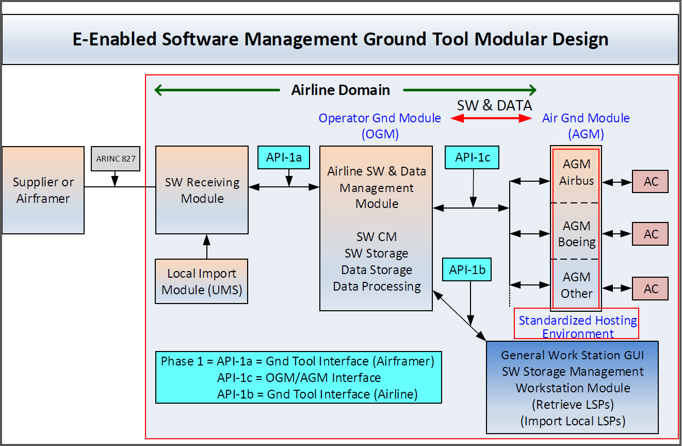
Figure 2 – New Concept - Modular e-Enabled Ground Support System

The OGM will interface to the AGM through API-1c. This will require that all AGM are designed or modified to interface to the OGM standard that will be defined in this standard. This will avoid the need to develop the API-2 (phase 2) of the original APIM proposal.
For aircraft planned in the future, the overall single, unified software management system could be more easily implemented to accept an airline’s fleet of disparate aircraft software from any manufacturer. This would greatly simplify the airlines’ processes into the next 100 years of powered flight.
Through all phases, there are a few details that would significantly assist the airlines in managing their processes.
- The desired method of software distribution is media-less.
- The desired method of software staging on aircraft is wirelessly.
- A mechanism for a hosted system should be available. Some airlines do not want or do not have the capability to host and maintain the Information Technology (IT) infrastructure required to support software intensive aircraft.
- Downloading data from the aircraft is also a function related to eEnabled ground system transport and storage, whether wireless, media based or wired for the following data:
- Aircraft system reports
- Flight Ops Quality Assurance data
- Security log data
- FLS configuration data

Planned usage of the envisioned specification
Note: New airplane programs must be confirmed by manufacturer prior to completing this section.

New aircraft developments planned to use this specification yes ☐ no ☐
Airbus: (aircraft & date)
Boeing: (aircraft & date)
Other: (manufacturer, aircraft & date)
Modification/retrofit requirement yes ☒ no ☐
Specify: Ground System, Desired
Needed for airframe manufacturer or airline project yes ☒ no ☐
Specify: Desired
Mandate/regulatory requirement yes ☐ no ☒
Program and date: (program & date)
Is the activity defining/changing an infrastructure standard? yes ☐ no ☒
Specify (e.g., ARINC 429)
When is the ARINC standard required? March 2021
What is driving this date? Time necessary to define, prepare and alter systems
Are 18 months (min) available for standardization work? yes ☒ no ☐
If NO please specify solution: _________________
Are Patent(s) involved? yes ☐ no ☒
If YES please describe, identify patent holder: _________________

Issues to be worked
The ground system applications must support the following:
- A secure means of validating that FLS has been provided from a trusted source and the FLS integrity has not been compromised.
- The ability to digitally sign the FLS with the airline or operator digital signature (as required).
- Storage of the FLS.
- Distribution of the FLS wirelessly to aircraft and/or via ground systems like proxy servers, USB sticks or maintenance laptops.
- PKI infrastructure as required by the ground and aircraft systems.
- A repository for aircraft data.

Benefits

Basic benefits
Operational enhancements yes ☒ no ☐
For equipment standards:
        - Is this a hardware characteristic? yes ☐ no ☒
        - Is this a software characteristic? yes ☒ no ☐
        - Interchangeable interface definition? yes ☐ no ☒
        - Interchangeable function definition? yes ☒ no ☐
If not fully interchangeable, please explain: _______________
Is this a software interface and protocol standard? yes ☒ no ☐
Specify: All of the above is as it relates to ground systems and interface with aircraft
Product offered by more than one supplier yes ☒ no ☐
Identify: Boeing and Airbus

Specific project benefits (Describe overall project benefits.)

Benefits for Airlines
Large initial acquisition and build, and ongoing maintenance cost savings for airlines that operate or plan to operate any aircraft manufacturer’s “eEnabled” aircraft will be realized from commercial product and licensing costs, hosting fees, IT infrastructure costs, and Engineering, IT, and IT Security resources.
Also, operators desire to have one process to perform eEnabled FLS management. This will minimize problems due to human factors caused by the complexity of using multiple systems for one type of task.
Regulatory requirements will also be simplified with the standardization of ground applications, infrastructure and processes.

Benefits for Airframe Manufacturers
Simplification with one industry standard

Benefits for Avionics Equipment Suppliers
(Describe any benefits unique to the equipment supplier’s point of view.)

Documents to be Produced and Date of Expected Result
Identify Project Papers expected to be completed per the table in the following section.

Meetings and Expected Document Completion
The following table identifies the number of meetings and proposed meeting days needed to produce the documents described above.

Activity | Mtgs | Mtg-Days  (Total) | Expected  Start Date | Expected Completion Date
ARINC Project Paper 851: Aircraft Software Ground Tool Definition | 9 | 27 | Jan 2017 | Mar 2021
Web meetings | 6/year |  | Feb 2017 | Mar 2021

Please note the number of meetings, the number of meeting days, and the frequency of web conferences to be supported by the ARINC IA Staff.

Comments
Airbus, Boeing, and all other aircraft manufacturers will have to support this standardization if it is to be accomplished. IT and IT Security involvement will be instrumental.

Expiration Date for the APIM
April 2022

Completed forms should be submitted to the AEEC Executive Secretary.

