Tier 1 Tier 2 Example

The example below describes an unwanted situation and how it must not be done.

**Background**

Tier1 buys a PN 123 from Tier2. Tier2 sells the unit on the world market under PN 123.

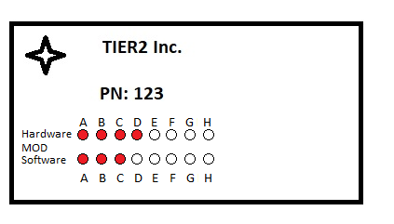

Tier 1 installs a second ID Plate with a new Tier1 PN on the unit (e.g. PN: 456) and sells it on the world market and provides a new Tier1 CMM.

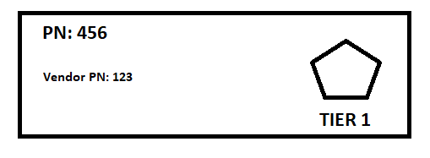

The new ID Plate contains Tier PN: 456 and a reference to Tier2 PN: 123. In addition, the original TIER2 ID Plate is still on the unit.

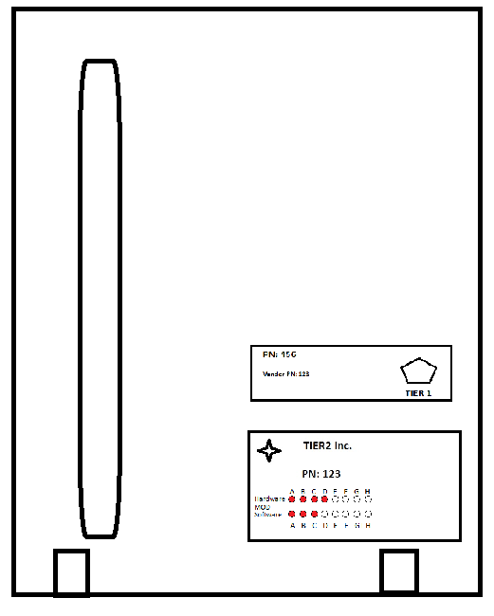

**Partnumber**

Under which PN should the above presented PN be handled? What will be the leading PN. Normally you have two OEM on the Equipment but who will be the responsible TIER1. Under which PN will the unit be released, to be compliant with the TC Holders Documentation?

**Software MOD Issues**

Tier2 delivers the SRU for repair. Due to some revisions the delivered spare boards is equipped with the latest software release called D. Boards including Software Rev C. are no longer available. Tier1 did not release a VSB on the Software. If the Board with Software Revision D would be installed the unit has an unapproved state and cannot be released to service any more.

In this case, the Tier2 provides new units with the new Software PN to Tier1. Therefore, Tier1 new units have an undescribed state

**Hardware MOD issues**

After a certain while, the unit needs to be modified.

Tier2 releases an SB for all field units requesting to modify the field units and mark the mod with a mod dot. For all new units a new PN 123A is released.

To be compliant Tier1 releases also an VSB. Tier1 changes the Tier1 PN into 457 and ignores the MOD DOT. But the new name plate also contains the new Tier2 PN 123A.

Now the unit has now 3 different PN on two labels showing 2 different MOD states.

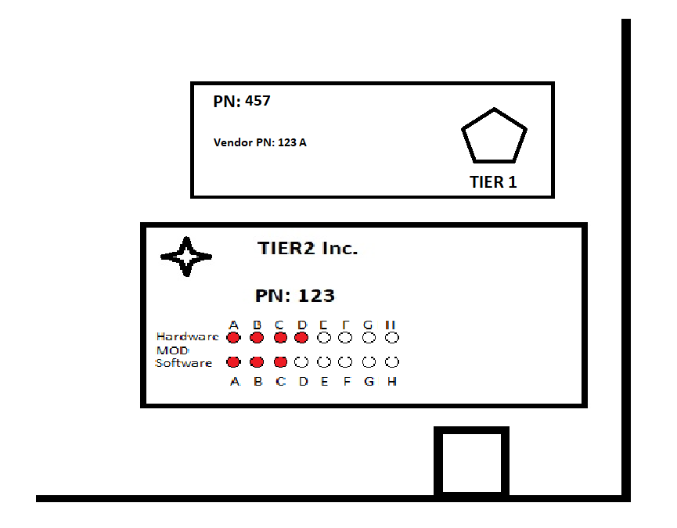

Therefore the unit has an unapproved state and cannot be released to service any more.

Basic Questions arising from this example:

1. What is the leading PN and how this is marked on the unit?
2. How is TIER1 informed to about modifications and changes by Tier2?
3. How is the TIER1 PN implemented in TIER2 Processess?