The following are proposed updates to the ARINC 661 Specification to add new Graphical Primitive Widgets for Triangle Fan and Triangle Strip – similar to the Triangle Fan and Triangle Strip Symbol Commands.

Graphical Primitive Widgets for Triangle Fan and Triangle Strip allow more control over the appearance of these graphical elements at runtime.

**Proposed Updates to ARINC 661 Specification**

**3.10.4 GpTriangleFan**

Categories:

* Graphical Representation
* Dynamic motion

Description:  
The graphical primitive GpTriangleFan widget enables the definition of a shape composed out of a fan of triangles. The first three vertices define the first triangular section. Each subsequent vertex defines a new triangular section, sharing the first and last vertices of the previous triangular section. At least three vertices must be specified. Any convex polygon can be represented as a triangle fan, by just specifying its vertices in the natural order. A triangle fan is not necessarily a convex polygon, though.

The following figure shows how the Vertices (V0 ..V6) of a triangle fan define a filled shape formed out of triangles. When drawn, a triangle fan does not draw the interior lines or vertex labels shown in this figure. In this case, it defines a concave polygon:

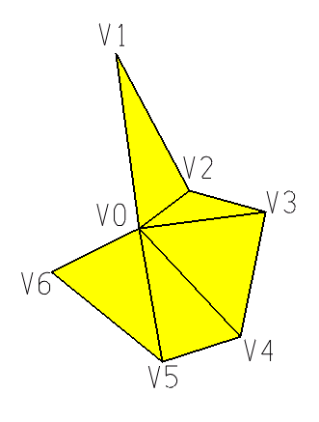

**Figure 3.10.4-1 – Triangle Fan – Concave Polygon**

The following figure illustrates a convex polygon case:

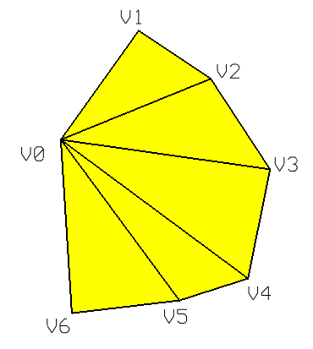

**Figure 3.10.4-2 – Triangle Fan – Convex Polygon**

Restriction:   
None

GpTriangleFan Parameters are defined in Table 3.10.4-1.

**Table 3.10.4-1 – GpTriangleFan Parameters**

|  |  |  |
| --- | --- | --- |
| **Parameters** | **Change** | **Description** |
| *Commonly Used Parameters* | | |
| WidgetType | D | A661_GP_TRIANGLE_FAN |
| WidgetIdent | D | Unique identifier of the widget. |
| ParentIdent | D | Identifier of the immediate container of the widget. |
| Visible | DR | Visibility of the widget |
| StyleSet | DR | Reference to predefined graphical characteristics inside CDS. |
| Anonymous | D | Ability to be modified at run-time by the UA. |
| *Specific Parameters* | | |
| ColorIndex | DR | Color index of the boundary line, see section 3.1.3.3.1. |
| Halo | D | Halo is a full outline in a contrasting color (typically black) to enhance readability. See Section 3.1.3.3 for a description of possible values. |
| Filled | D | If set to True, interior of TriangleFan will be filled. |
| FillIndex | DR | Fill Pattern index see section 3.1.3.3.1. |
| MaxNumberOfVertices | D | The maximum number of vertices to be defined for the widget. |
| NumberOfVertices | DR | The number of vertices currently defined for the widget. |
| Vertices | DR | The array of vertices as (X,Y) pairs. |

GpTriangleFan Creation Structure is defined in Table 3.10.4-2.

**Table 3.10.4-2 – GpTriangleFan Creation Structure**

| **CreateParameterBuffer** | **Type** | **Size (bits)** | **Value/Range When Necessary** |
| --- | --- | --- | --- |
| WidgetType | ushort | 16 | A661_GP_TRIANGLE_FAN |
| WidgetIdent | ushort | 16 |  |
| ParentIdent | ushort | 16 |  |
| Anonymous | uchar | 8 | A661_FALSE  A661_TRUE |
| Visible | uchar | 8 | A661_FALSE  A661_TRUE |
| StyleSet | ushort | 16 |  |
| ColorIndex | uchar | 8 | (valid palette index) |
| Filled | uchar | 8 | A661_FALSE  A661_TRUE |
| FillIndex | uchar | 8 | (valid fill index) |
| Halo | uchar | 8 | A661_FALSE  A661_TRUE  A661_SAME_LEVEL |
| UnusedPad | N/A | 16 | 0 |
| MaxNumberOfVertices | ushort | 16 | Must be greater than or equal to 3. |
| NumberOfVertices | ushort | 16 | Must be greater than or equal to 3, and  must be less than or equal to  MaxNumberOfVertices. |
| Vertices | array of (long,long) | 64 * NumberOfVertices | There are NumberOfVertices of (x,y)  pairs. |

The GpTriangleFan does not send any event.

Available SetParameters identifiers and associated data structure are defined in Table 3.10.4-3.

**Table 3.10.4-3 – GpTriangleFan Runtime Modifiable Parameters**

|  |  |  |  |
| --- | --- | --- | --- |
| **Name of the Parameter to Set** | **Type** | **Size (bits)** | **ParameterIdent Used in the ParameterStructure** |
| Visible | uchar | 8 | A661_VISIBLE |
| StyleSet | ushort | 16 | A661_STYLE_SET |
| ColorIndex | uchar | 8 | A661_COLOR_INDEX |
| FillIndex | uchar | 8 | A661_FILL_INDEX |
| NumberOfVertices | ushort | 16 | A661_NUMBER_OF_ENTRIES |
| Vertices [up to NumberOfVertices] | long x 2 | {64}+ | A661_VERTICES_ARRAY |

**3.10.5 GpTriangleStrip**

Categories:

* Graphical Representation
* Dynamic motion

Description:  
The graphical primitive GpTriangleStrip widget enables the definition of a shape composed out of a strip of a linked strip of triangles. The first three vertices define the first triangular section. Each subsequent vertex defines a new triangular section, sharing the last two vertices of the previous triangular section. It is drawn using the current color.

The following figure shows how the Vertices (V0 ..V5) of a triangle strip define a filled shape formed out of triangles. When drawn, a triangle fan does not draw the interior lines or vertex labels shown in this figure.

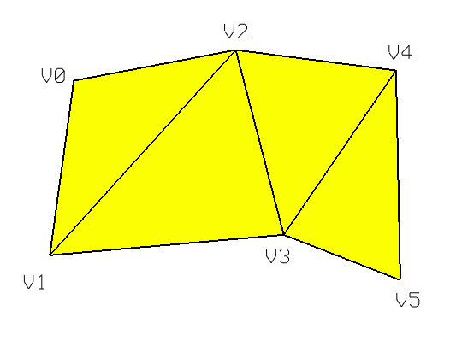

**Figure 3.10.4 – Triangle Strip**

GpTriangleStrip Parameters are defined in Table 3.10.5-1.

**Table 3.10.5-1 – GpTriangleStrip Parameters**

| **Parameters** | **Change** | **Description** |
| --- | --- | --- |
| *Commonly Used Parameters* | | |
| WidgetType | D | A661_GP_TRIANGLE_STRIP |
| WidgetIdent | D | Unique identifier of the widget. |
| ParentIdent | D | Identifier of the immediate container of the widget. |
| Visible | DR | Visibility of the widget |
| StyleSet | DR | Reference to predefined graphical characteristics inside CDS. |
| Anonymous | D | Ability to be modified at run-time by the UA. |
| *Specific Parameters* | | |
| ColorIndex | DR | Color index of the boundary line, see section 3.1.3.3.1. |
| Halo | D | Halo is a full outline in a contrasting color (typically black) to enhance readability. See Section 3.1.3.3 for a description of possible values. |
| Filled | D | If set to True, interior of TriangleStrip will be filled. |
| FillIndex | DR | Fill Pattern index see section 3.1.3.3.1. |
| MaxNumberOfVertices | D | The maximum number of vertices to be defined for the widget. |
| NumberOfVertices | DR | The number of vertices currently defined for the widget. |
| Vertices | DR | The array of vertices as (X,Y) pairs. |

GpTriangleStrip Creation Structure is defined in Table 3.10.5-2.

**Table 3.10.5-2 – GpTriangleStrip Creation Structure**

| **CreateParameterBuffer** | **Type** | **Size (bits)** | **Value/Range When Necessary** |
| --- | --- | --- | --- |
| WidgetType | ushort | 16 | A661_GP_TRIANGLE_STRIP |
| WidgetIdent | ushort | 16 |  |
| ParentIdent | ushort | 16 |  |
| Anonymous | uchar | 8 | A661_FALSE  A661_TRUE |
| Visible | uchar | 8 | A661_FALSE  A661_TRUE |
| StyleSet | ushort | 16 |  |
| ColorIndex | uchar | 8 | (valid palette index) |
| Filled | uchar | 8 | A661_FALSE  A661_TRUE |
| FillIndex | uchar | 8 | (valid fill index) |
| Halo | uchar | 8 | A661_FALSE  A661_TRUE  A661_SAME_LEVEL |
| UnusedPad | N/A | 16 | 0 |
| MaxNumberOfVertices | ushort | 16 | Must be greater than or equal to 3. |
| NumberOfVertices | ushort | 16 | Must be greater than or equal to 3, and  must be less than or equal to  MaxNumberOfVertices. |
| Vertices | array of (long,long) | 64 * NumberOfVertices | There are NumberOfVertices of (x,y)  pairs. |

GpTriangleStrip does not send any event.

Available SetParameters identifiers and associated data structure are defined in Table 3.10.5-3.

**Table 3.10.5-3 – GpTriangleStrip Runtime Modifiable Parameter**

| **Name of the Parameter to Set** | **Type** | **Size (bits)** | **ParameterIdent Used in the ParameterStructure** |
| --- | --- | --- | --- |
| Visible | uchar | 8 | A661_VISIBLE |
| StyleSet | ushort | 16 | A661_STYLE_SET |
| ColorIndex | uchar | 8 | A661_COLOR_INDEX |
| FillIndex | uchar | 8 | A661_FILL_INDEX |
| NumberOfVertices | ushort | 16 | A661_NUMBER_OF_ENTRIES |
| Vertices [up to NumberOfVertices] | long x 2 | {64}+ | A661_VERTICES_ARRAY |

**Impact to other parts of Spec**

**3.2.1 Widget Summary**

Table 3.2.1 summarizes the Widget Library.

**Table 3.2.1 – Widget Library Summary**

|  |  |
| --- | --- |
| … | |
| *WIDGETS ADDED FOR SUPPLEMENT 7* | |
| ScaleContainer | A ScaleContainer widget applies a scaling transformation to a group of widgets. |
| Selector | The Selector widget allows the user to select a single entry from a set of entries displayed according to the specified graphical layout. |
| Tree | A Tree widget is a set of items organized as a tree. A Tree widget behaves similarly to the ScrollList widget, except that the entries are grouped hierarchically. |
| GpTriangleFan | The graphical primitive GpTriangleFan allows definition of a shape composed out of a fan of triangles. |
| GpTriangleStrip | The graphical primitive GpTriangleStrip allows definition of a shape composed out of a strip of a linked strip of triangles.. |

…

**3.2.3.1 Possible Children of Container Widgets**

To Be Determined.

GpTriangleFan and GpTriangleStrip would mimic the existing GpTriangle widget.

**4.6 ARINC 661 Keyword Values**

…

**Table 4.6-7 – Widgets (16 bits)**

| **ARINC 661 Widgets (16 bits)** | |
| --- | --- |
| *Specification range* | *0xA000 – 0xA7FF* |
| A661_ACTIVE_AREA | 0xA010 |
| … | … |
| A661_GP_TRIANGLE | 0xA150 |
| A661_GP_TRIANGLE_FAN | 0xA151 |
| A661_GP_TRIANGLE_STRIP | 0xA152 |
| … | … |
| * *Reserved for OEM Customization* | * *0xA800 to 0xAFFF* |

…

**5.2.4.10 Triangle Fan**

The TRIANGLE_FAN command defines a filled shape composed out of a fan of triangles. The first three vertices define the first triangular section. Each subsequent vertex defines a new triangular section, sharing the first and last vertices of the previous triangular section. At least three vertices must be specified. Any convex polygon can be represented as a triangle fan, by just specifying its vertices in the natural order. A triangle fan is not necessarily a convex polygon, though. It is drawn using the current color. ~~The TRIANGLE_FAN command does not correspond to any Gp widget.~~

The following figure shows how the Vertices (V0 ..V6) of a triangle fan define a filled shape formed out of triangles. When drawn, a triangle fan does not draw the lines or vertex labels shown in this figure. In this case it defines a concave polygon:

…

**5.2.4.11 Triangle Strip**

The TRIANGLE_STRIP command defines a filled shape composed out of a linked strip of triangles. The first three vertices define the first triangular section. Each subsequent vertex defines a new triangular section, sharing the last two vertices of the previous triangular section. It is drawn using the current color. ~~The TRIANGLE_STRIP command does not correspond to any Gp widget.~~

The following figure shows how the Vertices (V0 ..V5) of a triangle strip define a filled shape formed out of triangles. When drawn, a triangle fan does not draw the lines or vertex labels shown in this figure.

…