Table 3. Comparison of VDL2 IP Support Options and Request for Industry Input

|  | **Option 1**  **(**CL + Orange v1) | **Option 2**  (CO + Orange v2) | **Option 3**  (CO + 8208 + RFC1356)  Using SVC or PVC |
| --- | --- | --- | --- |
| **Link Operation** | Connectionless (backward compatibility with CO VDL required in some instances) | Connection-oriented (either existing deployment or Super VGS) | Connection-oriented (either existing deployment or Super VGS) |
| **IP-AVLC Link Layer Interface** | Orange Interface using full Orange Protocol | Orange interface using scaled down Orange protocol. | Indirect IP-AVLC Interface using ISO 8208 and RFC 1356 |
| **Frame Type** | Unnumbered Information (UI) Frame | Information (INFO) Frame | Information (INFO) Frame |
| **Address Type** | Unicast | Unicast | Unicast |
| **Downlink Diversity Gain** | Yes. | Yes for superVGS (gain dependent on number of clouds).  No for existing deployment. | Yes for superVGS (gain dependent on number of clouds).  No for existing deployment. |
| **Handoffs among GSs or VGSs on the same Frequency** | No handoffs. | No or reduced for super VGS.  Yes for existing deployment. | No or reduced for super VGS.  Yes for existing deployment. |
| **AVLC retransmissions** | No RRs for UI traffic | Yes | Yes |
| **Ordered and Confirmed Data Delivery** | Yes via orange v1 | Yes via existing AVLC. | Yes via existing AVLC. |
| **AVLC Parameter Expansion** | AVLC (GSIF) parameter expansion to include IP support  AVLC UI Support Parameter | AVLC (GSIF) parameter expansion to include IP support | AVLC (GSIF) parameter expansion to include IP support |
| **IPI/EIPI changes** | 1a, no change for IPI/EIPI (assumption in Boeing whitepaper is that UI traffic is IPS)  1b and 1c, changes are not fully defined. ATN/OSI and IPS would need to be added for the orange layer to direct the packet correctly | New IPI needed for IPS traffic, 20xxxx/21xxxx proposed | No change needed, using existing 8208 header |
| **Subnetwork Security** | Included in Orange for link layer (DTLS 1.2) | Included in Orange for link layer (DTLS 1.2) | Separate security layer (not built in the existing protocol but can be added). Security solution should be similar regardless of which approach is taken. |
| **Frag/de-frag Function** | Yes, via Orange v1 | Yes, via Orange v2 | Yes, via 8208 |
| **AVLC Frame Size Constraint** | No, orange will use the max available frame size. | No, orange will use the max available frame size. | No, limit to 251 if 8208 uses 128 as it does currently.  Yes, if increasing the 8208 size to 256, the AVLC size will need to be increased. |
| **Multi Frequency Management Support** | Yes, with some updates required (still needs to be agreed upon). | Yes, natively supported. | Yes, natively supported. |
| **AOA / ATN/OSI Service Impact, avionics** | No impact for1a) AOA/ATN use connection-oriented and do not use orange, IPS is connectionless using orange.  Changes for: 1b) AOA and ATN use connectionless and orange, IPS use connectionless and orange 1c) ATN use connection-oriented, AOA use connectionless and IPS use connectionless and orange | No for connection oriented (including superVGS). IPS will be implemented without impacting AOA/ ATN/OSI | No for connection oriented (including superVGS). IPS will be implemented without impacting AOA/ ATN/OSI |
| **AOA / ATN/OSI Service Impact, ground** | Ground changes for AOA/ ATN/OSI would be required for 1b and 1c to support orange and UI frames and central processing. | Ground changes needed to support Orange v2 and SuperVGS (if implemented) | Ground changes needed to support SuperVGS (if implemented) |
| **Backward compatibility with current implementation** | The connectionless impact on the current connection-oriented needs to be assessed.  Yes, if no change in the current standard is needed and no impact of CL is found on current implementation (Q: What is the behavior of avionics on reception of unnumbered frames conveying data? A: Current avionics will ignore/silently discard a UI or send a FRMR in some cases).  No, otherwise | Yes | Yes |
| **Data header overhead** | Orange V2 adds 2 bytes: IPI (1 Byte) + EIPI/Segment type (1byte) | Orange v2 will add 1 byte per packet | The overhead due to 8208 is 3 bytes per packet: 1 byte for the packet header (Pr/Ps) and 2 bytes for the logical channel number. RFC1356 will not add overhead. |
| **Antenna diversity benefit dependency** | Benefit comes from use of UI frames dependent on roll out of UI frames. Legacy aircraft will not see a benefit. | Benefit from Super VGS, separate from IPS roll out. Legacy aircraft will benefit. | Benefit from Super VGS, separate from IPS roll out. Legacy aircraft will benefit. |
| **Prototype Maturity** | IMS testing: IPS traffic has been tested using Connectionless VDL and Orange v1 protocol (option1). The testing included security and management messages along with ATNPKT encapsulated FANS 1/A (AFN, CPDLC, and ADS-C) messages, AOC messages, and Baseline 1 (CM and CPDLC) messages. Testing was done using Boeing 737 test bench and with the ecoDemo 737 Max 9 test flights. Testing utilized a ground IPS Gateway and included connectivity to an airline partner and FAA end systems.  Honeywell testing: Orange v1 prototyped and running in a 758 CMU and tested using simulation tools. | No. (Orange V2 is newly defined, no plans for demonstration). | SITA testing: A specific build of the SITA VGC software was developed with the ability to identify incoming RFC 1356 calls and to route them to an external COTS CISCO router. That special build was deployed in a VGC in the SITA lab in Montreal. An RFC 1356 call was initiated from an aircraft emulator implemented by the COTS Airtel PVDL unit. The RFC 1356 call was routed by the VGC in the lab to an external COTS CISCO router which was part of the lab ethernet network. A COTS PC connected to the lab network then generated Telnet traffic towards the Airtel PVDL unit using the putty application.  Honeywell testing: IPS over 8208 prototyped and tested using simulation tools only sent generic IP traffic. |
| **Deployment** | Independent deployment from existing services for 1a (UI frames will be independent of existing AVLC traffic on numbered info frames). Implementing 1b and 1c adds dependencies. | Independent IPS deployment from existing services (no SuperVGS), but there is risk to existing services due to shared AVLC network  Dependent on SuperVGS deployment for all services for SuperVGS+Orange V2 approach. | Independent IPS deployment from existing services (no SuperVGS), but there is risk to existing services due to shared 8208 and AVLC network  Dependent on SuperVGS deployment for all services for SuperVGS+8208/RFC1356 approach. |
| **Industry Preference Input (1 is least favorite, 3 is most favorite)** |  |  |  |

The following architecture drawing represent the different options described in the table. These drawings do not explicitly address security.

Option 1

Figure 1: Option 1c. Note that Orange v1 could be used to provide security for the other stacks if needed.

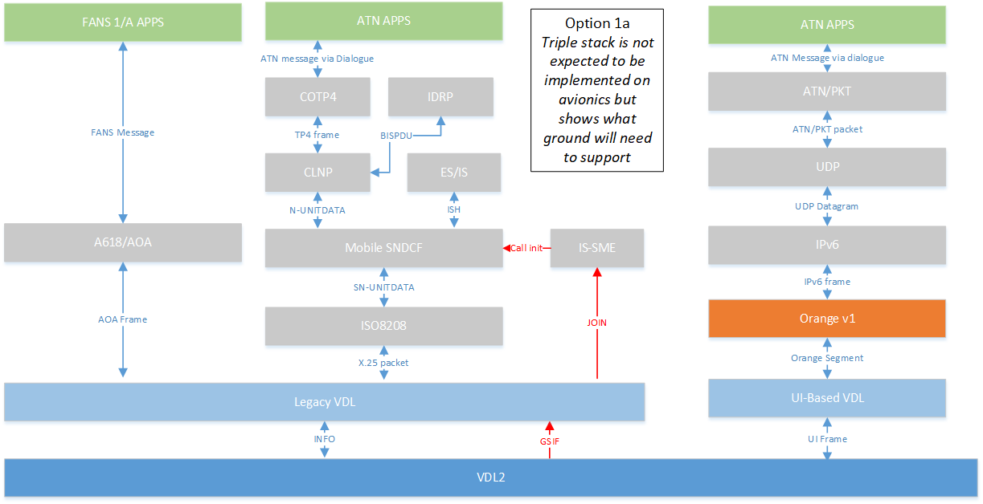

Figure 2: Option 1a. Note that Orange v1 could be used to provide security for legacy traffic if needed.

Figure 3: Option 1b. Note that Orange v1 could be used to provide security for AOA traffic if needed.

Option 2

Figure 4: Option 2. Note that Orange v2 could be used to provide security for AOA and ATN/OSI traffic if needed.

Option 3

Figure 5: Option 3. Security considerations still need to be added to this drawing.