Description of options for implementing variable VDL Mode 2 CSMA channel busy detection thresholds based on the aircraft’s air-ground status

1. The problem

As background information to put in context the material in this document, the reason why a variable CSMA channel busy detection threshold is being proposed is that there are many airport environments where the background noise is higher than the current threshold of -98 dBm. In most cases, the high level of background noise is due to external interference sources such as LED lighting or other airport infrastructure. When such interference is present the channel appears busy and that prevents aircraft radios, and sometimes ground station radios, from transmitting, thus effectively jamming the channel. By raising the detection threshold to -92 dBm, which is higher than the most frequently detected level of interference, the channel would not appear to be occupied and aircraft radio would be able to transmit.

1. The solution

In order to mitigate the impact of external interference on VDL Mode 2 traffic flow, multiple participants in AEEC and Eurocae meetings have proposed a new requirement for the implementation of changes in the airborne VDR radios to use the higher channel busy detection threshold but only when the aircraft is on the ground.

1. The challenge

While conceptually simple, the actual implementation of such changes is more complex because of the fact that even though AEEC-750 specifications clearly indicate that a discrete Weight-On-Wheels (WOW) switch contact wire is required, in actual installation it is found quite often that the required wiring is not installed. An additional challenge is that even if the installation of the required wiring was mandated, it would be nearly impossible for the VDR software to know *a priori* whether the voltage detected on the assigned pin is due to an open circuit or due to a wired WOW contact. Controlling the VDR operation based on an ambiguous input source would therefore be unacceptable.

1. The workaround

First, a consideration for the different VDL Mode avionic architectures that exist today.

Integrated avionics

They are shown conceptually in the diagram below:

External onboard peripherals

429 buses

VDR

function

CMU

function

Discrete inputs

These are the avionics where the CMU function and the VDR function are packaged or integrated in a single LRU. In this type of avionics, the aircraft’s air-ground status is already known without any ambiguity.

Federated avionics

They are shown conceptually in the diagram below:

External onboard peripherals

429 buses

VDR

CMU

MP 14B  
Air/Ground discrete  
(if wired)

Discrete inputs

These are the avionics where the CMU and the VDR are packaged in separate LRU units and communicate with each other through the 429 using the ASIP protocol. It is in this type of avionics where the aircraft’s air-ground status is known by the CMU but needs to be determined without ambiguity by the VDR.

Option #1: direct extract of air/ground status from the contents of downlink frames

The most direct and consistent way for the VDR to determine whether the aircraft in which it is operating is in the air or on the ground is to check the value of the air/ground that is signalled by the CMU in downlink frames. The contents of the downlink frames that the CMU requests the VDR to transmit is passed from the CMU to the VDR using the UNITDATA_IND command. The format of the UNITDATA_IND command is shown below:

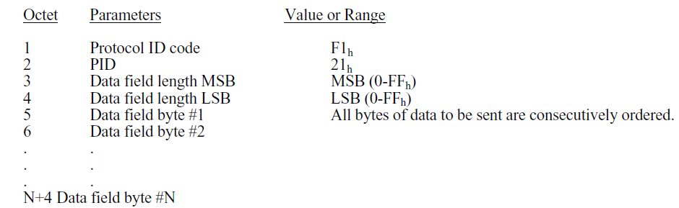

In other words, the first byte of a downlink frame that the VDR is requested to transmit is in byte 5 of the command.

Furthermore, the structure of the first four bytes of any downlink frame is shown below:

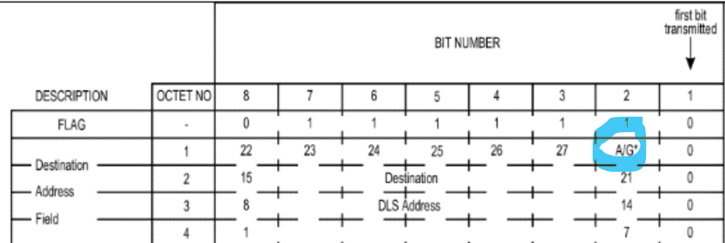

As shown, the value of the air/ground bit is the second least significant bit of the first byte and it is coded as follows:

Air/ground bit = 1 means that the aircraft is on the ground

= 0 means that the aircraft is in the air

Therefore, the complete specification for the way the VDR should determine the aircraft’s air/ground status is:

1. If the VDR is in state 7
2. And if the VDR is operating in Mode 2
3. Then it determines the aircraft’s air/ground status by reading the value of the 2nd least significant bit in the 5th byte of any UNITDATA_IND command that it receives from the CMU

Based on the value of the air/ground status bit:

1. If the air/ground bit = ground then the channel busy threshold level is set at -92 dBm
2. If the air-ground bit = air then the channel busy threshold level is set at -98 dBm

Option #2: indirect determination of the aircraft’s air/ground status

Another possible way for the VDR to determine if the aircraft is on the ground or in the air is by measuring the strength of received VDL frames. The VDR must receive and process all VDL Mode 2 transmissions that it detects in order to determine whether those transmissions are addressed to it. When the aircraft is on the ground, because of its proximity to the ground station, the strength of the RF signal emanating from the ground station is much higher than when the aircraft is in the air. Based on empirical data, it has been found that when an aircraft is on the ground the RSSI signal strength of its transmissions is detected by the VDR well above -60 dBm. Therefore, the detected signal strength can be used to determine indirectly whether an aircraft is on the ground or in the air. The complete description would be:

1. If the VDR is in state 7
2. And if the VDR is operating in Mode 2
3. If the radio receives a valid VDL frame from any ground station
4. If the RSSI signal strength of the RF signal carrying that frame was above -60 dBm then the aircraft can be assumed to be on the ground and the CSMA channel busy detection threshold should be set at -92 dBm
5. After receiving at least one uplink frame from a ground station whose signal strength exceeds -60 dBm, if the radio does not detect any uplink frames from ground stations exceeding -60 dBm during a time interval of 5 minutes then it can assume that the aircraft in which it is operating is in the air and it should set the channel busy threshold to -98 dBm