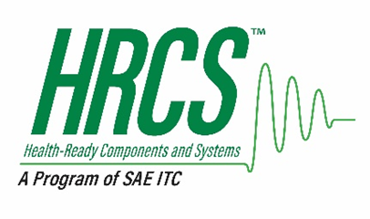
Health-Ready Components & Systems™ (HRCS™)
A Program of SAE ITC ®

MEMBERSHIP FEE SCHEDULE

Revision History

Approved Date | Description
Date | Original Version

Membership Level | Eligible Participants | Annual Membership Fee | Project and Part Registration Fees | Payment Terms
Bronze | ALL | $3,000 | As needed | Net 60 days
Silver | ALL | $6,000 | As needed | Net 60 days
Gold | ALL | $9,000 | As needed | Net 60 days
Strategic Partner | By Invitation | In-kind services | As needed | Net 60 days

