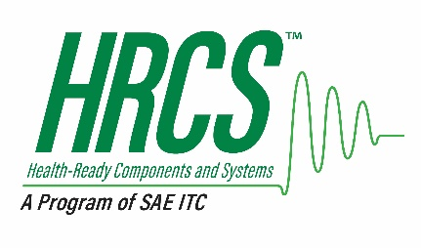

Health-Ready Components & Systems™ (HRCS™)
A Program of SAE ITC ®

Charter Agreement

Purpose of this Document

SAE Industry Technologies Consortia® (“SAE ITC”) provides a neutral, legal framework for industry entities to convene and solve key technical challenges on a pre-competitive basis. The Health-Ready Components and Systems (“HRCS”) consortium has been organized as an industry Program of SAE ITC to establish best practices and uniform information sharing methods between OEMs and their supplier base. This will facilitate industry-wide application of Integrated Vehicle Health Management (“IVHM) technology to improve asset operational availability, sustainment, and logistical efficiencies.

The purpose of this Charter Agreement (“Charter”) is to establish the terms and conditions under which participants (“Members”) will meet and function as an industry consortium Program (“Program”) of SAE ITC to develop a Health-Ready Components and Systems Program.

This document establishes HRCS as a Program of the SAE ITC and outlines the scope, objectives, vision, and mission of HRCS, as well as the relationship between HRCS and the SAE ITC and its policies, including the Antitrust Guidelines, Confidentiality and Intellectual Property Policy, and the general operation of HRCS. This document refers to and is supported by the following attachments:

- Attachment 1: Membership Agreement between Member organizations and HRCS which outlines the basic terms and obligations of membership, Program support, use and ownership of intellectual property and funding. By signing the Member Agreement, Members agree to the terms and conditions outlined in this Charter including all appendices, schedules and addendums, policies of SAE ITC and Program policies as established or updated by HRCS.

- Attachment 2: Fee Schedule to support the work of HRCS. The fees may increase or decrease due to changes in the scope, timing and nature of the work and operational costs (e.g. inflation).

- Attachment 3: Operating Rules that outline the responsibilities of the Members and SAE ITC staff, including membership levels, benefits, engagement expectations and roles, funding, management, administration and work activities of the Program. The HRCS Operating Rules is considered a “living document” supporting the work of the Program, and as such may be amended from time to time with approval of the SAE ITC Program Manager.

- Attachment 4: SAE ITC Antitrust Compliance Guidelines set forth by SAE ITC for all its Programs.

- Attachment 5: HRCS Membership Application specifying the prospective Member’s intent and confirming understanding of the membership levels and fees. This document is submitted prior to acceptance and signing of the Membership Agreement.

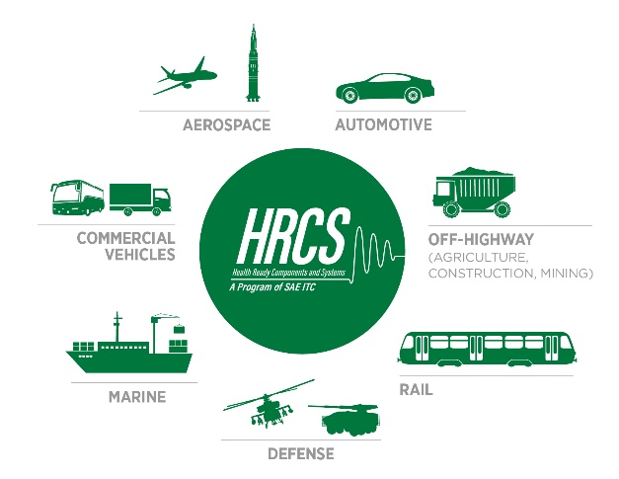

- Foreword

Integrated Vehicle Health Management (IVHM) technology has the potential to enable significant benefits for a myriad of assets (aircraft, automotive, trucking, shipping, rail, mining, and other industries) in terms of performance, availability, and safety. However, the level of deployment of IVHM implementations has been limited with respect to high-end functionality such as predictive analytics or prognostics. One of the primary barriers is the lack of uniform information sharing methods between OEMs and their supplier base. This key barrier is addressed by SAE JA6268, Surface Vehicle and Aerospace Recommended Practice: “Design & Run-Time Information Exchange for Health-Ready Components.”

Health-ready components are supplier-provided components or subsystems which have been augmented to monitor and report their own health, or alternatively, those where the supplier provides the integrator or OEM sufficient information to accurately assess the component’s health via a higher-level system already on the asset.

For aerospace and automotive suppliers, market forces will drive the need to achieve greater industry-wide application of IVHM technology, which will in turn drive new health-ready requirements that suppliers must ultimately meet. Accordingly, the recommended practice contained in SAE JA6268 standard has two primary objectives: (1) to encourage the introduction of a much greater degree of IVHM functionality in the future at a much lower cost, and (2) to address legitimate intellectual property concerns by providing recommended IVHM design-time and run-time data specification and information exchange alternatives.

For the OEMs and fleet operators, a wider deployment of IVHM opens new market opportunities, better ways to serve their customers, and economic benefits derived from business process improvements in areas of asset operational availability, sustainment, and logistics efficiencies.

Related SAE standards committees (e.g., HM-1, OBD-II, E-32, and ARINC Industry Activities, etc.) are already established under the SAE Group to produce IVHM, OBD, OMS, and Aerospace standards. The HRCS will provide an industry neutral forum for these technical committees and others to develop strategies and implementation processes. These will enable the uniform exchange of design and run-time data between suppliers, integrators, and OEMs to promote the development and deployment of Health-Ready components and advance IVHM implementations in aerospace, automotive and other industries.

Scope

The HRCS is established as a Program Participant under SAE ITC. It will develop, promote, and deploy a common set of requirements, characterization processes, documents and standards specific to the reliable and secure exchange of design and run-time data between suppliers, integrators and OEMs. This is intended to:

- Increase trust and collaboration between supplier, integrator, and OEM communities during IVHM system implementations through a focused set of processes and standards that integrate industry best practices.

- Encourage the introduction of greater of IVHM functionality at lower cost.

- Address legitimate intellectual property concerns by providing recommended IVHM design-time and run-time data specification and information exchange alternatives.

- Simplify supplier sourcing and IVHM implementation decisions by facilitating the sharing of Health-Ready Component information.

- Provide best practices and lessons learned for risk mitigation strategies both for end users (e.g., capability for proactive maintenance) and organizations (e.g., supply chain management).

Vision and Mission
To establish a global HRCS/IVHM community to create best practices and uniform information sharing methods between OEMs and their supplier base. This will facilitate industry-wide application of IVHM technology with HRCS that improve asset operational availability, sustainment, and logistical efficiencies.

HRCS will educate its Members and industry regularly about progress of HRCS and IVHM technologies with a focus on uniform communications and standardized protocols. Training sessions and technology demonstration events (which can also be combined with conference events where applicable) are anticipated.

HRCS will carefully select the providers of membership services, define applicable registration and qualification processes and approvals, and define process for regular review and confirmation based on customer feedback and performance. Contact information of registered and component suppliers will be made available via a database to the members.

The Health-Ready Components & Systems Program

HRCS Leadership

Leadership of the HRCS will be provided by the Executive Committee which is elected by the Membership in accordance with the Operating Rules. Administrative policies and procedures of the HRCS will be developed by SAE ITC for review and input from the HRCS voting Membership. SAE ITC will enter into agreements, receive revenues, and periodically report to the voting membership of the resources available for supporting the HRCS.

Funding

As an industry managed Program, HRCS is self-funding with the Members responsible for funding the daily operations, initiatives and projects. HRCS will be primarily funded by membership fees. Additional funding is envisioned to be mixed: project fees, event and conference related fees, sponsorship, database listing fees and other. A fund will exist to support:
- Labor costs
- Travel and Meeting administrative costs
- Marketing and promotion expenses
- Communications and printing costs
- Deployment and implementation of initiatives
- Operational stability of the Program by maintaining sufficient cash balances;
- Sufficient margin for reinvestment and growth to support initiatives which benefit the industry.

Membership & Voting

Membership and voting shall be in accordance with the Operating Rules of the HRCS. Upon approval, a Membership fees invoice will be issued to new organization members.

Procedures
Administration and operation of HRCS shall be in accordance with established SAE ITC Policies and Procedures including Antitrust Guidelines, policies and procedures, and HRCS Operating Rules. Other procedures, not inconsistent with SAE ITC and HRCS policies and procedures, will be added and revised on an ongoing basis by the Executive Committee and HRCS voting membership.

Notices
Any notice required or permitted to be given under this Charter shall be given in writing and shall be hand delivered, sent by electronic mail or facsimile, sent by certified or registered mail or sent by overnight courier service to the Member at such address or email address as the Member may have specified in writing to SAE ITC and the Program.

Notices shall be deemed effective (i) if delivered personally, upon receipt, (ii) if delivered by certified or registered mail, three business days after deposit with the post office, (iii) if delivered by overnight courier, one business day after deposit with a recognized private carrier; and (iv) if delivered by electronic mail or facsimile transmission, the business day such electronic mail message or facsimile transmission is sent during normal business hours of the recipient, then on the next business day.

All Notices to be submitted to HRCS shall be delivered to:

Mr. Peter H. Grau
HRCS Program Manager
400 Commonwealth Drive
Warrendale, PA 15096
Phone: 240-334-2580
Email: peter.grau@sae-itc.org

Antitrust

Each Member agrees to abide by the antitrust laws of the United States and the Antitrust Guidelines of SAE ITC in its dealings with and as a Member of HRCS. Details are outlined in the Antitrust Guidelines.

Intellectual Property Rights and Confidentiality

Each Member is required to sign the HRCS Member Agreement prior to joining HRCS, which holds Members to the appropriate dissemination of information obtained or accessed in connection with HRCS.
All information provided by the parties to this Charter will be considered confidential information for the sole purpose of developing the deliverables identified above for use by HRCS and its Members. It may not be distributed to any third party or used for any other purpose without written permission of the parties.
Any intellectual property, such as copyrighted works or data, provided by the parties to the Charter will remain the property of the respective Member organization. However, the parties acknowledge and agree that the copyrights in and to any new or modified copyrightable material developed as part of the activities contemplated by this Charter and, in the future, by HRCS itself, will be exclusively owned by SAE ITC. All Members of HRCS agree to license, under Fair, Reasonable, and Non-Discriminatory terms, any standards-essential patents or other intellectual property rights that are commercially necessary to practice under the standards or specifications created by HRCS.

Amendments
Any revision of or amendments to this Charter shall be in writing and signed by all parties hereto and the Consortium’s Executive Director.

Termination
Upon violation of the terms or condition of this Charter or of SAE ITC’s policies or procedures, SAE ITC shall have the right to terminate this Charter upon thirty (30) days written notice to the HRCS Members and failure of the Members or the Executive Committee to remedy the noted violation.

Upon termination, except for failure to comply with the antitrust or intellectual property policies of SAE ITC or Member’s failure to pay any outstanding account receivable, SAE ITC shall complete any Program support in progress at the time of termination and shall be compensated for the same in accordance with this Charter.

The termination of this Charter shall not relieve the HRCS Members, including current or future Members, from obligations the Members may have to SAE ITC for fees or charges for Program support or otherwise. Further, the Intellectual Property provisions of this Charter will survive the termination thereof.

The HRCS Members may terminate this Charter upon sixty (60) days’ written notice to SAE ITC with 100% agreement of the Membership. In addition, any HRCS Member may terminate its participation in this Agreement and withdraw from the consortium at any time upon sixty (60) days’ written notice to the SAE ITC HRCS Program Manager and the Executive Committee Members.

- Dissolution
Upon dissolution of HRCS, any and all remaining assets thereof remaining after the payment of obligations of the HRCS shall be transferred or assigned to SAE ITC.

13.0 Insurance
SAE ITC shall maintain reasonable coverages of insurance for itself and HRCS Activities. The Leadership Committee will apprise the SAE ITC staff of HRCS activities in a timely manner to ensure that adequate insurance coverages are in place. A Certificate of Coverage may be furnished to the Leadership Committee upon request.

14.0 Governing Law; Interpretation
This Charter is governed by and shall be construed in accordance with the laws of the State of Pennsylvania, exclusive of its conflicts of laws principles. This Charter does not create any agency, partnership, joint venture, employment, or franchise relationship. No party has the right to create any obligation on behalf of the other. All parties hereby agree and acknowledge that the relationship hereunder is non-exclusive.

15.0 Severability
If any provision in this Charter is found to be invalid, unlawful or unenforceable to any extent, the parties shall endeavor in good faith to amend this Charter to preserve its intention. If the parties fail to agree on such an amendment, such invalid provision will be enforced to the maximum extent permitted by law or, if not enforceable, will be severed from the remaining terms, conditions and provisions, which will remain in full force and effect.
16.0 Entire Agreement
The provisions of this Charter and all appendixes, addenda, exhibits and schedules hereto, including all documents incorporated herein by reference, constitute the entire agreement among the parties and supersede all prior agreements and understandings relating to the subject matter thereof. Subject to the foregoing, this Charter shall be binding upon and inure to the benefit of the parties hereto, and their respective successors and assigns.

Accepted and Agreed to by:

Company Name  By: Person Name  Title: xxxxx  Signature  Date: | Company Name  By: Person Name  Title: xxxxx  Signature  Date:
Company Name

By: Person Name
Title: xxxxx

Signature

Date:

SAE Industry Technologies Consortia

By: Laurie Strom
Title: Executive Vice President, COO

Signature

Date:

