1.0 Introduction (BOEING) 1

1.1 Purpose 1

1.2 Scope 1

1.3 Relationships to other Standards Activities and Documents 2

1.4 Document Organization 2

2.0 ATN/IPS OVERALL ARCHITECTURE (TH) 4

2.1 Assumptions and Constraints 4

3.0 ATN/IPS AIRBORNE ARCHITECTURE (HONEYWELL) 5

3.1 Architecture Overview (TH) 5

3.1.1 Airborne Architecture Overview 5

3.1.2 ATN/IPS System Functions 5

3.1.3 Interfaces to External Systems 5

3.1.4 Redundancy Considerations 5

3.2 ATN/IPS Core Functions (HW) 6

3.2.1 Applications Adaptation (BOEING) 6

3.2.2 Transport (RC) 6

3.2.3 QoS/Priority (TH) 6

3.2.3.1 Prioritization within the ATN/IPS System 7

3.2.3.2 QoS Management 7

3.2.4 Compression (RC IMS) 7

3.2.4.1 Lossless Compression Methods 8

3.2.4.2 Minimum Supported Compression Methods for IPS 8

3.2.4.2.1 Application Data Compression 9

3.2.4.2.2 Network and Transport Layer Compression 9

3.2.4.2.3 Datalink or Link Layer Compression 10

3.2.5 Adressing and Routing (HW) 10

3.2.5.1 Aircraft Addressing 10

3.2.5.2 Access Subnetwork Addressing 11

3.2.5.3 Routing 11

3.2.6 Multi-link (RC) 11

3.2.7 Mobility Considerations (BOEING) 12

3.2.8 Segregation (HW) 12

3.3 ATN/IPS Supplementary (Non-Core) Functions (BOEING) 12

3.4 ATN/IPS Core Interfaces (AIRBUS) 13

3.4.1 External 13

3.4.2 Internal 13

3.5 ATN/IPS Core Performance Requirements (AIRBUS) 13

4.0 SECURITY (RC) 16

4.1 TBD 16

5.0 ATN/IPS AIRBORNE IMPLEMENTAION OPTIONS (RC) 17

5.1 Overview and Assumptions 17

5.2 ARINC 429 17

5.3 ARINC 664 17

5.4 Ethernet 17

5.5 Etc. 17

5.6 Redundancy Considerations 17

6.0 AIRBORNE APPLICATION DATA CONSIDERATIONS (BOEING) 18

6.1 B1/B2 18

6.2 FANS1/A 18

6.3 ACARS 18

6.4 Non-DSI Encapsulation 18

6.5 Etc. 18

ATTACHMENT 1 List of Acronyms 🡨 FROM 658 19

ATTACHMENT 2 GLOSSARY 🡨 FROM 658 25

APPENDIX A ATN/IPS GROUND ARCHITECTURE CONSIDERATIONS (RC IMS) 30

A-1 Potential Ground Architectures 30

A-1.1 Full End-to-End 30

A-1.2 Multiple “Segment Correlations” 30

A-2 Gateway Architectures 30

A-2.1 Dual-Stack (OSI / IPS) 30

A-2.2 Dual-Stack (ACARS / IPS) 30

A-2.3 Triple-Stack (ACARS / OSI / IPS) 30

A-3 Gateway Functional Requirements (BOEING) 30

APPENDIX B AIRBUS PROFILES (AIRBUS) 31

B-1 Federated 31

B-2 Modular 31

APPENDIX C BOEING PROFILES (BOEING) 32

C-1 Federated 32

C-2 Modular 32

# Introduction (BOEING)

## Purpose

It is generally agreed by aviation stakeholders that the future aviation network communication infrastructure will be based on selected commercial Internet Protocol (IP) standards. This future aviation communication network has been referred to in ICAO as ATN/IPS[1] (Aeronautical Telecommunication Network/Internet Protocol Suite) and is considered as the successor in the long term of the previously defined ICAO network infrastructure based on the Open Systems Interconnection (OSI) model and referred to as ATN/OSI. The ATN/IPS network will be implemented onboard an aircraft and the ground infrastructure to support safety related services, including Air Traffic Services (ATS) and Aeronautical Operational Control (AOC) that often operate over the Airline Communication and Reporting System (ACARS).

Therefore, the Airlines Electronic Engineering Committee (AEEC) has initiated the development of the required avionics standards to support ATN/IPS. AEEC has acknowledged that ATN/IPS standards development is complex and it needs to be coordinated with other organizations such as ICAO, EUROCAE and RTCA. Furthermore, the exact scope and the potential impact on aircraft communication functions, such as applications and communication media, need to be understood. In addition, there may be interdependencies with related industry standards and those that need to be developed by other organizations.

Therefore, the AEEC has agreed to proceed in two steps for the development of the ATN/IPS avionics standards.

The first step was the analysis and capture of the high-level user requirements for ATN/IPS focusing on the airline, but also considering when possible the ground users (ANSPs), requirements, investigating what is needed for ATN/IPS standardization for aviation, considering the current and/or expected plans of the other standardization organizations, and focusing in identifying what exactly needs to be developed by AEEC for ATN/IPS. The outcome of this first step was a detailed plan for the work to be carried out by AEEC in the second step defining also the perimeter of the necessary ARINC Standards for ATN/IPS, as well as general recommendations for the general ATN/IPS standardization work that is required in aviation. The recommendations will be a valuable input/feedback to the ATN/IPS standardization groups in ICAO, EUROCAE, and RTCA.

## This document represents the second step of the aforementioned process, which is the execution of the recommendations coming out of the Step 1 work in relation to the effort to develop ARINC Standards for ATN/IPS.Scope

This document serves as an ARINC Standard to define the avionics architecture, functions, and an IPS profile that describes implementation options and constraints as well as higher level details regarding the accommodation of different applications. The scope of this standard will correspond to the Communications Management Unit (CMU) (or equivalent avionics). This will include, as necessary, other systems that interface and interoperate with the CMU or equivalent function.

This document also covers the necessary end-to-end context of ATN/IPS, as it is recognized that some of the requirements that are levied on the aircraft will also require similar requirements on the peer ground side. This needs to take different aspects of the potential ground side into account, including deployment options and architectures, transition phases, security, and other aspects. Therefore, ground requirements and considerations are also captured in this document.

The intent of this document, in coordination with other related industry standards, is to provide the level of detail necessary to achieve ATN/IPS standardization.

## Relationships to other Standards Activities and Documents

ATN/IPS as whole represents a broad range of functions and components. These necessarily span many different standards development organizations. Phase 1 of the ATN/IPS standardization activity produced the ARINC Report 658: Internet Protocol Suite (IPS) for Aeronautical Safety Services – Roadmap Document (A658). Within this document is a discussion of other related standards organizations that impact or are impacted by ATN/IPS. Some of these groups are depicted in Figure 1 below.

At a high level, the groups above the IPS box make use of IPS services. The groups on the same level of the IPS box have contents that either make up technical parts of IPS or define requirements for IPS. The groups below the IPS box represent functions that the IPS service will interface to or use. Note that for the case of the Ku and Ka band standards the line is dotted, as these are not protected spectrum links. However, in the interest of commonality, interactions between the groups may still be of interest.

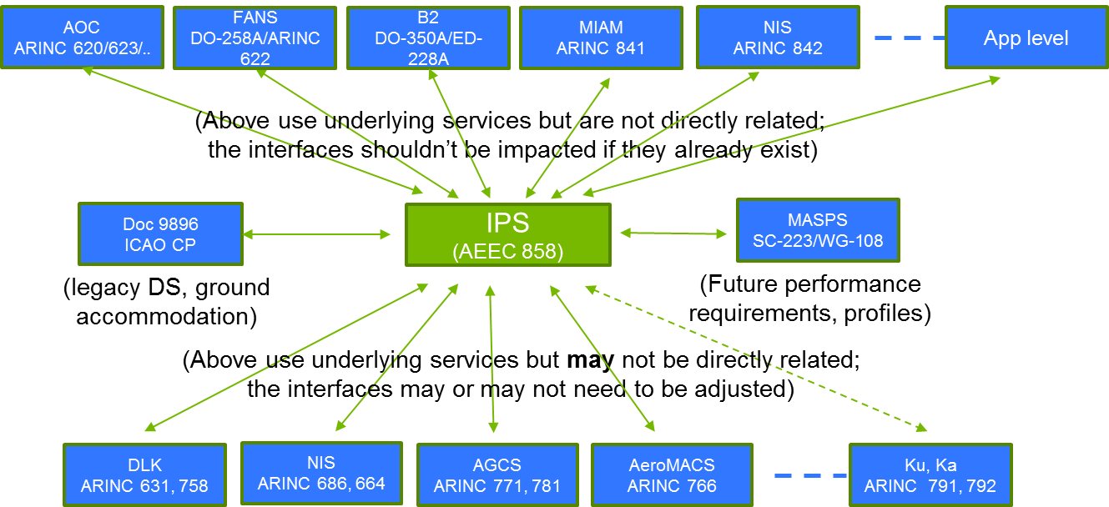

Figure 1. Standards Body Relationships to ATN/IPS

This document as well as relevant documents from other SDOs are expected to be based upon and coordinated with updated versions of the ICAO Document 9896, which defines the agreements in ICAO for ATN/IPS, and on prevalent commercial IP network technology (e.g., IETF RFC 2460 for IPv6) with the modifications necessary to support aeronautical safety services.

For all of the identified groups and their respective standards, changes may be required to accommodate functional or interface differences. These groups will need to have a continued dialog with the AEEC IPS subcommittee to ensure that work scopes are adjusted as appropriate to accommodate ATN/IPS-related items. This coordination will likely include both formal and informal interactions to ensure work is not duplicated nor missed between the groups.

In addition, the A658 Roadmap document will continue to be updated to reflect the latest work divisions, gap analysis, and other related coordination information to ensure traceability and provided updated status.

## Document Organization

This document is generally organized in six sections as follows:

* Section 1 – Introduction

This section ….

* Section 2 – ATN/IPS Overall Architecture

This section ….

* Section 3 – ATN/IPS Airborne Architecture

This section ….

* Section 4 – Security

This section ….

* Section 5 – ATN/IPS Airborne Implementation Options

This section ….

* Section 6 – Airborne Application Data Considerations

This section ….

* Attachment 1 – List of Acronyms

This attachment provides a list of acronyms used in the report.

* Attachment 2 – Glossary

This attachment explains the precise meaning of terms used in this report to avoid ambiguity and confusions.

* Appendix A – ATN/IPS Ground Architecture Considerations

This appendix ….

* Appendix B – Airbus Profiles

This appendix ….

* Appendix C – Boeing Profiles

1. In this document the term “ATN” is used to refer generically to the Aeronautical Telecommunications Network and could be either ATN/IPS or ATN/OSI. Furthermore, if only “IPS” is used, this is considered equivalent to referring to “ATN/IPS”.