1.0 Introduction (BOEING) 1

1.1 Purpose 1

1.2 Scope 1

1.3 Relationships to other Standards Activities and Documents 2

1.4 Document Organization 2

2.0 ATN/IPS OVERALL ARCHITECTURE (TH) 4

2.1 Assumptions and Constraints 4

3.0 ATN/IPS AIRBORNE ARCHITECTURE (HONEYWELL) 5

3.1 Architecture Overview (TH) 5

3.1.1 Airborne Architecture Overview 5

3.1.2 ATN/IPS System Functions Overview 6

3.1.2.1 Application Adaptation 6

3.1.2.2 Core IPS Functions 6

3.1.2.3 Non-Core IPS Functions 6

3.2 Application Adaptation (RC-IMS) 6

3.2.1 ATN Application Adaption 6

3.2.2 ACARS Application Adaption 6

3.2.3 ATNPKT Format 8

3.2.3.1 Fixed Part 8

3.2.3.1.1 ATNPKT Version 8

3.2.3.1.2 DS Primitive 8

3.2.3.1.3 App Tech Type 8

3.2.3.1.4 More Bit 9

3.2.3.1.5 Presence Flags 9

3.2.3.2 Variable Part 10

3.2.3.2.1 Source ID 12

3.2.3.2.2 Destination ID 12

3.2.3.2.3 Sequence Numbers 12

3.2.3.2.4 Inactivity Time 12

3.2.3.2.5 Called Peer ID 12

3.2.3.2.6 Calling Peer ID 12

3.2.3.2.7 Content Version 13

3.2.3.2.8 Security Indicator 13

3.2.3.2.9 Quality of Service 13

3.2.3.2.10 Result 13

3.2.3.2.11 Originator 13

3.2.3.2.12 User Data 13

3.3 ATN/IPS Core Functions (HW) 15

3.3.1 Transport (RC) 15

3.3.2 IPv6 Network Layer 16

3.3.2.1 IPv6 Header 17

3.3.2.2 IPv6 Payload 18

3.3.2.3 IPv6 Addressing 18

3.3.2.3.1 Aircraft Addressing 18

3.3.2.3.2 Ground Addressing 19

3.3.2.3.3 Address Acquisition 19

3.3.3 Network Stack Support Functions 20

3.3.3.1 ICMPv6 20

3.3.3.1.1 ICMPv6 Messages 20

3.3.3.2 Network and Transport Layer Header Compression 21

3.3.3.3 Mobility 21

3.3.3.3.1 Mobility Signaling 21

3.3.3.3.2 Mobility Considerations 21

3.3.3.4 VPN 21

3.3.4 QoS/Priority (TH) 21

3.3.4.1 Prioritization within the ATN/IPS System 22

3.3.4.2 QoS Management 22

3.3.5 Multi-link and Air-Ground Media Selection (RC) 23

3.3.6 Packet Filter Firewall 24

3.3.7 Legacy Datalink Adaptation 24

3.3.7.1 Link Layer Compression 24

3.3.8 Data Segregation (HW) 24

3.4 ATN/IPS Supplementary (Non-Core) Functions (BOEING) 25

3.4.1 Configuration Management 25

3.4.2 IPS System Management 25

3.4.3 Comm Management 25

3.4.4 Radio Management 25

3.4.5 Security Management 26

3.4.6 Redundancy Support 26

3.5 ATN/IPS Information Message (RC) 26

3.6 ATN/IPS Core Interfaces (AIRBUS) 27

3.6.1 External 27

3.6.2 Internal 28

3.7 ATN/IPS Core Performance Requirements (AIRBUS) 28

4.0 SECURITY (RC) 30

4.1 TBD 30

5.0 ATN/IPS AIRBORNE IMPLEMENTAION OPTIONS (RC) 31

5.1 Overview and Assumptions 31

5.2 ARINC 429 31

5.3 ARINC 664 31

5.4 Ethernet 31

5.5 Etc. 31

5.6 Redundancy Considerations 31

6.0 AIRBORNE APPLICATION DATA CONSIDERATIONS (BOEING) 32

6.1 B1/B2 32

6.2 FANS1/A 33

6.3 Other ACARS Messages 33

6.4 AOC Applications (non-ACARS) 33

6.5 Future Safety Services Applications 34

ATTACHMENT 1 List of Acronyms 🡨 FROM 658 35

ATTACHMENT 2 GLOSSARY 🡨 FROM 658 41

APPENDIX A ATN/IPS GROUND ARCHITECTURE CONSIDERATIONS (RC IMS) 46

A-1 Potential Ground Architectures 46

A-1.1 Full End-to-End 46

A-1.2 Multiple “Segment Correlations” 46

A-2 Gateway Architectures 46

A-2.1 Dual-Stack (OSI / IPS) 46

A-2.2 Dual-Stack (ACARS / IPS) 46

A-2.3 Triple-Stack (ACARS / OSI / IPS) 46

A-3 Gateway Functional Requirements (BOEING) 46

APPENDIX B AIRBUS PROFILES (AIRBUS) 47

B-1 Federated 47

B-2 Modular 47

APPENDIX C BOEING PROFILES (BOEING) 48

C-1 Federated 48

C-2 Modular 48

# Introduction (BOEING)

## Purpose

It is generally agreed by aviation stakeholders that the future aviation network communication infrastructure will be based on selected commercial Internet Protocol (IP) standards. This future aviation communication network has been referred to in ICAO as ATN/IPS[1] (Aeronautical Telecommunication Network/Internet Protocol Suite) and is considered as the successor in the long term of the previously defined ICAO network infrastructure based on the Open Systems Interconnection (OSI) model and referred to as ATN/OSI. The ATN/IPS network will be implemented onboard an aircraft and the ground infrastructure to support safety related services, including Air Traffic Services (ATS) and Aeronautical Operational Control (AOC) that often operate over the Airline Communication and Reporting System (ACARS).

Therefore, the Airlines Electronic Engineering Committee (AEEC) has initiated the development of the required avionics standards to support ATN/IPS. AEEC has acknowledged that ATN/IPS standards development is complex and it needs to be coordinated with other organizations such as ICAO, EUROCAE and RTCA. Furthermore, the exact scope and the potential impact on aircraft communication functions, such as applications and communication media, need to be understood. In addition, there may be interdependencies with related industry standards and those that need to be developed by other organizations.

Therefore, the AEEC has agreed to proceed in two steps for the development of the ATN/IPS avionics standards.

The first step was the analysis and capture of the high-level user requirements for ATN/IPS focusing on the airline, but also considering when possible the ground users (ANSPs), requirements, investigating what is needed for ATN/IPS standardization for aviation, considering the current and/or expected plans of the other standardization organizations, and focusing in identifying what exactly needs to be developed by AEEC for ATN/IPS. The outcome of this first step was a detailed plan for the work to be carried out by AEEC in the second step defining also the perimeter of the necessary ARINC Standards for ATN/IPS, as well as general recommendations for the general ATN/IPS standardization work that is required in aviation. The recommendations will be a valuable input/feedback to the ATN/IPS standardization groups in ICAO, EUROCAE, and RTCA.

This document represents the second step of the aforementioned process, which is the execution of the recommendations coming out of the Step 1 work in relation to the effort to develop ARINC Standards for ATN/IPS.

## Scope

This document serves as an ARINC Standard to define the avionics architecture, functions, and an IPS profile that describes implementation options and constraints as well as higher level details regarding the accommodation of different applications. The scope of this standard will correspond to the Communications Management Unit (CMU) (or equivalent avionics). This will include, as necessary, other systems that interface and interoperate with the CMU or equivalent function.

This document also covers the necessary end-to-end context of ATN/IPS, as it is recognized that some of the requirements that are levied on the aircraft will also require similar requirements on the peer ground side. This needs to take different aspects of the potential ground side into account, including deployment options and architectures, transition phases, security, and other aspects. Therefore, ground requirements and considerations are also captured in this document.

The intent of this document, in coordination with other related industry standards, is to provide the level of detail necessary to achieve ATN/IPS standardization.

## Relationships to other Standards Activities and Documents

It is recognized that the ATN/IPS as whole represents a broad range of functions and components. These necessarily span many different standards development organizations. Phase 1 of the ATN/IPS standardization activity produced the ARINC Report 658: Internet Protocol Suite (IPS) for Aeronautical Safety Services – Roadmap Document (A658). Within this document is a discussion of other related standards organizations that impact or are impacted by ATN/IPS. These groups will need to have a continued dialog to ensure that work scopes are adjusted as appropriate to accommodate ATN/IPS-related items. This coordination will be an on-going activity, and will include other AEEC, RTCA and ICAO groups. The A658 document sections will updated to reflect the latest work divisions, gap analysis, and other related coordination information.

This document as well as relevant documents from other SDOs are expected to be based upon and coordinated with updated versions of the ICAO Document 9896, which defines the agreements in ICAO for ATN/IPS, and on prevalent commercial IP network technology (e.g., IETF RFC 2460 for IPv6) with the modifications necessary to support aeronautical safety services.

## Document Organization

This document is generally organized in six sections as follows:

* Section 1 – Introduction

This section ….

* Section 2 – ATN/IPS Overall Architecture

This section ….

* Section 3 – ATN/IPS Airborne Architecture

This section ….

* Section 4 – Security

This section ….

* Section 5 – ATN/IPS Airborne Implementation Options

This section ….

* Section 6 – Airborne Application Data Considerations

This section ….

* Attachment 1 – List of Acronyms

This attachment provides a list of acronyms used in the report.

* Attachment 2 – Glossary

This attachment explains the precise meaning of terms used in this report to avoid ambiguity and confusions.

* Appendix A – ATN/IPS Ground Architecture Considerations

This appendix ….

* Appendix B – Airbus Profiles

This appendix ….

* Appendix C – Boeing Profiles

This appendix ….

# ATN/IPS OVERALL ARCHITECTURE (TH)

Overall E2E Architecture diagram / description

## Assumptions and Constraints

Including the ground segment, more details in Appendix.

# ATN/IPS AIRBORNE ARCHITECTURE (HONEYWELL)

Color Legend:

GREY = Bulleted thoughts to be turned into text

BLUE = Bulleted thoughts to be turned into text; moved from other sections

YELLOW = Notes, questions, TBD

## Architecture Overview (TH)

This section provides an overview of the ATN/IPS system architecture. It considers the boundary of the system, its relationship to applications and equipment external to the system, and the protocols and interfaces presented by the system to other parts of the aircraft avionics.

This section also considers and defines the core functions that define the behavior of the system in relation to existing and future applications’ data. Some of these core functions are standardized by other bodies and are described here in relation to those standards. Other core functions are described and standardized within this document.

Functions that are part of the IPS system but are not core to its operation are also described here. The realization of these functions may be implementation specific however their behavior is described here and some of this functionality shall be subject to standardization within this document.

Key issues / questions:

* The context diagram used in ARINC 658 will need to be modified probably in order to be aligned with the following list of the core functions
* Some of the core functions need to be defined accurately in order to agree on their scope (e,g, QoS / priority, Compression, Segregation) and they will have to be inserted in the glossary (not present in ARINC 658)
* The redundancy aspects should be first discussed at this level and impact on the architecture (interfaces, comm management, …)

### Airborne Architecture Overview

(Context diagram – Placeholder figure; see separate PPT presentation for discussion)

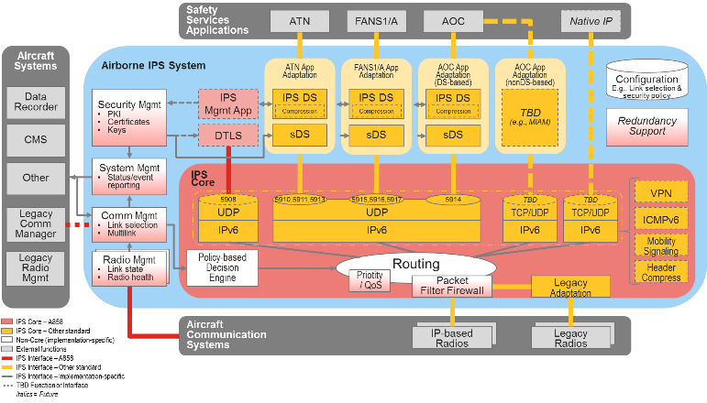

Figure 3-1 – ATN/IPS System Context Diagram – Avionics Perspective

### **ATN**/IPS System Functions Overview

(TBD – Summary-level descriptions of the major elements of the context diagram, with details in subsequent sub-sections of Section 3.)

#### Application Adaptation

#### Core IPS Functions

#### Non-Core IPS Functions

## Application Adaptation (RC-IMS)

Adaptation of the existing ATN/OSI, FANS 1/A, and AOC applications is accomplished using the IPS dialogue service (DS) and the aeronautical telecommunication network packet (ATNPKT).

### ATN Application Adaption

The DS to support ATN/OSI, as specified in Doc 9880, Part III (2010 edition), provides the interface between the ATN applications and the ATN/OSI upper layers. For ATN/IPS, the IPS DS, as specified in ICAO Doc. 9896, replaces the ATN/OSI DS to minimize impact on the ATN applications. The ATN message flow over the IPS DS is depicted in Figure 3-2.

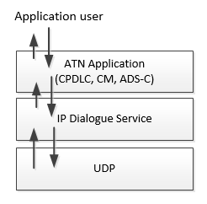

**Figure 3-2 – ATN/IPS Upper Layers**

### ACARS Application Adaption

The IPS DS will also be used to support the ACARS applications. The application (AOC or FANS will be indicated in the App Tech type filed in ATNPKT. The ACARS message flow over the IPS dialogue service over the ACARS convergence function interface is depicted in Figure 3-3.

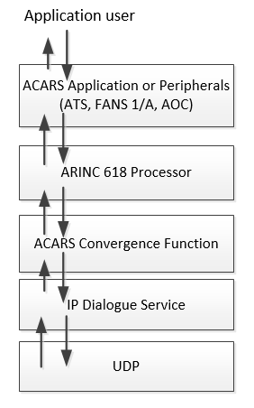

**Figure 3-3 – ATN/IPS Upper Layers**

For ACARS applications, only the following dialog service primitives are used:

* D-START
* D-START cnf
* D-DATA
* D-ABORT
* D-ACK

Details of the ACARS Convergence Function are shown in Figure 3-4.

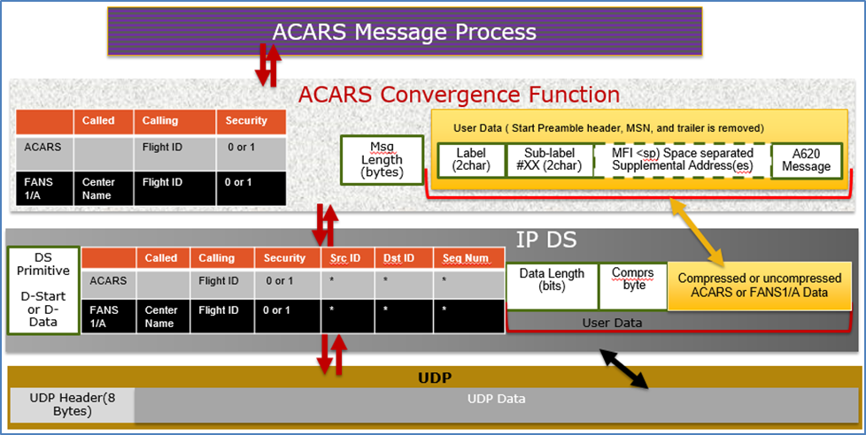

**Figure 3-4 – ACARS to IPS DS Convergence Function**

### ATNPKT Format

The ATNPKT is defined in ICAO Doc. 9896 and is described herein as to its use in ATN and ACARS application adaptation. The ATNPKT consists of a fixed part and a variable part consisting of supplementary header information followed by user data. The layout of ATNPKT is shown in Figure 3-5.

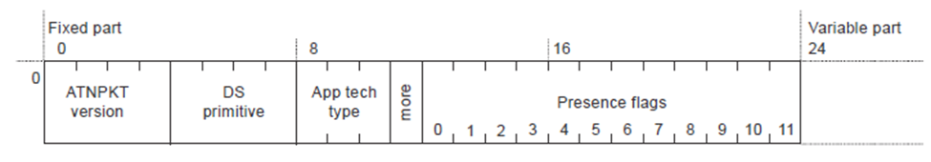

**Figure 3-5 – ATNPKT Format**

The following sections describe the fixed and variable parts of the ATNPKT.

#### ****Fixed Part****

##### ****ATNPKT Version****

The ATNPKT Version is a 4-bit field and shall be set to 1. This number may be incremented in the future for modifications of the ATNPKT.

##### ****DS Primitive****

The Dialogue Service (DS) primitive is a 4-bit field with the following values assigned for use in the IPS Messaging.

**Table 3-1 – ATNPKT DS Primitives**

|  |  |
| --- | --- |
| **Value** | **Assigned DS Primitive** |
| 1 | D-START |
| 2 | D-START cnf |
| 3 | D-END |
| 4 | D-END cnf |
| 5 | D-DATA |
| 6 | D-ABORT |
| 7 | D-UNIT-DATA |
| 8 | D-ACK |
| 9 | D-KEEPALIVE |

The DS peers are the aircraft (avionics) and the IPS Ground System.

##### ****App Tech Type****

This field identifies the type of application data that is being carried. Four application technology types have been defined:

* b000 – indicating ATN/IPS DS
* b101 – indicating AOC DS
* b010 – indicating management
* b011 – indicating FANS/IPS DS

##### ****More Bit****

The More bit is used to indicate segmentation of the UDP datagrams (specifically the ATNPKT). The More bit usage is as follows:

* 0 – a single segment or the last segment of a segmented message
* 1 – the first or an intermediate segment of a segmented message

The More bit will always be set to “0” for DS Primitives 6, 7, 8, and 9.

##### ****Presence Flags****

The presence flags are 12 bits which indicate the presence of optional fields within the variable part of the ATNPKT. A value of 1 is used to indicate the presence of the optional field. The following are the presence flags as well as the format of the presence field.

**Table 3-2 – ATNPKT Presence Fields**

|  |  |  |  |  |  |
| --- | --- | --- | --- | --- | --- |
| **Bit** | **Optional Field** | **Size (bits)\*** | | **Description** | **Notes** |
|  | Length | Value |  |  |
| 0 | Source ID | N/A | 16 | DS connection identifier of the sender |  |
| 1 | Destination ID | N/A | 16 | DS connection identifier of the recipient |  |
| 2 | Sequence Numbers | N/A | 8 | Sequence numbers (Ns, Nr)  Sequence numbers can range from 0 to 15 |  |
| 3 | Inactivity Time | N/A | 8 | Inactivity timer value of the sender (in minutes) |  |
| 4 | Called Peer ID | 8 | 24 to 64 | Called peer ID (provided by the local DS-user) | 1 |
| 5 | Calling Peer ID | 8 | 24 to 64 | Calling peer ID (provided by the local DS-user) | 1 |
| 6 | Content Version | N/A | 8 | Version of the application data carried |  |
| 7 | Security Indicator | N/A | 8 | Security requirements:  0 – no security (default value)  1 – Secured dialogue supporting key management  2 – Secured dialogue  3 … 255 – reserved |  |
| 8 | Quality of Service | N/A | 8 | ATSC routing class:  0 – no traffic type policy preference  1 – “A”  2 – “B”  3 – “C”  4 – “D”  5 – “E”  6 – “F”  7 – “G”  8 – “H”  9 … 255 – reserved |  |
| 9 | Result | N/A | 8 | Result of a request to initiate or terminate a dialogue:  0 – accepted (default value)  1 – rejected transient  2 – rejected permanent  3 … 255 – reserved |  |
| 10 | Originator | N/A | 8 | Originator of the abort:  0 – user (default value)  1 – provider  2 … 255 – reserved |  |
| 11 | User Data | 16 | 0 to 8184 | User data (provided by the local DS-user) |  |
| NOTES:  1 = this field has customized meaning for A620 data (see corresponding section for definition)  * = when length is present it always precedes the value | | | | | |

#### ****Variable Part****

The variable part of the ATNPKT is dependent on the presence fields flagged in the fixed part of ATNPKT, the DS primitive being invoked, and the state of the DS.

The following table identifies the ATNPKT parameters present for each of the DS protocol messages. The table includes the fixed variables (always present) and the variable fields.

**Table 3-3 – ATNPKT Presence Fields**

|  |  |  |  |  |  |  |  |  |  |
| --- | --- | --- | --- | --- | --- | --- | --- | --- | --- |
| **Protocol Message** | **D-START** | **D-START cnf** | **D-DATA** | **D-UNIT-DATA** | **D-END** | **D-END cnf** | **D-ABORT** | **D-ACK** | **D-KEEPALIVE** |
| Fixed part | | | | | | | | | |
| ATNPKT version | M | M | M | M | M | M | M | M | M |
| DS Primitive | M | M | M | M | M | M | M | M | M |
| Application Technology Type | M | M | M | M | M | M | M | M | M |
| More | M | M | M | M(5) | M | M | M(5) | M(5) | M(5) |
| Presence Flags | M | M | M | M | M | M | M | M | M |
| Variable part | | | | | | | | | |
| Source ID | M(4) | M(4) | - | - | - | - | (1) | - | - |
| Destination ID | - | M(4) | M(4) | - | M(4) | M(4) | M(2) | M | M |
| Sequence numbers | M(4) | M(4) | M(4) | M | M(4) | M(4) | M | M | M |
| Inactivity time | O(3) | O(3) | - | - | - | - | - | - | - |
| Called peer ID | O(3) | - | O(6) | O | - | - | - | - | - |
| Calling peer ID | O(3) | - | O(6) | O | - | - | - | - | - |
| Content version | O(3) | O(3) | - | O | - | - | - | - | - |
| Security indicator | O(3) | O(3) | - | O | - | - | - | - | - |
| Quality of service | O(3) | - | - | - | - | - | - | - | - |
| Result | - | M(3) | - | - | - | M(3) | - | - | - |
| Originator | - | - | - | - | - | - | O | - | - |
| User Data | O(4) | O(4) | M(4) | M | O(4) | O(4) | O | - | - |
| NOTES:  (O = optional, M = mandatory, - = precluded to use)   1. Source ID is present if D-ABORT is sent after D-START and before D-START cnf is received. 2. Destination ID is absent if D-ABORT is sent after D-START and before D-START cnf is received. 3. For segmented messages, this parameter is present only in the first segment. 4. For segmented messages, this parameter is present in all the segments. 5. The More bit is always set to “0” 6. Used for A620 messages (see Table 3-4). For segmented messages, only present in the first segment. | | | | | | | | | |

When the ATNPKT is used to carry A620 data (e.g., FANS1/A, AOC), select message fields are re-defined as shown in Table 3-4.

**Table 3-4 – ATNPKT Field Definitions for A620 Messages**

|  |  |  |  |  |
| --- | --- | --- | --- | --- |
|  | **Called Peer** | | **Calling Peer** | |
|  | Downlink | Uplink | Downlink | Uplink |
| AOC | - | - | Flight ID* | - |
| FANS1/A | Center Name | - | Flight ID* | Center Name |
| NOTES: * Included only when the Flight ID changes or airborne IPS reauthenticates | | | | |

##### ****Source ID****

The Source ID identifies the DS connection at the sender side when present in the D-START, D-START cnf, and D-ABORT primitives. The source ID is a 2-byte field that conforms to ISO 8208 field definition.

##### ****Destination ID****

The destination ID identifies the DS connection at recipient side and is present in the D-START cnf, D-DATA, D-END, D-END cnf, D-ABORT, D-ACK and D-KEEPALIVE primitives. The destination ID is a 2 byte field that conforms to ISO 8208 field definition.

##### ****Sequence Numbers****

The sequence number is an 8 bit field and is present in all DS primitives. The field consists of the sequence number sent, N(S), and the next sequence number to be received, N(R), as shown in Figure 3-6.



**Figure 3-6 – ATNPKT Format**

There are 16 possible sequence numbers, the value of which ranges from 0 through 15. For D-ACK and D-KEEPALIVE, only the N(R) number is meaningful.

##### ****Inactivity Time****

The inactivity time represents the time (in minutes) of the inactivity timer on the send side. The use of this field is not required for IPS Communications where the IPS Gateway is the IP termination point (for A620 Host communications). Use of this for IPS Aircraft to IP Ground System is to be defined by those end systems.

##### ****Called Peer ID****

The called peer ID identifies the intended peer DS-user. The called peer ID will be either a 24-bit ICAO aircraft identifier or a 3–8 character ICAO facility designation and have the format 24 to 64 bits. This is an optional field with D-START.

If the D-DATA or D-START primitive is for FANS 1/A data downlink, then this field is a 4-7 byte mandatory field and the meaning of this field is defined to be the Center Name.

##### ****Calling Peer ID****

The calling peer ID identifies the initiating peer DS-user. The calling peer ID will be either a 24-bit ICAO aircraft identifier or a 3–8 character ICAO facility designation and have the format 24 to 64 bits. This is an optional field with D-START.

If the D-DATA or D-START primitive is for AOC data downlink, then this field is an 8 byte optional field and the meaning of this field is redefined to be the ICAO flight ID. This field will be populated by the aircraft whenever the flight ID has changed or the aircraft has re-authenticated.

If the D-DATA or D-START primitive is for FANS 1/A data downlink, then this field is a 4-byte to 7-byte mandatory field and the meaning of this field is defined to be the Center Name.

##### ****Content Version****

The content version field is used to indicate the application’s version number.

##### ****Security Indicator****

The security indicator is an 8-bit field used to convey the level of security. The possible values of this field are shown in Table 3-5.

**Table 3-5 – ATNPKT Security Indicator Field**

|  |  |
| --- | --- |
| **Value** | **Security Level** |
| 0 | No security (default value) |
| 1 | Secured dialogue supporting key management |
| 2 | Secured dialogue |
| 3 - 255 | Reserved |

##### ****Quality of Service****

The Quality of Service (QoS) is an 8-bit field use to convey the quality of service.

##### ****Result****

The result is an 8-bit field set by the destination DS-user in order to indicate whether or not the requested dialogue initiation or termination completed successfully. The possible values of this field are shown in Table 3-6.

**Table 3-6 – ATNPKT Result Field**

|  |  |
| --- | --- |
| **Value** | **Result Definition** |
| 0 | Accepted |
| 1 | Rejected (transient) |
| 2 | Rejected (permanent) |
| 3 - 255 | Reserved |

##### ****Originator****

The originator is an 8-bit field that indicated the source of a D-ABORT. The possible values of this field are shown in Table 3-7.

**Table 3-7 – ATNPKT Originator Field**

|  |  |
| --- | --- |
| **Value** | **Originator Definition** |
| 0 | User (default) |
| 1 | Provider |
| 2 - 255 | Reserved |

##### ****User Data****

The user data field of the ATNPKT contains application data. The user data is variable size, 0 bytes to a maximum of 8184 bytes.

As shown in Figure 3-7, the User Data field is prefaced by a two-byte length parameter and a one-byte compression parameter.

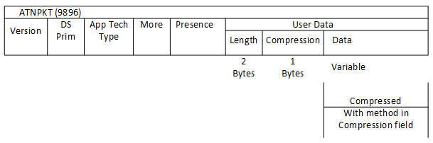

**Figure 3-7 – ATNPKT User Data Field Parameters**

The length parameter specifies the length of the uncompressed or compressed payload (in bits), and the compression parameter indicates either no compression or the data compression method/algorithm used to compress the payload data. The values for the compression parameter are shown in Table 3-8. At a minimum, IPS avionics systems, IPS gateways, and IPS ground end systems must support the DEFLATE algorithm; however, the compression parameter supports the addition of other compression algorithms in the future.

**COMMENTARY**

Some ASN.1 encoded messages have been found to increase in size when compressed. The compression parameter allows the ground and/or aircraft to determine compressibility and indicate the most efficient method of conveying the data, which may be with no compression.

**Table 3-8 – Compression Parameter**

|  |  |  |
| --- | --- | --- |
| **Bit** | **Meaning** | **Description** |
| 1-4  (LSB) | Compression field | 0 – No compression  1 – DEFLATE compression  2-15 – Reserved (for future compression methods) |
| 5-8 | Reserved | Reserved |

If the user data field contained within a D-DATA primitive exceeds 1024 bytes, ICAO Doc. 9896 specifies segmentation of the user data using the More bit in the ATNPKT fixed header part. In a fragmented payload, only the first ATNPKT contains the length and compression parameters.

Given that the maximum size of the IPv6 packet is 1280 bytes, the following table illustrates that the maximum ATNPKT size fits easily fits into the IPv6 packet.

**Table 3-9 – IPv6 Packet Allocation**

|  |  |
| --- | --- |
| **Allocation** | **Bytes** |
| IPI | 1 |
| IPv6 Header | 40 |
| UDP Header | 8 |
| ATNPKT Fixed part | 3 |
| ATNPKT variable part (excluding user data), includes length of user data | 31 |
| ATNPKT user data | 1024 |
| MIC | 4 |
| **Total** | **1111** |

## ATN/IPS Core Functions (HW)

### Transport (RC)

Support for the existing, non-IPS applications requires the provision of a transport layer instance. ICAO 9896 specifies that nodes requiring a connectionless transport mechanism shall use UDP as defined in RFC 768.

The Core function of ATN/IPS uses UDP transport. As per the ICAO 9896 definition, ATNPKT provides the reliability needed for safety services. ATNPKT data are sent/received via UDP datagrams over IP and provides the expected performances for the safety services.

Transport layer port numbering for IPS services is defined in ICAO Doc. 9896, as follows:

**Table 3-10 – Port Assignments for IPS Services**

|  |  |
| --- | --- |
| **Service Name** | **Port** |
| Authentication/Management | 5908 |
| (ATN) CM | 5910 |
| (ATN) CPDLC | 5911 |
| (ATN) ADS-C | 5913 |
| ACARS | 5914 |
| (FANS) AFN | 5915 |
| (FANS) ADS-C | 5916 |
| (FANS) CPDLC | 5917 |

It should be noted that although supported under ICAO 9896, TCP implementation is optional for avionics nodes and is up to the implementer for additional services outside of the defined scope, and then only when they require a connection oriented transport service. Consequently, TCP may be used for additional services (native IP applications…), but no specific air-ground protocol requires TCP. For example, on the ground side, the ground systems may use BGP4+ which relies on TCP but such a protocol will not be used on the avionics side.

*QUESTION: If the application adaptation exists in the application space equipment, will the UDP/IP function also exist there? If it exists in the IPS System then what is the protocol between the application equipment and the IPS system?*

* End-to-end communication details. The transport section can provide details on how the avionics system and the ground center (ATC or Airline host) will manage the link: link initiated by the ground, link initiated by the air.
* Transport Protocols: presentation of the transport layers selected by ICAO (TCP, UDP, MP-TCP, RTCP...). This can be connection-oriented and/or connectionless transport protocols. This section should clearly define how these protocols will be used depending on the application type. Ideally, the same protocol should be used for all air-ground link to simplify the avionics system.
  + Note: RTCA is recommending that UDP is required and TCP is an option
  + Need to consider constraints imposed by some of the communication links
* Ports: ports being used as defined by ICAO. In the frame of the ARINC standard, some details can be added about the fact that these ports can be part of the configuration of the system.
  + Consider addressing in the application section of the document (e.g., ports for FANS, AOC, etc.)
  + Handling of ephemeral port numbers (e.g., SBB)
* Link with profiles that will need to be applied by the transport layers to be compliant with the ATS performance requirements.
  + Profiles will be defined in RTCA

### IPv6 Network Layer

The IPv6 function implements the IPv6 protocol defined by RFC 2460 and required by ICAO 9896. This function implements all the features of IPv6 required by ICAO 9896 and further defined by the profiles developed by RTCA SC-223.

The IPv6 packet consists of header and data, and for IPS, the payload data consists of the UDP header, the ATNPKT, and the last 4 bytes of the computed MIC as shown in Figure 3-8.

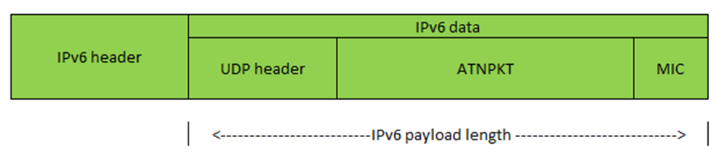

**Figure 3-8 – IPv6 Packet**

The maximum size of the IPv6 packet, per RFC 8200, is 1280 octets. Because of the ICAO Doc. 9896 limitations on the size of the ATNPKT, the maximum IPv6 packet for IPS will be slightly less than this as shown in Figure 3-9.

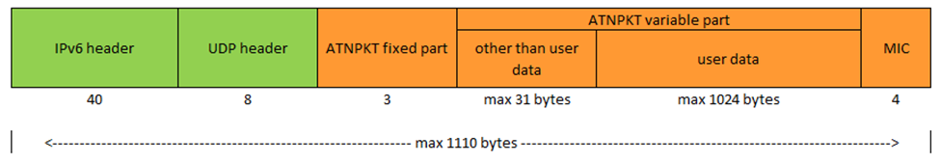

**Figure 3-9 – IPv6 Packet Size for IPS**

#### IPv6 Header

The IPv6 header is the first 40 bytes of the IPv6 packet and is laid out as follows:

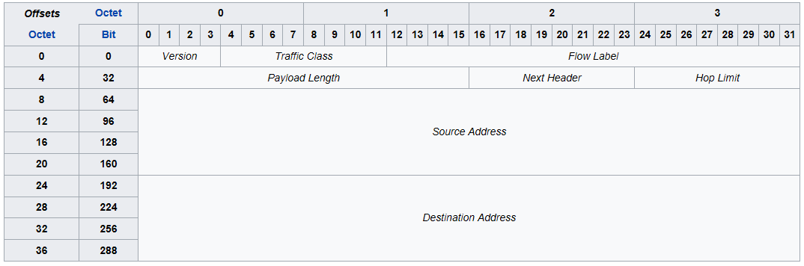

**Figure 3-10 – IPv6 Header Format**

The IPv6 header consists of:

* Version – the constant 6 – “0110”
* Traffic Class - These 8 bits are divided into two parts. The most significant 6 bits are used for Type of Service to let the Router Known what services should be provided to this packet. The least significant 2 bits are used for Explicit Congestion Notification (ECN). Default is all bits set to “0”.
* Flow Label – used to maintain sequential flow of packets. Default is all bits set to “0”.
* Payload Length – The 16-bit Payload Length field contains the payload length, that is, the length of the data field following the IPv6 header, in octets. (The length is across the UDP header, the ATNPKT, and the MIC as shown in Figure 3-8.)
* Next Header – The 8-bit Next Header field identifies the type of header immediately following the IPv6 header and located at the beginning of the data field (payload) of the IPv6 packet. The value of 0x11 in this field identifies the UDP transport protocol used by a packet’s payload.
* Hop Limit - This field is used to stop packet to loop in the network infinitely. This is same as TTL in IPv4. The value of Hop Limit field is decremented by 1 as it passes a link (router/hop). When the field reaches 0 the packet is discarded.
* Source Address – follows IPS aircraft and ground addressing described in Section 3.3.2.3.
* Destination Address – follows IPS aircraft and ground addressing described in Section 3.3.2.3.

#### IPv6 Payload

The IPv6 payload consists of the UDP packet which is carrying the ATNPKT or Native IP application data. These are described separately.

#### IPv6 Addressing

##### Aircraft Addressing

Each IPS aircraft will have a unique network address. This address is structured as shown in Figure 3-11.

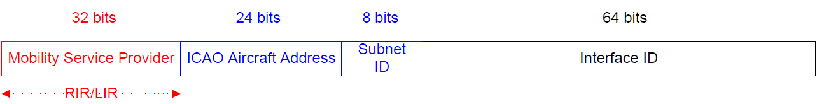

**Figure 3-11 – IPS Aircraft Addressing**

The aircraft address includes:

* Mobility Service Provider – the ‘home’ entity based on the assigning service provider (i.e. ARINC North America, SITA, ADCC, KAC, AeroThai, Airline Agency, etc.)
* ICAO Aircraft Address - the 24 bit ICAO aircraft address; this address shall be used by the IPS Gateway to look-up the aircraft tail number
* Subnet ID – Mobility Service Provider assigned value (could be based on agency ID [airline ID])
* Interface ID – Mobility Service Provider assigned value (could be based on fleet, tail, etc.)

Each aircraft will have a nomadic fixed address assigned, by the primary service provider / ICAO, to the aircraft for all interfaces. Each interface has a DSP assigned and media specific globally routable IPv6 prefix.

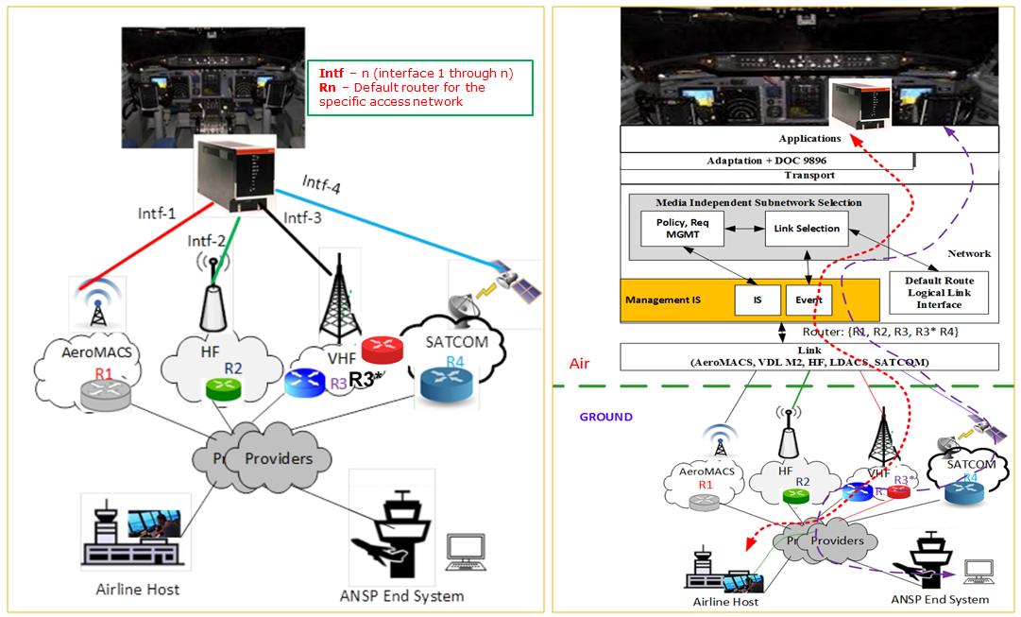

**Figure 3-12 – Multihoming with Multiple IP Addresses**

Traffic originated or destine to aircraft will use the aircraft nomadic IPv6 address as the source or destination IP address regardless of air to ground media. The avionics host follows the default gateway mechanism, which will choose the unify gateway among more than one default route.

Communication service provider will manage their own address; their Administrative Domains obtains IPv6 address prefix assignments from their Local Internet Registry (LIR) or Regional Internet Registry (RIR).

* Sub-netting – e.g. how to assign proposed addressing scheme (per ICAO/RTCA discussions) onboard the aircraft (apportionment of the /56 prefix) – e.g. having a dedicated subnet for ACD, AISD (safety), towards each airborne radio. This would/could also link to traffic segregation (based on subnetwork).
* The role of airborne radios in the addressing scheme
* Impact on the onboard Layer3 devices (Airborne Router, Airborne radios (if L3))
* Multiple points of attachment (e.g., SATCOM, LDACS, AeroMACS)

##### Ground Addressing

The structure of the IPS Ground Address is shown in Figure 3-13.

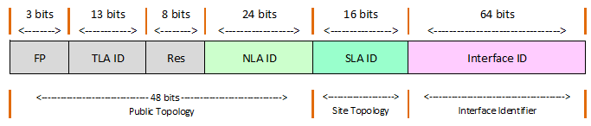

**Figure 3-13 – IPS Aircraft Addressing**

The ground address is an IPv6 global address and is composed of the following fields:

* FP – Format Prefix, 001 for aggregatable global unicast addresses
* TLA ID – Top level Aggregation Identifier, these are allocated by IANA to local internet registries
* RES – reserved for future use (for expansion of TLA ID or NLA ID)
* NLA ID – Next Level Aggregation Identifier identifies a specific customer site.
* SLA ID – Site Level Aggregation Identifier, identifies subnets within a specific site.
* Interface ID – Interface Identifier, identifies the interface of a node on a specific site.

Additional information on IPv6 addressing is available in RFC 4291.

##### Address Acquisition

Although ICAO Doc. 9896 specifies the implementation methodology of the IPS addressing of equipment on the aircraft, the mechanisms whereby the aircraft obtains one or more addresses related to its current point of attachment to the ground network are still evolving and may depend on services provided by the local service provider.

* IP address acquisition – stateless autoconfiguration / DHCPv6 server / static configuration

### Network Stack Support Functions

#### ICMPv6

The ICMPv6 function defined in RFC4443 provides a network layer error reporting function which is required to support IPv6 features such as Path MTU Discovery. It also allows reachability of nodes to be determined by a sending node using the ICMP Echo (ping) command.

##### ICMPv6 Messages

When a message successfully transits the RF from Aircraft to Ground station, there are still many issues that could occur. The ground network will attempt to deliver each message to its intended destination. There are a few issues that could arise; each will be responded to via an ICMPv6 message. ICMPv6 Messages take the form shown in Figure 3-14.

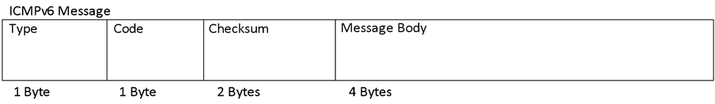

**Figure 3-14 – ICMP Message Format**

While there is an extensive set of ICMP messages that could be sent in an IPv6 network, the following ICMP messages will be supported initially for IPS:

**Table 3-11 – Supported ICMP Messages**

|  |  |  |  |
| --- | --- | --- | --- |
| **Type** | **Code** | **Error Message** | **Example Scenario** |
| 1 | 0 | No route to destination | If an IPS Ground System network is down then this message will inform the aircraft. |
| 1 | 3 | Address Unreachable | The particular computer this message is addressed for is powered off. |
| 1 | 4 | Port Unreachable | The particular application this message is address for is not running |
| 1 | 5 | Source address failed ingress/egress policy | Sent message is restricted from transmission by country or DSP policy. IE encryption in China |
| 128 | 0 | Echo Request | The Aircraft or IPS Gateway wishes to verify connectivity is up. This message is sent at the direction of the operator(s). |
| 129 | 0 | Echo Reply | The Aircraft or IPS Gateway is responding to the Echo Request and is operational. |

#### Network and Transport Layer Header Compression

The network and transport layer headers are compressed together using Robust Header Compression (ROHC) as defined in RFC 5795, plus profiles for IP per RFC 3843 (as amended), UDP per RFC 3095 (as amended), and TCP per RFC 6816. Reducing the header size will allow for smaller packet sizes over the RF spectrum.

 **Figure 3-15 – Example of RHOC Compression**

#### Mobility

##### Mobility Signaling

* A signaling mechanism related to the ground based mobility solution – typically a mechanism providing: location announcement information; preferred priority of links in an uplink direction

##### Mobility Considerations

Likely just a reference to the relevant documents defining mobility.

* Background on solutions, including explanation of mobility solutions chosen and descriptions of representative architectures
* Interop guidance

Specific requirements for the implementation

#### VPN

* Transport (D/TLS) layer tunnel to a ground entity

### QoS/Priority (TH)

Objective:

* Define the QoS aspects supported by the communication manager
* Describe the different level of prioritization in the ATN/IPS router

Key issues / questions:

* The main aspect related to prioritization is related to the segregation between ACD and AISD
* Do we want to insert additional levels of prioritization?
  + Prioritization between ATS and AOC in the ACD domain
  + Different ATS applications (ATN B3 over FANS)
* At the network layer, the QoS is managed by the communication manager -> interaction with the radios and the applications
* Resource reservation is specific to the radios
* Need to ensure that the IPS router does not prevent the Communication Manager to get QoS information from the traffic (e.g. IPSec)
  + - 1. **Prioritization within the ATN/IPS System**
* For different application types

The ATN/IPS system shall support data traffic associated with the AC Domain, which currently carries application traffic including ATS and AOC. Furthermore, it is anticipated that further applications will be hosted on this system in future.

It is thus necessary that the system be able to prioritize traffic such that safety critical communications do not suffer delay or loss through the presence of lower priority data. While the handling of data outside of the ATN/IPS System is out of the control of the system, prioritization shall be effected at all points within the system where a conflict of priority may exist.

It is assumed that control of prioritization rests with the ATN/IPS system and is not driven by any characteristic of the data traffic that cannot be verified by that system. This would imply that the DS field of packets could only be used for prioritization if it were to be set by the ATN/IPS system or if the application was trusted by the system.

* + - 1. **QoS Management**
* Interaction with application and radio bearers (protocols used to talk to external systems)
* Availability of the QoS information
* Traffic shaping mechanisms (in order not to overflow a given datalink)
* Definition of queuing mechanisms
* Flow control mechanisms (in case of a congested datalink)

The ATN/IPS System, whilst not having control over the quality of service offered by any particular bearer, may use whatever means available to determine the communications performance of attached bearers. The information obtained may be used to allow selection of the most appropriate bearer or bearers at any given location or phase of flight.

The ability to determine the performance of each radio gives the ATN/IPS system the ability to intelligently switch bearers or to add/subtract bearers in a multilink environment thereby making best use of the communications environment.

This model of operation may be extended to use other metrics, such as link cost, to choose how to route data. This has particular relevance when the aircraft is on the ground where ground based communications such as AeroMACS or WiFi offer significantly better performance (delay, bandwidth, etc.) at a lower cost.







### Multi-link and Air-Ground Media Selection (RC)

The multi-link and air-ground media selection function exercises control over selection of the best media and the main routing function. It ensures predictable routing behavior based on configured policy but does not imply a specific routing protocol. Selection policy may be based on one or more factors including traffic prioritization (indicated by the DSCP field of the IP header), source and/or destination address, transport layer port numbers, or other identifiable features of the traffic.

Description of the objectives/assumptions of the multi-link:

* No simultaneous transmission of the same message on different links
* Set-up several links in parallel with available communication means,
  + I.e., when the aircraft detects link availability, it should setup the link so that it is “ready” (need to define what we mean by “ready”, e.g., ready to transfer data, implications of security on link establishment, implications of route selection and default route selection, etc.)
* Evaluate the priority between links when a downlink needs to be sent based on various criteria such as, the airline preference, the link availability & quality, the aircraft geographical location

Multi-link mechanisms selected for ATN/IPS:

* Various options to be evaluated during the standardization phase (Vertical handover): MIH, ATN/IPS specific simple solution... This should have some links with the mobility solution described in §3.2.8.
* Link selection algorithm based on link quality, airline customization (cost), security, load, bandwidth...
  + Framework that can support the provision and constraints. But some aspects may not need to be specified precisely from an interop perspective – need to find the dividing line.

Need for a link supervisor to evaluate the link quality and modify dynamically the link preference order? (Network reputation, game theory based, specific ATN/IPS solution...)

* Air-to-ground (outbound from airborne apps) routing – should the destination address of the packet be taken into account for selection of the A-G link, or not (i.e. default route over each A-G link, selection only based on CoS (DSCP), aircraft/link state, etc.)?
* Ground-to-Air (inbound toward airborne apps) routing – how to apply prioritization in this direction?
* IPV6 signaling (like RS/RA, NS/NA, other ICMPv6 signaling) – the role of the airborne router in generation/reception of these
* Use of the DSCP tags – how the router will evaluate the DSCP tags in the IPv6 header
  + Only A🡪G, or also G🡪A?
  + Policy based routing – use of the DSCP tags as a class of service (CoS) identifier (inserted in the packets by the airborne end system) to apply policy based routing (i.e. select the A-G link based on the combination of DSCP tag and aircraft/link state, etc.)
  + QoS – use a DSCP tag in a standard way to apply per-hop-behavior (PHB) in the whole infrastructure (or at least access networks) and/or to do traffic shaping on the outbound interface of the router
* Static vs. dynamic routing – shall the airborne router implement a routing protocol and keep a routing table reflecting the state of routes on the ground?
* Routing engine performance – what is the required throughput, allowed latency, etc. of the routing engine?

### Packet Filter Firewall

* Filtering packets in an uplink direction (based on black/white lists provided by the configuration function)

### Legacy Datalink Adaptation

#### Link Layer Compression

The Layer 2 framing of IPS data is not compressed so that each frame can be routed without the use of costly decompression methods (i.e., performance cost at each hop). The Message Integrity Check (MIC) is used at layer 2 between the aircraft and service provider for authenticating each message. The MIC is an HMAC derived from mutual authentication established at the beginning of the session with the service provider.



**Figure 3-16 – General Example showing non-Compressed Link Layer Fields**

 **Figure 3-17 – VHF-specific Example showing non-Compressed Link Layer Fields**

### Data Segregation (HW)

Including discussion of safety/non-safety usage, AOC/ATC traffic

* Access network segregation (may be able to rely on that)
* Message traffic segregation (is this really needed?)
* Link to the different on-aircraft architectures
* VPN tunnels (initiated in the IPS core; intersects with the Security section)
* Firewalling (intersects with Security section)

Need to clarify the scope/intent of this section:

* Segregation of safety and non-safety application traffic in one airborne router?
* Airborne router access to safety and non-safety A-G links?
* Mixing safety traffic and non-safety links? Or non-safety traffic and safety links?
* Segregation of ATC and safety AOC traffic? Is prioritization not enough in this case?

## ATN/IPS Supplementary (Non-Core) Functions (BOEING)

Identify any necessary interactions or functional interfaces; may not be necessary to define, but should capture assumptions / constraints

**Need architecture and scope to be first identified before specifying non-core functions.**

### Configuration Management

* Link selection policy configuration (e.g. priorities of links for given conditions)
* Packet filter firewall configuration (e.g. white lists/black lists)
* IP address related configuration (e.g. any static address assignments)
* Routing table configuration (possible static aspects of the routing/policy based routing)

### IPS System Management

* Health monitoring of the Airborne IPS system and reporting to aircraft systems
* Security event secure storage, monitoring and reporting to aircraft systems (e.g. packet firewall blocking events, SDS data integrity mismatch, etc.)

### Comm Management

* The “brain” performing the link selection decision based on the status of the datalinks (reported by airborne radios, and possibly the A/G route monitoring mechanism) and the state of the aircraft (e.g. flight phase, geographical position, etc.). It instantiates the decisions via the Policy based routing function.
* Link Availability Monitoring
  + A signaling mechanism for the ground to determine what links are currently available with the aircraft.
* Synchronization/coordination with an External Comm Manager (TBD)

### Radio Management

* A function monitoring the state of all datalinks (via status reports from the airborne radios) and monitoring the health of the airborne radios (i.e. it verifies that no reception of status changes of the datalinks is not caused by a non-operative radio).

### Security Management

* PKI functions
  + Management of keys used by the security-related functions, like SDS, security events secure storage or VPNs (TBD)
* Certificate Management
  + Loading of the certificates used by the security-related functions, like SDS or VPNs(TBD), certificate revocation functions, …

### Redundancy Support

* + - Functions supporting redundant implementations, like state date distribution (for hot redundancy) or master/slave decisions (cold/warm redundancy)

## ATN/IPS Information Message (RC)

The IPS Information message will be generated by an ATN/IPS aircraft every 10 (parameter) minutes in order to provide aircraft information for the ground to update its uplink delivery options. The IPS Information message will also be useful as a supplemental source of position information.

The message will be sent with the IPS IPI (0x8E) and the first byte of the UDP data field will have a key tag value of 0x0B preceding IPS Information message to indicate that this is an IPS Information message. The IPS Information message is shown in Figure 3-18.

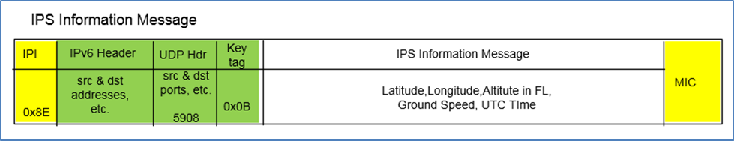

**Figure 3-18 – IPS Information Message**

The IPS Information message will contain latitude, longitude, altitude, ground speed and UTC. The layout and details of the position report data are shown in Figure 3-19 and Table 3-12.

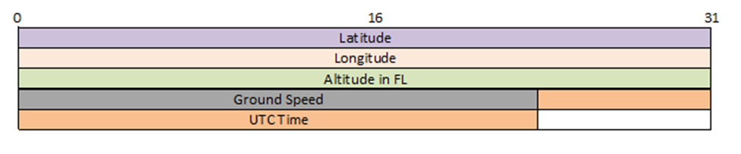

**Figure 3-19 – IPS Information Message Data Format**

**Table 3-12 – IPS Information Message Data Details**

|  |  |  |
| --- | --- | --- |
| **Field** | **Format** | **Remarks** |
| Latitude | Radians | pi/2 to -pi/2  negative South of equator |
| Longitude | Radians | pi to –pi  negative West of meridian |
| Altitude | Flight levels (in hundreds of feet) | 0 to 999 |
| Ground Speed | In knots | 0 to 999 |
| UTC | Year 8 bits { 0 = 2017},  4 bit Month {1-12},  5 bit Day of the Month (1-31},  6 bit Minute (0-59),  5 bit Hour (0-23),  4 bits Seconds (1-15) | Seconds resolution of 4 seconds or increment of 4 i.e. 21 seconds to be encoded to 6 |

## ATN/IPS Core Interfaces (AIRBUS)

### External

**Need architecture and scope to be first identified before specifying all necessary external interfaces.**

The objective of this section is to provide the detailed **functional definition** of all ATN/IPS airborne function external interfaces, which could be identified as services:

* Name of the interface/service
* Parameters
* Protocol if necessary

The section will be organized per type of interface:

* Interface with applications or external adaptation layers (FANS 1/A, AOC/MIAM over IP, B2 application dialog service based)
* Native IPS applications ⬄ Core ATN/IPS function
* Interface with management functions (monitoring, security, external com manager, displays TBC,…)
* Interface with communication links (VDL2, SATCOM, AeroMACS,…)
* …

Some examples:

* Application: Dialog service based primitives, management primitives (purge, link status, addresses management…)
* Links: Link status, Link establishment, Send packet, receive packets…
  + Take a look at the concepts in A839 (MAGIC), e.g., media-independent interface definition and media-dependent adaptation
* Management: Configuration primitives/interfaces (addresses, users, routing policies…) Reporting/monitoring primitives/interfaces…

### Internal

Local implementation dependent – Need architecture first before identifying and assessing it is necessary to describe internal interfaces. Need to assess what needs to be defined vs. what can be local implementation.

* Core ATN/IPS function ⬄ ATN application adaptation
  + ATNPKT?/UDP datagram?/IPv6 packet?
  + To be standardized elsewhere (TBD)
* Core ATN/IPS function ⬄ FANS 1/A application adaptation
  + ATNPKT?/UDP datagram?/IPv6 packet?
  + To be standardized elsewhere (TBD)
* Core ATN/IPS function ⬄ AOC application adaptation
  + ATNPKT?/UDP datagram?/IPv6 packet?
* Other(?)
  + Implementation specific(?)

## ATN/IPS Core Performance Requirements (AIRBUS)

Any requirements that we need to apply to the core to meet the required service needs (e.g. number of independent connections, time to establish a secure connection, volume of traffic, etc)

This section will detail the following aspects/requirements:

* The ATN/IPS router shall allow meeting the ATS performances requirements per RCP240/RSP180. How these requirements could be apportioned among the different sub-functions of the CORE ATN/IPS should be explained.
* The ATN/IPS router shall allow meeting the ATS performances requirements per RCP130/RSP160 as per ED228 SPR. How these requirements could be apportioned among the different sub-functions of the CORE ATN/IPS should be explained.
* The ATN/IPS router shall allow meeting the ATS performances requirements per RCP60/RSP60 predicted by SESAR 15.2.4. How these requirements could be apportioned among the different sub-functions of the CORE ATN/IPS should be explained.

Note: To meet these objectives: the ATN/IPS functions shall minimize the protocol overhead.

This section will be further detailed and will define (list not exhaustive):

* How many simultaneous “connexions” need to be supported
* How many IP packets (per time unit) can be routed
* How many “messages” (application level) can be managed (per time unit)
* Duration for secured “connexion” establishment/release
* Duration for secured “connexion” handover between links (depending on multilink concept)
* Duration for link handovers (anticipation?)
* ATC performance versus AOC performance
* Expected throughput at application level (considering protocol/link maintenance, security) versus links physical throughput
* …

Reminder from A658:

|  |  |  |  |
| --- | --- | --- | --- |
| **Performance Parameter** | **ATN B1**  ED-120 SPR standard published  Based on Eurocontrol generic ACSP requirements document | **B2**  ED-228 SPR standard published  Based on most stringent RCP130/RSP160 | **B3**  SESAR 15.2.4 predicted (no standard yet)  Based on most stringent RCP60/RSP60 |
| Transaction Time One way (sec) | 4sec - 95% of messages  12sec – 99.9% of messages | 5sec - 95% of messages  12sec – 99.9% of messages | 2sec - 95% of messages  5sec – 99.9% of messages |
| Transaction Time Two way (sec) |  | 10sec - 95% of messages  18sec – 99.9% of messages | 4sec - 95% of messages  8sec – 99.9% of messages |
| Availability – CSP | 0.999 | 0.9995 | 0.999995  (maybe reduced by multi-link) |
| Availability – Aircraft |  | 0.99 | 0.999 |
| Integrity | 1-10-5 | Not specified  Must be good enough to meet RCP/RSP | Not specified  Must be good enough to meet RCP/RSP |
| Security | Physical protection  Unauthorized access | Not specified but Unauthorized access protection needed, ICAO requirements | Technical security requirement likely |

# SECURITY (RC)

## TBD

# ATN/IPS AIRBORNE IMPLEMENTAION OPTIONS (RC)

## Overview and Assumptions

## ARINC 429

## ARINC 664

## Ethernet

## Etc.

## Redundancy Considerations

Not sure if this should be included, but multiple ports may be needed depending on functional requirements that are trying to be met

# AIRBORNE APPLICATION DATA CONSIDERATIONS (BOEING)

ATN/IPS is intended to provide an efficient and robust network infrastructure common to both Air Traffic Services (ATS) and Aeronautical Operational Communications (AOC) safety service applications. One of the basic goals of the application interface is to support the use of existing applications over IPS without requiring changes to those applications. This offers the benefit of not changing end systems on the aircraft, and it facilitates commonality and reuse of existing procedures. However, achieving this goal is made more difficult by legacy interfaces that tightly couple network and application technologies.

To use the ATN/IPS system effectively, applications need a compatible interface definition. For legacy applications that are non-native-IP, a specialized interface is needed to communicate with peers and preserve maximum application compatibility. Native IP applications (i.e., those designed to take advantage of IP via TCP or UDP directly) may need a different type of interface to communicate via IPS.

For legacy applications, ICAO Doc. 9896 specifies an IPS Dialog Service (DS), which includes an accommodation layer for applications that use OSI and ACARS protocols. The data encapsulation element, which is called the ATN Packet (ATNPKT) format, is used to convey state, connection, application, and other details between peer end systems.

As mentioned, not all applications will necessarily need the IPS DS per ICAO Doc. 9896, and may adapt more readily to the communication stack, making use of existing transport layer services. These differing needs must be considered based on the specific application.

The actual interface definition will be a local matter, depending on specific hardware and software choices by airframers and suppliers. Interoperability with peer applications is achievable as long as the interfaces conform to the definitions and protocols specified in ICAO Doc. 9896.

## B1/B2

The original intent of ICAO Doc. 9896 was to allow a replacement of the upper layer communication service (ULCS), as specified in the original ICAO Doc. 9705, with something that could be mapped to TCP and UDP. The mapping was specified with the intent of not requiring any changes to the applications themselves. From the application point of view, communication with peers would act the same as if the applications were using OSI protocols.

This was achieved by the combination of defining the IPS DS and the ATNPKT format. The IPS DS provides the dialog service interface to the ATN applications, replacing the ULCS DS primitives in a compatible way. The purpose of the ATNPKT is to convey information between peer applications. ATNPKT is carried in the payload part of the transport protocol (UDP), and it is used to convey parameters of the service primitives that cannot be mapped to existing IP or transport header fields. The ATNPKT also conveys information to indicate the Dialog Service protocol function (e.g., the type of DS primitive). Note that while ICAO Doc. 9896 specifies both TCP and UDP transport options, the B1/B2 application use only the UDP transport protocol to provide commonality and due to the generally smaller data size of B1/B2 application data.

To ensure interoperability between peer OSI-based implementations when using IPS networking, accommodation of the OSI-based ATN applications must adhere to the provisions specified in the “Legacy ATN Applications” section of ICAO Doc. 9896, Part II.

## FANS1/A

IPS is also intended to support legacy, ACARS-based FANS-1/A applications (note that other ACARS-based safety applications are discussed in Section 6.3). The FANS-1/A structure contains a message payload (CPDLC, ADS-C, and AFN messages) that is put into a communication envelope in accordance with ARINC Specification 622. For IPS, this envelope is mapped to the contents of an ATNPKT. Since ACARS-based applications have different communications parameters than OSI-based applications, the elements of the ATNPKT are used differently for FANS1/A messages. This includes the ATNPKT parameters as well as the primitive types, which are used to reflect the connectionless nature of the ACARS protocol while also providing the necessary reliability. The mapping to ATNPKT is defined to allow maximum compatibility with existing end systems on the aircraft and ground while also providing benefits of moving towards the IPS infrastructure.

To ensure interoperability between peer FANS1/A-based implementations when using IPS networking, accommodation of the FANS-1/A applications must adhere to the provisions specified in the “Legacy FANS-1/A Applications” section of ICAO Doc. 9896, Part II

## Other ACARS Messages

AOC and non-FANS-1/A ATS applications supporting safety and regularity of flight currently supported over ACARS can also make use of the IPS infrastructure. This can be accomplished using the IPS Dialog Service, an adaptation layer or IP-based messaging solution (for example Media Independent Aircraft Messaging – MIAM per ARINC Specification 841).

The AOC and non-FANS-1/A ATS structure has a message payload (e.g., as defined in ARINC 702A, or ARINC 623 messages) that is put into a communication envelope. For IPS, these payloads may be mapped to the contents of an ATNPKT. As described previously in Section 6.2, since ACARS-based applications have different communications parameters than OSI-based applications, the elements of the ATNPKT are used differently for ACARS messages. This includes the ATNPKT parameters as well as the primitive types, which are used to reflect the connectionless nature of the ACARS protocol while also providing the necessary reliability. The mapping to ATNPKT is defined to allow maximum compatibility with existing end systems on the aircraft and ground while also providing benefits of moving towards the IPS infrastructure.

To ensure interoperability between ACARS-based implementations when using IPS networking, accommodation of AOC and non-FANS-1/A ATS applications must adhere to the provision specified in the “Other ACARS Applications” section of ICAO Doc. 9896, Part II.

## AOC Applications (non-ACARS)

Non-ACARS AOC applications serving airline operations and supported by general, non-safety IP services to the aircraft are assumed outside the scope of ATN/IPS. Cockpit voice is also assumed outside the ATN/IPS standardization effort. These applications may base their provisions on IPS to take advantage of commonalities and unified architectures; however, additional requirements (e.g. software partitioning, design assurance level of some components, etc.) may require further considerations.

Non-ACARS applications may use the IPS Dialog Service interface, which may require further definition of the ATNPKT format, or they may use a different interface. If a new interface is used with UDP transport, then an error detection and correction scheme should be implemented to guard against lost packets. Optionally, if a new interface is used with TCP transport, then bandwidth considerations need to be taken into account.

## Future Safety Services Applications

New ATS (e.g., B3), AOC, and air/ground SWIM applications to support future safety services may be developed as native IPv6 applications using IPS. Standard profiles and interfaces may need to be developed to support different application types, including reliable/non-reliable transport, unicast and/or multicast delivery, and support for application-specific QoS settings. While it is impossible to predict future applications’ requirements, the IPS provisions for current and near-term applications should provide adequate capabilities for usage.

1. List of Acronyms *🡨 FROM 658*

4DT Four Dimensional Trajectory

4DTRAD Four Dimensional Trajectory Datalink

A-G or A/G Air-to-Ground

A-ISAC Aviation Information Sharing and Analysis Center

AC Advisory Circular

ACARS Aircraft Communications Addressing and Reporting System

ACD Aircraft Control Domain

ACL ATC Clearance

ACM Aircraft Communications Message

ACMS Aircraft Condition Monitoring System

ACR Avionics Communications Router

ACSP Air/Ground Communications Service Provider

ADS-C Automatic Dependent Surveillance-Contract

ADS-C EPP ADS-C Extended Projected Profile

AEEC Airlines Electronic Engineering Committee

AeroMACS Aeronautical Mobile Airport Communications System

AFN ATS Facilities Notification

AIM Aeronautical Information Management

AIREP Aircraft Report

AIS/MET Aeronautical Information Services/Meteorological

AISD Aircraft Information Services Domain

ALGA Active Low Gain Antenna

AMC ATC Microphone Check

AMET Airborne Meteorological

ANSP Air Navigation Service Provider

AOA ACARS Over AVLC

AOC Airline Operational Control

ARAC Aviation Rulemaking Advisory Committee

ARU AeroMACS Radio Unit

ASBU Aviation System Block Upgrade

ASN Access Service Network

ASN-GW Access Service Network Gateway

ATA Air Transport Association

ATC Air Traffic Control

ATM Air Traffic Management

ATN Aeronautical Telecommunication Network

ATS Air Traffic Services

ATSP Air Traffic Service Provider

ATSU Air Traffic Services Unit

AUTOMET Automatic Meteorological (report)

AVLC Aviation VHF Link Control

BLOS Beyond Line Of Sight

BS Base Station

CA Certificate Authority

CAA Civil Aviation Authority

CARATS Collaborative Actions for Renovation of Air Traffic Systems (Japan)

CDU Control Display Unit

CDM Collaborative Decision Making

CLNP Connectionless Network Protocol

CM Context Management

CMF Communications Management Function

CMU Communications Management Unit

CNS/ATM Communications Navigation Surveillance/Air Traffic Management

CoS Class of Service

COTP Connection Oriented Transport Protocol

COTS Commercial Off The Shelf

CP Communications Panel (ICAO)

CP Certificate Profile (PKI)

CPDLC Controller Pilot Data Link Communications

CPU Central Processing Unit

CRL Certificate Revocation List

CSN Connectivity Network Service

CSP Communication Service Provider

CSR Certificate Signing Request

D8PSK Differential 8-Phase Shift Keying

D-ATIS Digital Automatic Terminal Information Service

D-OTIS Datalink Operational Terminal Information Service

D-TAXI Digital TAXI

DAL Design Assurance Level

DCL Departure Clearance

DCNS Data Communications Network Service

DDoS Distributed Denial of Service

DLIC Data Link Initiation Capability

DLS-IR Data Link Services Implementing Rule

DME Distance Measuring Equipment

DoD Department of Defense

DoS Denial of Service

D-RNP Dynamic Required Navigation Performance

DS Dialog Service

DSI Dialog Service Interface

DSP Data Link Service Provider

EASA European Aviation Safety Agency

ECAC European Civil Aviation Conference

EFB Electronic Flight Bag

EIPI Extended Initial Protocol Identifier

EIRP Equivalent Isotropically Radiated Power

ESA European Space Agency

EU European Union

FAA Federal Aviation Administration

FANS Future Air Navigation System

FCI Future Communications Infrastructure

FDD Frequency Division Duplex

FEP Front End Processor

FF/ICE Flight and Flow Information for a Collaborative Environment

FIR Flight Information Region

FIS Flight Information Service

FMF Flight Management Function

FMS Flight Management System

FY Fiscal Year

G-G or G/G Ground-to-Ground

GANP Global Air Navigation Plan

GATM Global Air Traffic Management

GES Ground Earth Station

GHz Gigahertz

GNSS Global Navigation Satellite System

HDLC High-level Data Link Control

HF High Frequency

HFDL High Frequency Data Link

HGA High Gain Antenna

ICAO International Civil Aviation Organization

ICS Internet Communication Service

IER Information Exchange and Reporting

IETF Internet Engineering Task Force

IM Information Management

IMA Integrated Modular Avionics

IMS Information Management Services

IOC Initial Operational Capability

IP Internet Protocol

IPI Initial Protocol Identifier

IPS Internet Protocol Suite

IPsec Internet Protocol Security

IPv4 / IPv6 Internet Protocol Version 4 or Version 6

IS Information Services

ISO International Standards Organization

ISWG Infrastructure Specific Working Group

ITP In-Trail Procedure

ITU International Telecommunication Union

LDACS L Band Digital Aviation Communication System

LEO Low Earth Orbit

LGA Low Gain Antenna

LOS Line of Sight

MAS Message Assurance

MASPS Minimum Aviation System Performance Standards

MCDU Multi-purpose Control and Display Unit

MET Meteorological

MHz Megahertz

MIAM Media Independent Aircraft Messaging

MOPS Minimum Operational Performance Standards

MP-TCP Multi-Path Transmission Control Protocol

MRO Maintenance Repair and Overhaul

NAS National Airspace System

NextGen Next Generation Air Transportation System

NM Nautical Miles

NOTAM Notice to Airmen

OCL Oceanic Clearance

OEM Original Equipment Manufacturer

OFDM Orthogonal Frequency Division Multiplexing

OSWG Operational Specific Working Group

OTIS Operations Terminal Information System

PFIS Passenger Flight Information Systems

PGW Protocol Gateway

PIESD Passenger Information Services Domain

PKI Public Key Infrastructure

PLP Packet Layer Protocol

PMC Program Management Committee

POA Plain Old ACARS

PPPoE Point to Point Protocol over Ethernet

PR Position Reporting

PS Policy Statement

PT Project Team

QAR Quick Access Recorder

QoS Quality of Service

RCP Required Communication Performance

RCTP Required Communication Technical Performance

RF Radio Frequency

RFC Request For Comment

RNP Required Navigation Performance

RSP Required Surveillance Performance

RSTP Required Surveillance Technical Performance

SAL Security Assurance Level

SARPS Standards and Recommended Practices

Satcom Satellite Communications

SBB Swift Broadband

SBD Short Burst Data

SCTP Stream Control Transmission Protocol

SDO Standards Development Organization

SDR Software Defined Radio

sDS Secure Dialog Service

SDU Satellite Data Unit

SESAR Single European Sky Air Traffic Management (ATM) Research

SIGMET Significant Meteorological Information

SNAcP Subnetwork Access Protocol

SPR Safety and Performance Requirement

SWaP Size Weight and Power

SWIM System Wide Information Management

TAC Technical Advisory Committee

TACAN Tactical Air Navigation

TBD To Be Determined

TBO Trajectory Based Operations

TCP Transmission Control Protocol

TDLS Terminal Data Link System

ToR Terms of Reference

TSO Technical Standard Order

UDP User Datagram Protocol

UI Unnumbered Information

ULCS Upper Layer Communication Services

US United States

USB Universal Serial Bus

V&V Verification and Validation

VDL VHF Data Link

VDLM2 VHF Data Link Mode 2

VHF Very High Frequency

VOLMET Vol (flight) Meteo (weather)

VPN Virtual Private Network

WG Working Group

WiMAX Worldwide Interoperability for Microwave Access

WoW Weight on Wheels

XID eXchange Identification

1. GLOSSARY *🡨 FROM 658*

AAC – Aeronautical Administrative Communications

Communication used by aeronautical operating agencies related to the business aspects of operating their flights and transport services. This communication is used for a variety of purposes, such as flight and ground transportation, bookings, deployment of crew and aircraft or any other logistical purposes that maintain or enhance the efficiency of over-all flight operation.

ACARS – Aircraft Communications Addressing and Reporting System

A digital datalink network providing connectivity between aircraft and ground end systems (command and control, air traffic control).

ACD – Aircraft Control Domain

It consists of systems and networks whose primary functions are to support the safe operation of the aircraft. This domain connects to high-priority Air Traffic Services (ATS) and some Airline Operational Control (AOC) communications.

ADS-C – Automatic Dependent Surveillance-Contract

ADS-C is the same as ADS-A. Automatic Dependent Surveillance-Addressedis a datalink application that provides for contracted services between ground systems and aircraft. Contracts are established such that the aircraft will automatically provide information obtained from its own on-board sensors, and pass this information to the ground system under specific circumstances dictated by the ground system (except in emergencies).

Airborne ATN/IPS System

An airborne component that supports main ATN/IPS functions.

AISD – Aircraft Information Services Domain

This domain provides general purpose routing, computing, data storage and communications services for non-essential applications. The AISD domain can be subdivided into two sub-domains;

* Administrative sub-domain, which provides operational and airline administrative information to both the flight deck and cabin,
* Passenger support sub-domain, which provides information to support the Passengers

AOA – ACARS Over Aviation VHF Link Control

AOA is an attempt at gaining some early benefits of digital technology without the full risk of ATN. It is a step between full ACARS and full ATN. The most significant near-term benefit is the reduction of VHF congestion problems by transitioning traffic to the VDLM2 air/ground network. AOA allows airborne and airline host applications to remain unchanged (character format). The airborne AOA process packages the data so that it can be routed over the digital VDLM2 network. At some point on the ground, the data is restored to its original format for processing by legacy airline host applications. VDLM2 operates at 31.5 kbps versus ACARS at 2.4 kbps.

AOC – Airline Operational Control (Aeronautical Operational Control)

Operational messages used between aircraft and airline dispatch centers or, by extension, the DoD to support flight operations. This includes, but is not limited to, flight planning, flight following, and the distribution of information to flights and affected personnel.

APC – Aeronautical Passenger Communications

Communication relating to the non-safety voice and data services to passengers and crew members for personal communication.

Application

Functions that provide the services needed by the users. Applications are grouped into Application sets that are associated to specific network protocols. In the ACD domain the Applications sets are providing air traffic and operational control services.

ATN – Aeronautical Telecommunications Network

An internetwork architecture that allows ground/ground, air/ground, and avionic data subnetworks to interoperate by using common interface services and protocols based on the ISO OSI Reference Model.

ATN/IPS Node

An ATN/IPS node is a device that implements IPv6. There are two types of ATN/IPS nodes; 1) the ATN/IPS system that forwards Internet Protocol (IP) packets not explicitly addressed to itself and 2) ATN/IPS host, which does not have the capability to route traffic flows.

ATN/IPS

Internetwork consisting of ATN/IPS nodes and networks operating in a multinational environment in support of Air Traffic Services (ATS) as well as aeronautical industry service communication such as Aeronautical Operational Control (AOC) and Aeronautical Administrative Communications (AAC).

ATS – Air Traffic Services

A generic term meaning variously, flight information service, alerting service, air traffic advisory service, air traffic control service. The latter is a service provided for the purpose of preventing collisions, expediting and maintaining an orderly flow of traffic.

ATSU – Air Traffic Services Unit

A unit established for the purpose of receiving reports concerning air traffic services and flight plans submitted before departure. It is a generic term meaning air traffic control unit, flight information center, or air traffic service reporting office.

CM – Communication Manager

This function manages the connectivity of the aircraft with the ground system. It is decomposed into two sub-functions:

* ATN/IPS Communication Manager, which manages in the ATN/IPS system the selection of the radio bearer for a dedicated traffic flow and the associated mode of communication.
* External Communication Manager, which performs router selection and associated vertical handover decisions. This entity may be extended to include the management of multi-domain link selections.

CMU – Communication Management Unit

The CMU performs two important functions: it manages access to the various datalink sub-networks and services available to the aircraft and hosts various applications related to datalink. It also interfaces to the flight management system (FMS) and to the crew displays.

CNS/ATM – Communication, Navigation, Surveillance/Air Traffic Management

CNS/ATM is a system based on digital technologies, satellite systems, and enhanced automation to achieve a seamless global Air Traffic Management. Modern CNS systems will eliminate or reduce a variety of constraints imposed on ATM operations today.

CPDLC – Controller-Pilot Data Link Communications

The CPDLC application provides for the exchange of flight planning, clearance, and informational data between a flight crew and air traffic control. This application supplements voice communications and, in some areas, data may supersede voice.

DS – Dialog Service

The Dialog Service serves as an interface between the ATN applications and the ATN/OSI or ATN/IPS upper layer protocols via the control function.

FANS-1/A – Future Aircraft Navigation System 1/A

A set of operational capabilities centered around direct datalink communications between the flight crew and air traffic control. Operators benefit from FANS-1/A in oceanic and remote airspace around the world.

FMF – Flight Management Function

A collection of processes or applications that facilitates area navigation (RNAV) and related functions to be executed during all phases of flight. The FMF is resident in an avionics computer and automates navigational functions reducing flight crew workload particularly during instrument meteorological conditions. The Flight Management System encompasses the FMF.

FMS – Flight Management System

A computer system that uses a large database to allow routes to be preprogrammed and fed into the system by a means of a data loader. The system is constantly updated with respect to position by reference to designated sensors. The sophisticated program and its associated database insure that the most appropriate aids are automatically selected during the information update cycle. The flight management system is interfaced/coupled to cockpit displays to provide the flight crew situational awareness and/or an autopilot.

Ground ATN/IPS Router

A ground device that is used to support ATN/IPS packet forwarding in both air/ground and ground/ground environments.

Infrastructure

This is a general term corresponding to the communication systems that support the application sets. It consists of the Network and Sub-networks functions.

LINK 2000+ – The EUROCONTROL LINK 2000+ Program

The European validation program that demonstrated controller-pilot data-link-communication (CPDLC) services into a set for implementation in the European Airspace using the ATN and VDLM2 (Aeronautical Telecommunication Network and VHF Digital Link).

MASPS – Minimum Aviation System Performance Standards

High-level documents produced by RTCA that establish minimum system performance characteristics.

MOPS – Minimum Operational Performance Standards

Standards produced by RTCA that describe typical equipment applications and operational goals and establish the basis for required performance. Definitions and assumptions essential to proper understanding are included as well as installed equipment tests and operational performance characteristics for equipment installations. MOPS are often used by the FAA as a basis for certification.

Multilink

Concept that defines the use of concurrent, existing and future communication links between air and ground (e.g., AeroMACS, LDACS and Satcom), depending on the defined criteria (performance needs).

NAS – National Airspace System

One of the most complex aviation systems in the world that enables safe and expeditious air travel in the United States and over large portions of the world’s oceans.

Network

The Network function is decomposed into two main sub-functions; a router that routes data packets from a source to a destination and the communication manager, which is responsible for the network and link selections.

Network Layer

The Network Layer is based on Internet Protocol (IP) ensuring global routing over interconnected packet-switched communication networks.

Physical and Link Layers

They are associated with the Sub-networks and handle the physical interface with the transmission medium (i.e., radio links).

PIESD – Passenger Information and Entertainment Services Domain

It is characterized by the need to provide passenger entertainment and network services. Beyond traditional IFE systems, it may also include passenger device connectivity systems, Passenger Flight Information Systems (PFIS), broadband television or connectivity systems.

SARPS – Standards and Recommended Practices

Produced by ICAO, they become the international standards for member states. As the name implies, they are only “recommended” practices. It is up to each member states to decide how/if to implement them.

Satcom – Satellite Communications

Communication service providing data, voice, and fax transmission via satellite. Allows aircraft to communicate in BLOS areas.

SESAR – Single European Sky ATM Research

European air traffic control infrastructure modernization program. SESAR aims at developing the new generation ATM system capable of ensuring the safety and fluidity of air transport worldwide over the next 30 years.

Sub-network

The sub-networks correspond to all radio systems that are used to communicate between the aircraft and the ground.

Transport Layer

The transport layer protocols are used to provide reliable or unreliable communication services over the ATN/IPS system. Those include TCP for reliable transport services and UDP that is used to provide best effort service.

VDL – VHF Data Link

Also known as VHF Digital Link, VDL is the LOS sub-network supporting data communications that are sent over VHF frequencies. The traditional VHF voice radio can be used in conjunction with a data modem to send data messages over VHF frequencies.

VDLM2 – VHF Data Link Mode 2

A datalink-only service designed to digitize VHF and improve the speed of the VHF link. VDLM2 is intended for use within the US and Europe as an interim datalink solution for enroute ATC functions. VDLM2 provides a 31.5 kbps channel rate.

Vertical Handover

[AI - Arnaud TH]

1. ATN/IPS GROUND ARCHITECTURE CONSIDERATIONS (RC IMS)
   1. Potential Ground Architectures
      1. Full End-to-End
      2. Multiple “Segment Correlations”
   2. Gateway Architectures
      1. Dual-Stack (OSI / IPS)
      2. Dual-Stack (ACARS / IPS)
      3. Triple-Stack (ACARS / OSI / IPS)
   3. Gateway Functional Requirements (BOEING)

1. AIRBUS PROFILES (AIRBUS)
   1. Federated
   2. Modular
2. BOEING PROFILES (BOEING)
   1. Federated
   2. Modular

1. In this document the term “ATN” is used to refer generically to the Aeronautical Telecommunications Network and could be either ATN/IPS or ATN/OSI. Furthermore, if only “IPS” is used, this is considered equivalent to referring to “ATN/IPS”.