APPENDIX C ATN/IPS Overview 2

C-1 Introduction 2

C-2 ATN/IPS Applications and Services 4

C-2.1 ATS Data Communications 4

C-2.1.1 ARINC 623 4

C-2.1.2 FANS 4

C-2.1.3 Baseline 1 (B1) 5

C-2.1.4 Baseline 2 (B2) 6

C-2.1.5 Beyond Baseline 2 7

C-2.2 AOC Data Communications 7

C-2.2.1 Current AOC Data Communications 7

C-2.2.2 Future AOC Data Communications 7

C-2.3 Aeronautical Information Management (AIM) 7

C-2.3.1 AIM Services 7

C-2.3.2 System Wide Information Management 8

C-2.4 Voice Services 8

C-3 Networks 8

C-3.1 ACARS 8

C-3.2 OSI 9

C-3.3 IPS 9

C-4 Candidate Communication Links 10

C-4.1 Terrestrial-based Communications 10

C-4.1.1 VHF Digital Link Mode 2 (VDLM2) 10

C-4.1.2 LDACS 11

C-4.2 Satellite Communications (Satcom) 11

C-4.2.1 Satcom Performance Class B – Medium Term 11

C-4.2.1.1 Inmarsat SBB 12

C-4.2.1.2 Iridium Certus 13

C-4.2.2 Satcom Performance Class A – Longer Term 15

C-4.3 Airport Surface Communications 15

C-4.3.1 AeroMACS 15

1. ATN/IPS Overview

FOREWORD

This appendix provides a comprehensive overview about what ATN/IPS is, including the protocol layers it addresses, the applications it will serve and the air-ground links it uses.The content of this appendix has been developed in the ARINC Report 658, and has been updated to support the reader of ARINC Specification 858 in understanding the scope of ATN/IPS. Updates are mainly editorial or clarifications in the light of on-going ATN/IPS standardization activities and evolution of the deployment roadmaps. Links with the relevant sections of this specification or sections from ARINC 658 have been also updated.

* 1. Introduction

ATN/IPS is intended to provide an efficient and robust network infrastructure common to both Air Traffic Services (ATS) and Aeronautical Operational Communications (AOC) safety service applications.

Figure C-1 illustrates a high-level ATN/IPS diagram showing the potential aircraft applications, the network stack, the network services, expected air/ground subnetworks, and the ground applications and network stack. ATN/IPS elements are shaded blue.

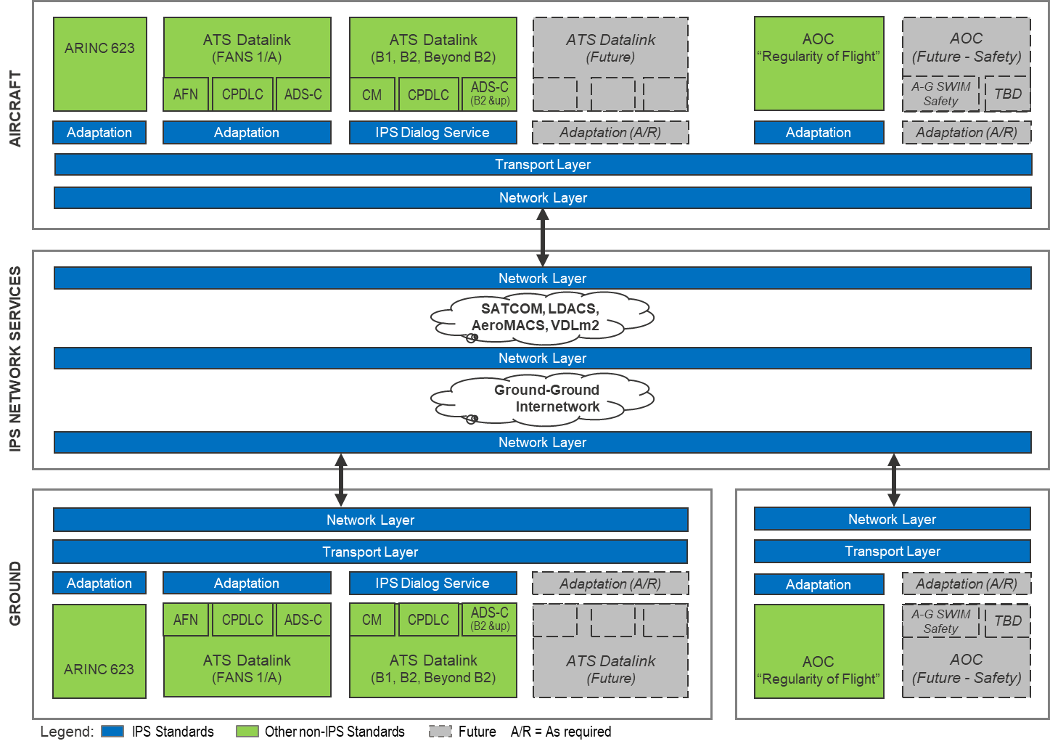

Figure C-1 – ATN/IPS Overview

As shown in Figure C-1, IPS supports both legacy applications, which require adaptation (e.g., using the ATN/IPS Dialog Service described in ICAO Document 9896), and future applications, which could be extensions of adapted legacy applications or new native IP applications not yet covered by ICAO Document 9896.

The following points summarize the target applications:

* ATS datalink applications supporting integrated air traffic control services in continental and oceanic airspace as part of the future Aeronautical Telecommunication Network (ATN). This includes Baseline 2 and future applications that will support in particularfull 4D trajectory based operations. IPS may also provide a network service for aircraft equipped with legacy ARINC 623 or FANS-1/A.
* AOC applications supporting safety and regularity of flight. This includes AOC services currently supported over ACARS (and adapted to support transmission over IP). Candidate AOC applications include flight plans, weather reports and forecasts, weight and balance information, Aircraft Condition Monitoring System (ACMS) reports, and aircraft position reports.

The ATN/IPS network service is designed and developed to support the safety, performance and security requirements for these applications in the airspaces in which it is deployed and for all phases of flight: airport, terminal maneuvering area, enroute, and oceanic/remote.

The ATN/IPS network connects air and ground assets over an internetwork comprising a series of interconnected networks, which use the IPv6 protocol suite specified within ICAO Document 9896 [*planned updated pending output of WG-I Mobility Sub-group*]. The design of the ATN/IPS considers which network layer protocols are required to support air/ground mobile connectivity, and how the upper communications layers provide the necessary end-to-end service required by each of the applications listed above. There may also be requirements that ATN/IPS would impose on Layer 2 (link layer) radio networks.This includes selection of a suitable transport protocol and any adaptation required to support legacy applications over the selected transport protocol.

Air/ground subnetworks, operated by one or more Communications Service Providers (ACSPs), provide communications between aircraft and ground entities. As examples, the diagram shows satcom, L-band terrestrial radio, and AeroMACS systems. Section 2.5 provides further detail regarding candidate communication systems.

On the ground, ANSPs, airlines, and other organizations (e.g., engine manufacturers) use their own ground network and connect directly to ACSPs or via intermediate ground service providers. For simplicity, the connectivity between ground end user networks and ACSPs may be viewed as a homogeneous ground/ground internetwork, where each air/ground subnetwork may present one or more “points of presence” onto the ground/ground internetwork, through which communications to connected aircraft can be routed.

Although not shown in Figure C-1, the transition to ATN/IPS must address interoperability among aircraft and ground entities exchanging messages among different networks. Aircraft may have dual protocol stacks for ATN and ACARS operation (e.g., OSI+ACARS or IPS+ACARS). Similarly, not all ground systems will support OSI and/or IPS variants. Therefore, ground system gateways will be required to support interoperability, as further described in ARINC 858 Part 2.

* 1. ATN/IPS Applications and Services

The aviation community, in concert with NextGen and SESAR programs, is expected to introduce ATN/IPS for a number of applications and services. The following applications and services are discussed in the context of the implications of introducing ATN/IPS.

* + 1. ATS Data Communications
       1. ARINC 623

**ARINC Specification 623:** *Character-Oriented Air Traffic Service (ATS) Applications* defines character-oriented ATS messages that are transmitted over ACARS via VHF, HF, and satcom datalinks.

Additional references for character-oriented ATS messages include:

* **EUROCAE ED-85A:** Data Link Application System Document for the Departure Clearance Data Link Service
* **EUROCAE ED-89A:** Data Link Application System Document for the ATIS Data Link Service
* **EUROCAE ED-106A:** Data Link Application System Document for the Oceanic Clearance Data Link Service

An adaptation layer is necessary to accommodate the exchange of ARINC 623 application messages over ATN/IPS. Note that although the current European Union (EU)/US Data Communications Harmonization Roadmap (ARINC Report 658 - Appendix A-2) does not reference ARINC 623 over ATN/IPS, the ATN/IPS technical solution should not preclude this functionality if stakeholders and a business case support it.

* + - 1. FANS

The Future Air Navigation System (FANS) application set includes communication (Controller Pilot Data Link Communications (CPDLC)) and surveillance (Automatic Dependent Surveillance-Contract (ADS-C)) ATS applications and uses the ACARS network. FANS was introduced in the mid-1990s. Boeing introduced FANS-1 services and Airbus developed a similar product called FANS A. Collectively the products are known as FANS-1/A. FANS-1/A+ is an improved version of FANS-1/A and includes a message latency detection function. New installations typically support FANS-1/A+. However, older installations may not have FANS-1/A+.

Primary references for FANS-1/A+ are:

* **ARINC Specification 622:** ATS Data Link Applications over ACARS Air/Ground Network
* **RTCA DO-258A/EUROCAE ED-100A:** Interoperability Requirements for ATS Applications Using ARINC 622 Data Communications

In addition, there is a large collection of documents that define functions and characteristics of the avionic and ground based systems.

FANS-1/A uses ACARS subnetworks including: VHF (VDL Mode 0/A using the “Plain Old” ACARS (POA) protocol and VDL Mode 2 using the ACARS over Aviation VHF Link Control (AVLC), or AOA, protocol); HF (using the HF Data Link (HFDL) protocol); and satcom (using the Data-2 protocol for Inmarsat Classic Aero satcom and the Short-Burst Data (SBD) protocol for Iridium). The worldwide coverage includes oceanic Required Navigation Performance (RNP)-4 routes that require data communications. Consequently, FANS-1/A is implemented on many aircraft that fly internationally because it provides Required Surveillance Performance (RSP) 180 and Required Communication Performance (RCP) 240 capabilities. The FAA Data Communications program has chosen FANS-1/A for use in domestic operations, including the introduction of Departure Clearance (DCL) operations in 2015 and plans to extend CPDLC services for enroute operations in 2019. FANS will also be able to use ACARS over new satellite services such as Inmarsat SwiftBroadband Safety (SBS) and Iridium Certus.

As shown previously in Figure C-1, an adaptation layer is necessary to accommodate the exchange of FANS-1/A application messages over ATN/IPS.

* + - 1. Baseline 1 (B1)

ATN is a communication architecture developed by ICAO to provide a global air/ground and ground/ground data link application and communications standard for air traffic services. ICAO Document 9705-AN/956 specifies the initial ATN technical provisions, and ICAO Document 9880-AN/466 amends and supersedes Document 9705 based on the results of ongoing validation and operational experience gained during implementation and deployment. These ICAO technical manuals specify the operation of ATN applications and the ATN End Systems (application entities). In addition, they specify the Communication Service (including Upper Layer Communication Services (ULCS) and Internet Communication Service (ICS)), which uses the OSI protocol stack.

B1 is a subset of the ICAO ATN applications that supports initial enroute datalink services. Specifically, B1 specifies the following datalink applications: Context Management (CM), ADS-C, CPDLC, and Flight Information Services (FIS).

Note: Avionics and ground systems currently implement the B1 CM and CPDLC applications. However, they do not implement the B1 ADS-C and Flight Information Service (FIS) applications.

The following RTCA/EUROCAE documents standardize B1:

* **RTCA DO-28B/EUROCAE ED-110B:** Interoperability Requirements Standard for Aeronautical Telecommunication Network Baseline 1 (ATN B1 Interop Standard)
* The interoperability between FANS-1/A and B1 is specified in:   
  **RTCA DO-305A/EUROCAE ED-154A:** [*Future Air Navigation System 1/A – Aeronautical Telecommunication Network Interoperability Standard (FANS-1/A – ATN B1 Interop Standard)*](http://www.eurocae.net/eshop/catalog/advanced_search_result.php?keywords=ED-154A)

In Europe, the Data Link Services Implementing Rule (DLS-IR) requires airspace users operating above Flight Level 285 and Air Navigation Service Providers (ANSPs) operating in the EU region to equip for operation of B1 over VDL Mode 2. Implementing Rule EC 2015/310 amends the initial regulation EC 29/2009 and is applicable from February 2018 forward. The DLS-IR mandates specific ATS services under the CM application (Data Link Initiation Capability (DLIC)) and the CPDLC application (Aircraft Communications Message (ACM), ATC Clearance (ACL) and ATC Microphone Check (AMC)), which were validated by the EUROCONTROL Link 2000+ Programme. The ETSI Community Specification (ETSI EN 303 214) and the EUROCONTROL Specification on Data Link Services (EUROCONTROL SPEC-0116) define the compliance for B1 systems.

ICAO Document 9880-AN/466 specifies technical provisions for B1 operation over the OSI protocol stack. To facilitate transition from OSI to IPS, ICAO Document 9896 defines provisions for an adaptation layer (shown previously in Figure C-1) that mimics the Dialog Service interface to support B1 operation over ATN/IPS. Note that the Dialog Service interface is the same for B2 as it is for B1, so the adaptation layer functions equivalently for both B1 and B2.

As noted in ARINC Report 658 - Appendix C-2.3, the long-term EU and US harmonization strategy includes the B2 application set and ATN/IPS. Therefore, as ATN/IPS implementations are fielded, it is expected that B2 will be the current data communications application standard. However, as ground systems transition to ATN/IPS, there will be a need to support B1 applications where they are deployed (currently only continental Europe). ATN/IPS-based ground systems using either B1 or B2 may communicate with OSI-based aircraft using either B1 or B2 (and vice versa) via an accommodation function similar to the Gateway discussed in   
ARINC 858 Part2.

* + - 1. Baseline 2 (B2)

Baseline 2 (B2) represents a significant expansion of B1 services aimed at supporting the totality of ICAO ATN applications that enable 4D trajectory based operations and airports services. B2 has several versions. The first version (B2A) will be implemented in Europe using ATN/OSI. This section covers all versions.

Compared to B1, B2 modifies the subset of datalink applications, which includes CM, ADS-C, and CPDLC. The following RTCA/EUROCAE documents specify the applicable B2 standards:

* **RTCA DO-350A/EUROCAE ED-228A:** Safety and Performance Standard for Baseline 2 ATS Data Communications (Baseline 2 SPR Standard)
* **RTCA DO-351A/EUROCAE ED-229A:** Interoperability Requirements Standard for Baseline 2 ATS Data Communications (Baseline 2 Interop Standard)
* **RTCA DO-352A/EUROCAE ED-230A:** Interoperability Requirements Standard for Baseline 2 ATS Data Communications, FANS-1/A Accommodation (FANS-1/A - ATS Baseline 2 Interop Standard)
* **RTCA DO-353A/EUROCAE ED-231A:** Interoperability Requirements Standard for Baseline 2 ATS Data Communications, ATN Baseline 1 Accommodation (ATN Baseline 1 - Baseline 2 Interop Standard)

Revision A adds Advanced Interval Management (AIM) and Dynamic RNP (D-RNP). B2 Revision “n” will incorporate corrections resulting from validation. However, it will not contain any new functionality.

EUROCONTROL under SESAR, and FAA under NextGen, have B2 capability in the future implementation roadmap. B2 is intended to support B1 ATS services, plus additional services under the CPDLC application (DCL, Digital TAXI (D-TAXI), In-Trial Procedure (ITP), Information Management (IM), Oceanic Clearance (OCL), Information Exchange and Reporting (IER), Four-Dimensional Trajectory Datalink (4DTRAD), D-RNP, and the ADS-C application (PR, IER, 4DTARD, D-RNP).

As shown previously in Figure C-1, an IPS dialog service adaptation layer is necessary to accommodate the exchange of B2 application messages over ATN/IPS.

* + - 1. Beyond Baseline 2

Beyond B2, yet-to-be-defined Baseline 3 (B3) services are foreseen to support longer-term operations in the 2030+ timeframe (i.e., Block 3 per ICAO’s Aviation System Block Upgrade (ASBU) plan). Definition of B3 may include applications of more stringent technical performance characteristics for the existing B2 services, as well as the definition of new services. The European SESAR 2020 Programme will be offering proposals for potential new services. The interface to ATN/IPS may use the dialog service or another interface may be defined.

* + 1. AOC Data Communications

AOC applications support services that generally fall into flight planning, weather, dispatching, ground handling, and messaging categories. ATN/IPS is intended to support these AOC applications.

COMMENTARY

AOC communication is evolving to use both ATN/IPS (AOC safety) and commercial IP (AOC non-safety).

* + - 1. Current AOC Data Communications

Current AOC applications operate predominantly over the ACARS network. This means that an adaptation layer is necessary to accommodate the exchange of AOC messages over ATN/IPS without changing the applications implemented by both avionics and ground systems.

* + - 1. Future AOC Data Communications

Future AOC applications should be designed to operate over the ATN/IPS network. This will simplify the adaptation layer necessary to accommodate the exchange of AOC messages over ATN/IPS.

* + 1. Aeronautical Information Management (AIM)
       1. AIM Services

RTCA SC-206 and EUROCAE WG-76 are in the process of developing Airborne Meteorological (AMET) and Aeronautical Information Management (AIM) Services including:

* Airspace Information Update
* Digital Notice to Airmen (NOTAM)
* Digital in-flight weather (VOLMET)
* Winds and temperature aloft
* Winds and temperature data for flight management
* Aerodrome weather
* Hazardous weather
* Environmental conditions in critical flight phases
* Weather imagery
* Runway visual range
* Digital Automatic Terminal Information Service (ATIS)
* Runway, taxiway, and obstacle information
* Special aircraft weather reports (AIREP/AUTOMET)
* Exchange of real-time aircraft derived data
* Others

The associated service message definitions are generic, technology agnostic, and can utilize both safety services protected spectrum and non-safety service broadband air/ground communications. Most of these new services will leverage the native internet protocol application-layer interfaces. Depending on the outcome of operational performance, safety assessment, and data quality requirements, some of these services may utilize ATN/IPS, when deployed.

* + - 1. System Wide Information Management

The ICAO Global Air Traffic Management Operational Concept describes System Wide Information Management (SWIM) as the integration of ATM information using a many-to-many information distribution model. Many geographically dispersed sources collaboratively provide information that is shared among relevant stakeholders to maintain situational awareness and improve operational decision-making.

At the time of this writing, air/ground SWIM is not intended to carry safety-critical data such as aircraft trajectory and tactical command and control. Current air/ground SWIM offerings support the exchange of non-safety-critical, advisory information such as weather and AIM that the aircraft flight crew uses to enhance situational awareness. The scope of ATN/IPS safety services does not include these non-safety air/ground SWIM information exchanges. If air/ground SWIM safety services are deployed in the future, these applications may leverage the native ATN/IPS application-layer interfaces or they may implement an adaptation layer, as illustrated previously in Figure C-1.

* + 1. Voice Services

While certain aeronautical mobile communication technologies may offer voice services, cockpit voice services are assumed to be outside the scope of the ATN/IPS standardization activity. If air/ground VoIP services over ATN/IPS are deployed in the future, further analysis will be required to ascertain requirements (e.g., performance, architecture, networking, and security) and whether ATN/IPS can support those requirements.

* 1. Networks
     1. ACARS

The Aircraft Communications, Addressing and Reporting System (ACARS) is an air/ground data communications system deployed initially in 1978 to support message exchanges between aircraft and airline operation center. ACARS uses aviation-unique, character-oriented, air/ground communications protocols (per ARINC Specifications 618, 619, and 620) to exchange messages no larger than approximately 3.5 kilobytes. ACARS supports both ATS and AOC message exchanges.

ACARS has evolved to use multiple subnetworks globally, including the following:

* VDL Mode 0/A (using the “Plain Old” ACARS (POA) protocol)
* VDL Mode 2 (using the ACARS over Aviation VHF Link Control (AVLC) or AOA protocol
* Inmarsat L-band satcom
* Iridium L-band satcom
* High Frequency Data Link (HFDL)

Since ACARS use is expected to continue beyond initial deployments of ATN/IPS, it may be necessary for aircraft equipage to support both ACARS and IPS networks (“dual-stack”), similar to current equipage that supports both ACARS and OSI.

In an ATN/IPS environment, no changes to the ACARS protocol stack are necessary. ATN/IPS may offer an alternate means for communicating ACARS messages, by carrying either the ACARS messages themselves (i.e., ARINC 618 data blocks) or the data contained in an ACARS message (i.e., the payload data in ARINC 618 data blocks). Ground gateways will be necessary to provide translation services.

* + 1. OSI

The deployment of Data Link Services Implementing Rule (DLSIR) in Europe that began in the early 2000’s implements the bit-oriented ATN Open Systems Interconnection (OSI) network protocols specified in ICAO Document 9880 (originally Document 9705 Edition 2 plus correcting actions specified in the EUROCONTROL DLSIR). The aviation-unique OSI protocol stack includes the International Standards Organization (ISO) 8208 Packet Layer Protocol (PLP), ISO 8473 Connection-Less Network Protocol (CLNP), ISO 8073 TP4 Connection-Oriented Transport Protocol (COTP), and “fast-byte” session and presentation layers. OSI is deployed only in Europe, supports only B1 ATS message exchanges, and uses only the VDLM2 subnetwork (although use of Inmarsat SBB as an additional subnetwork is in development/testing under the Iris Precursor Programme).

Initial B2 implementation in Europe (SESAR Very Large-Scale Demonstration) will also be based on OSI over VDLM2 subnetwork (and possibly over Inmarsat SBB).

In a mixed OSI-IPS environment, ground gateways may be necessary to provide accommodation of OSI-equipped aircraft communicating with IPS-based ground systems and/or IPS-equipped aircraft communicating with OSI-based ground systems. Reference ARINC 858 Part 2, which presents ground segment and transition accommodation considerations.

* + 1. IPS

The IPS protocol stack will eventually replace both the ACARS and OSI networks, and provide a convergence point for current and future applications. Various aviation standards organizations are planning to specify, or are in the process of specifying, the IPS protocol stack. The current version of ICAO Document 9896 specifies some initial considerations for the IPS protocol architecture, which include the connection-oriented Transmission Control Protocol (TCP) and extensions per RFC 793 and RFC 1323 (respectively); connectionless User Datagram Protocol (UDP) per RFC 768; and general Internet Protocol inter-networking based on IPv6 per RFC 2460. The ICAO technical manual further specifies Internet RFCs for mobility, addressing, inter-domain routing, quality-of-service, security, and so forth. However, these specifications are subject to change based on ongoing analyses of mobility and security alternatives.

* 1. Candidate Communication Links

ATN/IPS will use multiple subnetworks that operate in protected aeronautical spectrum allocated by ITU and ICAO for safety services. This section addresses candidate subnetworks including: terrestrial-based communications that provide Line of Sight (LOS) coverage (i.e., range of about 200 NM), satellite communications that provide Beyond Line of Sight (BLOS) coverage, and airport surface communications, which are a form of LOS used only when the aircraft is on the airport surface. Systems such as VHF Digital Link Mode 0/A, current aeronautical HF Datalink, and Performance Class C satcom are not considered to support ATN/IPS due to performance limitations.

The subnetwork descriptions in this section are summaries from ARINC Report 660B and other sources.

* + 1. Terrestrial-based Communications

Terrestrial-based communications support voice and datalink operations within line-of-sight coverage of ground stations. Most modern transport aircraft are forward-fit with ARINC 750 VHF Data Radios (VDRs) and are therefore capable of VHF datalink operations. Operations in areas that are not within VHF coverage (e.g., oceanic operations) depend on Beyond Line Of Sight (BLOS) communications such as satcom.

* + - 1. VHF Digital Link Mode 2 (VDLM2)

VDLM2 supports both B1 (OSI) and FANS-1/A (ACARS) services, and B2 services are expected to operate initially over VDLM2. It operates with a Common Signaling Channel (CSC) of 136.975 MHz, at the top of the aeronautical VHF band, with a channel width of 25 kHz using Differential 8-Phase Shift Keying (D8PSK) modulation to provide digital communications at a nominal data rate of 31.5 kbps. ICAO Document 9776 specifies the VDLM2 technical provisions, supported by the following documents:

* **ARINC Specification 631:** VHF Digital Data Link (VDL) Mode 2 Implementation Provisions
* **RTCA DO-224C:** Minimum Aviation System Performance Standards (MASPS) for Advanced VHF Digital Data Communications

European and US organizations are working together to identify terrestrial-based alternatives to VDLM2 (e.g., LDACS, reference Section C.4.1.2). Until those new communication means are defined and deployed, the number of VHF carrier frequencies has been increased for VDLM2, resulting in what is known as multi-frequency VDLM2.

ATN/IPS protocols are expected to work with existing VDLM2, similar to the way in which the ACARS over AVLC (AOA) protocol works with VDLM2. In addition, current VDLM2 optimization investigations, including initial laboratory and flight tests, show promising results. Pending further investigation, this optimization may yield several variants (e.g., connectionless using Unnumbered Information (UI) frames, or broadcast mode) that may offer better RF efficiency and robustness than current connection-oriented operation, and which can support ACARS and OSI, in addition to IPS. Protocol multiplexing is possible using the Initial Protocol Identifier (IPI), which tags the AVLC Frame content as being IPS, ACARS, or OSI, as needed. Further investigation should assess the need for reliability mechanisms to provide robust data transmission. As is the case for introduction of any new protocol, addressing transition requirements is necessary so that aircraft and ground systems can deal easily with different protocols simultaneously.

* + - 1. LDACS

The L-band Digital Aeronautical Communications System (LDACS) is an integral component of the Future Communications Infrastructure (FCI) identified in the FAA and EUROCONTROL Future Communications Study and endorsed by ICAO in 2008.

LDACS in considered, particularly in Europe, to complement VDLM2 data link operations (B2 services) when additional capacity is required and new services are necessary to support more stringent performance requirements (e.g., B3 including B2 with more stringent performance requirements).

The LDACS protocols utilize modern commercial technologies based on Frequency Division Duplex (FDD) with Orthogonal Frequency Division Multiplexing (OFDM) modulation. To date, Europe is taking the lead with LDACS definition and development efforts. Under the SESAR1 activities, the LDACS system specifications were refined, a transmitter prototype was built, and spectrum compatibility tests against Distance Measuring Equipment (DME) and Tactical Air Navigation (TACAN) were performed. Work on LDACS will continue in SESAR 2020, including the development of complete prototypes (i.e., transmit and receive functionality) and testing to investigate and ascertain spectral compatibility with other existing L-band systems.

LDACS will operate as a native ATN/IPS air/ground subnetwork. As of December 2016, ICAO initiated a group to develop the SARPs and Technical Manual for LDACS by the 2020 timeframe.

* + 1. Satellite Communications (Satcom)
       1. Satcom Performance Class B – Medium Term

As background, Satcom Performance Class C covers performance requirements included in the current ICAO SARPs, and supports oceanic datalink operations. Class C is applicable to existing systems, such as Inmarsat Classic Aero/I3, MTSAT, and Iridium, which have already been standardized by ICAO.

Satcom Performance Class B has more stringent performance requirements (as compared to Class C), such as those necessary to support initial 4D trajectory based operations for both oceanic and continental operations. Class B applies to the current generation of satcom systems, such as Inmarsat SBB/I4 and Iridium Certus.

* + - * 1. Inmarsat SBB

Inmarsat provides land, maritime, and aviation services with geo-synchronous satellites at an altitude of approximately 22,000 NM. Its coverage is from 80° N to 80° S with no polar coverage.

Inmarsat SwiftBroadband Safety (SB Safety) uses digital high-speed and secure IP broadband to support a host of new safety and operational applications. This is a natural evolution of Inmarsat Classic Aero services, which have served airlines for over 25 years.

SB Safety supports simultaneous voice and broadband data, with IP data at up to 432 kbps, and IP data streaming on demand at 32, 64, and 128 kbps. The SB Safety architecture, shown in Figure C-2, illustrates the high-level SB-Safety system architecture. Although not shown, the architecture includes redundancy, with primary operation over the SwiftBroadband link, and fallback operation over the Classic Aero satellite network. This enables a highly available, high priority link for the reliable and safe transfer of FANS/ACARS messages meeting RCP240 and RSP180 performance requirements, while also providing voice and non-safety IP data services to the cockpit.

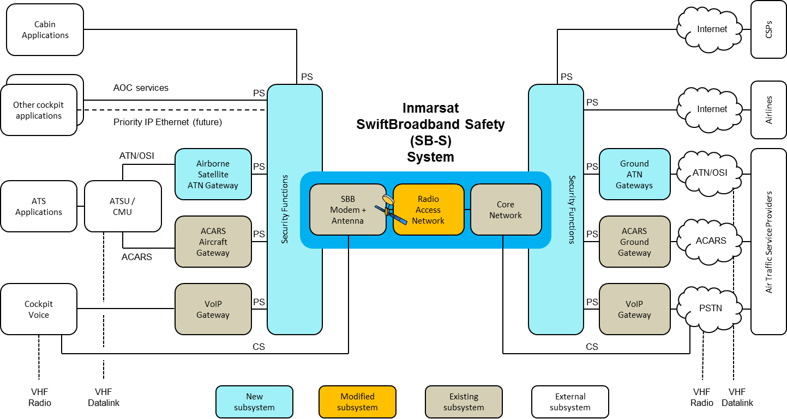

Figure C-2 – SwiftBroadband Safety High-level Architecture

The Inmarsat SBB safety services ensure that existing onboard avionics systems for the voice and ACARS services do not require changes to the system interfaces used for Classic Aero today.

For Class B, air/ground datalink standards development will extend RTCA SC-222 material considering EUROCAE ED-228A and ED-229A to cover continental airspace performance requirements, with support from SESAR P15.2.5 and the European Space Agency (ESA) Iris Precursor Programme (Inmarsat SBB evolution).

Inmarsat is now working on a program of upgrades to SwiftBroadband that will meet RTCA/EUROCAE performance standards for ATS datalink use in continental airspace. This service, which is currently under development in the context of the European Iris Precursor Programme with links to SESAR will enter pre-operational flight trials with Airbus. The operational objective is to support initial 4D applications within both oceanic domains (e.g., for sequenced arrivals) and European continental domain as a complement to the datalink capabilities provided by VDLM2. The service will also provide an additional capacity to support the growth of Airline Operational Communications (AOC) as required.

The proposed Iris system architecture is a natural evolution of the SB-Safety system developed for Oceanic Safety services, which itself is an adaptation of the commercial SwiftBroadband (SBB) system in service today. As shown previously in Figure C-2, Iris Precursor introduces ATN/OSI and Security gateways in both the air and ground segments. ATN Gateways encapsulate ATN/OSI traffic into the SBB IP data connection. The gateways present standard interfaces defined in the ICAO ATN Manual (ICAO 9705) for integration into ground/ground networks within the European ATM Network and, through minor modification, to the Air Traffic Services Unit (ATSU)/CMU on board the aircraft. The Security gateways create an IPsec Virtual Private Network (VPN) to protect ATS datalink traffic against potential controller masquerade and replay/modification attacks. Additional mechanisms deployed on the air and ground segments will mitigate denial of service attacks and prioritize SBB access for ATS services.

While the current datalink deployment in Europe is ATN/OSI-based, parallel industry initiatives are defining the approach to ATN/IPS for future datalink systems. Inmarsat has initiated a new program/study that is investigating potential Iris Precursor upgrades to support integration of ATN/IPS communications service into existing infrastructure. To achieve the objective of a globally interoperable service, international standards are required for future developments. The study will contribute key principles, design approaches, and propose inputs to the ICAO Communications Panel and ARINC IA Standards committees.

Inmarsat’s aim is to introduce ATN/IPS functionality by upgrading the Iris system with the introduction of an ATN/IPS gateway.

* + - * 1. Iridium Certus

The Iridium NEXT constellation, which completely replaces the Iridium Block 1 constellation, consists of 66 operational satellites, 6 in-orbit spares, and 9 ground spares. Iridium NEXT will offer the Iridium Certus Broadband Service with dramatically increased data speeds ranging from 88 kbps to 1.4 Mbps and with global pole-to-pole broadband service coverage.

The Iridium satellites are located in six distinct planes at a Low Earth Orbit (LEO) of 780 km and circle the Earth approximately once every 100 minutes, travelling at a rate of 27,088 km/h. The 11 mission satellites within each plane are spaced every 32.7 degrees and perform as nodes in the communications network. Satellite positions in adjacent odd and even numbered planes are offset from each other by one-half of the satellite spacing. This constellation ensures that at least one satellite covers every region at all times.

Each Iridium satellite has four cross-link antennas to allow it to communicate with and route traffic to the two satellites that are fore and aft of it in the same orbital plane, as well as to neighboring satellites in the adjacent co-rotating orbital planes. These inter-satellite links operate at approximately 23 GHz. Inter-satellite networking is a significant technical feature of the Iridium Satellite Network that enhances system reliability and capacity and reduces the number of gateways or Ground Earth Stations (GESs) required for global coverage. As part of the Iridium NEXT program, all GES locations have been updated and an encrypted teleport network has been built to interconnect GES locations.

Iridium NEXT satellites are classified as replacement satellites as they support the current Block 1 services as well as offer new waveforms for the Iridium Certus Broadband capability. Therefore, all legacy Iridium Block 1 devices will continue to operate under the Iridium NEXT constellation without interruption nor impact to certification as the RF features (e.g., Equivalent Isotropically Radiated Power (EIRP), and frequencies) are unchanged.

Iridium Certus is a multi-service platform offering simultaneous voice and broadband data services in five classes. Table C-1 summarizes the data rates along with associated antenna, Low Gain Antenna (LGA), Active LGA (ALGA), and High Gain Antenna (HGA). Note that the TX/RX speeds are usable data rates and exclude the headers required in the Iridium system.

Table C-1 – Iridium Certus Service Class

|  |  |  |  |
| --- | --- | --- | --- |
| Service Class | TX Speed (max) | RX Speed (max) | Antenna Type |
| Iridium Certus 100 | 176 kbps | 88 kbps | LGA |
| Iridium Certus 200 | 176 kbps | 176 kbps | LGA/ALGA |
| Iridium Certus 350 | 352 kbps | 352 kbps | HGA |
| Iridium Certus 700 | 352 kbps | 704 kbps | HGA |
| Iridium Certus 1400 | 524 kbps | 1408 kbps | HGA |

Services offered on each Iridium Certus terminal will include three independent voice lines, background IP data, streaming IP data, standard IP data, and short burst data. The use of simultaneous services is limited to the maximum transmit/receive speeds of the transceiver.

Figure C-3, illustrates the high-level Iridium Certus safety system architecture. It is planned that Iridium Certus will operate as both an ATN/OSI and ATN/IPS air/ground subnetwork in addition to traditional voice and ACARS services.

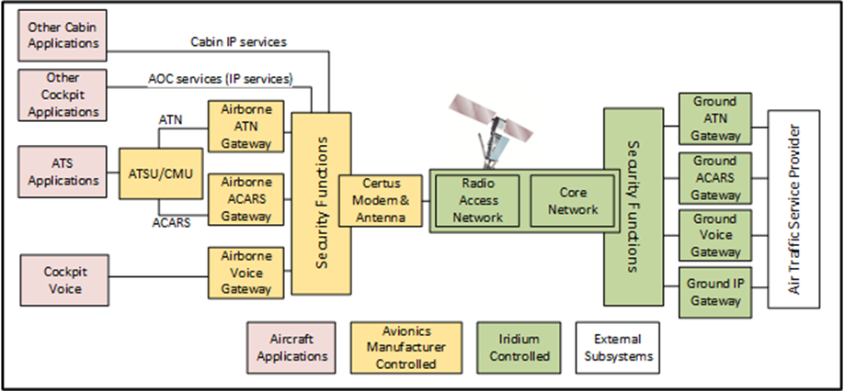

Figure C-3 – Iridium Certus Safety High-level Architecture

* + - 1. Satcom Performance Class A – Longer Term

Satcom Performance Class A provides more stringent performance requirements (as compared to Class B), such as those required to support full 4D trajectory based operations and future operational concepts being defined by SESAR and NextGen, and will support both oceanic and continental operations. Class A is applicable to future satcom systems that are not available today.

The Performance Class A requirements are important because they serve as design drivers and guidelines for the development of the future satcom systems. In addition, it is desired to develop a global (ICAO) standard for a satcom system supporting the Class A requirements and allowing different service providers using the same set of avionics to avoid interoperability/interference issues and stimulate equipage.

An input to the definition of the Satcom Performance Class A air/ground datalink standard will be from the work undertaken in the ESA Iris Programme.

It is expected that a Satcom Performance Class A system will operate as an ATN/IPS air/ground subnetwork.

* + 1. Airport Surface Communications
       1. AeroMACS

AeroMACS is a radio IP subnetwork that supports ATC and AOC applications for safety and regularity of flight on the airport surface. It operates on globally reserved ITU spectrum in the C-band (5091-5150 MHz) with locally optional extensions in the 5000-5030 MHz spectrum. ICAO Document 10044-AN/514 specifies the AeroMACS technical provisions, supported by the following RTCA/EUROCAE documents:

* **RTCA DO-345/EUROCAE ED-222:** Aeronautical Mobile Airport Communications System (AeroMACS) Profile
* **RTCA DO-346/EUROCAE ED-223:** Minimum Operational Performance Standards (MOPS) for the Aeronautical Mobile Airport Communication System (AeroMACS)
* **EUROCAE ED-227:** Minimum Aviation System Performance Standards (MASPS) for the Aeronautical Mobile Airport Communication System (AeroMACS)

AeroMACS is based on WiMAX, a cellular technology using a communications profile of the IEEE 802.16-2009 standard that enables the access of Mobile Stations (MS) to user applications on the surface. The Access Service Network (ASN) is provided by a number of Base Stations (BS) that operate in dedicated 5 MHz bandwidth channels and manage the access of the MSs to the common channel accessing configured channels in radio cells. An ASN Gateway (ASN-GW) manages the data path with the Connectivity Service Network (CSN) and handover within the access network.

An AeroMACS network provides an IP convergence sublayer to interface to IPv4 and IPv6 networks and applications on the ground. It supports QoS configuration, traffic prioritization, and Authentication, Authorization, and Accounting (AAA) security infrastructure.

It is expected that AeroMACS (IPv6) will operate as an ATN/IPS aircraft-to-ground subnetwork.