ARINC 424 NDB
Draft 3 of Supplement 24
Proposal

Location: TBD
Month DD-DD, 2024

runway Final End Points

V.6

Joshua Fenwick, Garmin – AVDB Team

SUMMARY
Garmin is proposing that the inserted landing threshold points (LTPs) be coded as final end points for FEP delivery option 1.

2021 NDB Revisions:
- Rev 1: Changed proposal from FEP to a new waypoint description code for the runway inserted points and added XML changes.
- Rev 2: Changed back to coding runway inserted points as FEPs. Added FEP delivery option sections.

2022 NDB Revision:
- Rev 3: Finalized changes to bring back to the 2022 NDB working group

2023 NDB Revision:
- Rev 4: Updated FEP delivery options to include runway FEP coding tables and made clear FEP delivery options 2-4 will not see any changes to runway inserted points.
- Rev 5: Keep FEP delivery option 1 as-is and clarify it now is different than the standard ARINC 424

2023 NDB Revision:
- Rev6: Additional changes from 2022 ARINC NDB meeting

- INTRODUCTION/ BACKGROUND
The Attachment 5 of the ARINC 424 specification has three different rules for what should be coded when the charted missed approach point is beyond the landing threshold.

From Attachment 5:

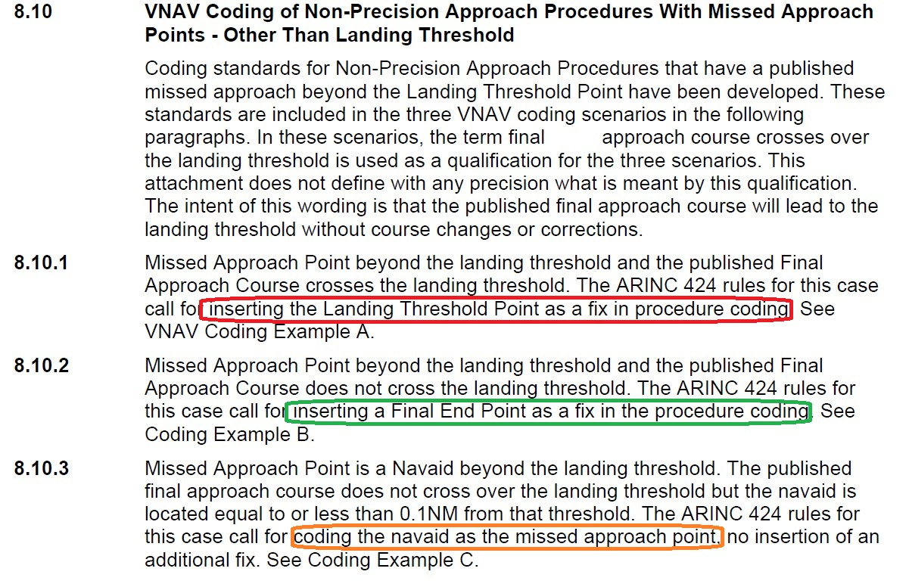
In last two cases, where the FEP or Navaid is coded, the charted MAP is coded with the Waypoint Description Code 4 (5.17 column 43) value of ‘M’ – Missed Approach Point. But in the first case, where the LTP is coded, the charted missed approach point is not flagged with the Waypoint Description Code 4 (5.17 column 43) value of ‘M’. The example of this is seen in Attachment 5 VNAV coding example A and B.

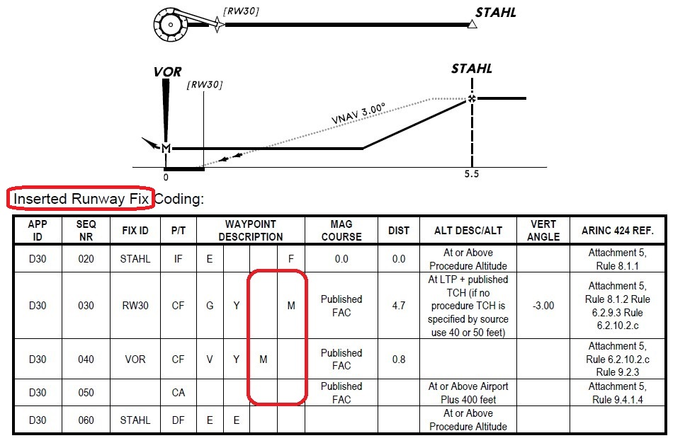
Figure 1: VNAV Coding Example A: Inserted Runway Fix
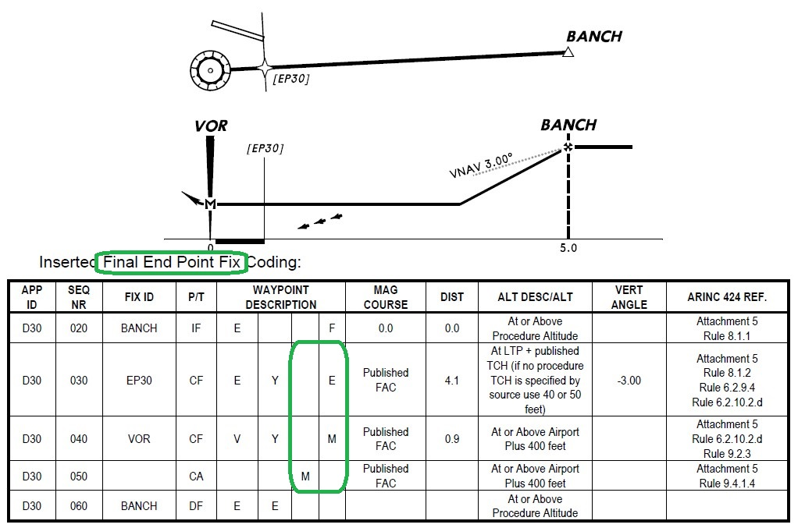
Figure 2: VNAV Coding Example B: Inserted Final End Point
- DISCUSSION and/or ACTION
The problem with the current Attachment 5 rules for inserting the landing threshold point (LTP) in the first case is that we lose the charted missed approach (MAP).

Garmin would like to know when the runway is being inserted using the Attachment 5 rule 8.10.1, so that we can always know the charted MAP. To this end, Garmin proposes to code the runway inserted points with the Waypoint Description Code 4 (5.17 column 43) value of ‘E’ – Final End Point so that the Navaid can be coded with the Waypoint Description Code 4 (5.17 column 43) value of ‘M’ – Missed Approach Point.
- Legacy ARINC 424 changes as depicted (Track Changes is Helpful)
  - Update Chapter 2.2.2, Procedure and Route Terms
    - Update definition for Final End Point
Final End Point (FEP)
The Final End Point (FEP) is a fix located in the Final Approach Coding which serves as the VNAV anchor point when the published MAP is beyond the runway threshold. The FEP is either a runway landing threshold or a created waypoint. Rules governing when a FEP is coded are contained in Attachment 5 of this specification.
  - Update Attachment 5 rules
    - Update 6.2.9.3 & 6.2.9.4 rules:
- If the published Missed Approach Point is beyond the runway threshold, and the runway threshold will be coded as the Final End Point fix in the lateral path, that fix will be on the established path, with no course changes.
- If the published Missed Approach Point is beyond the runway threshold and a runway threshold fix cannot be inserted as defined in Rule 8.10, a Final End Point waypoint is to be inserted into the final approach coding sequence. For complete details, see Rule 8.10.
    - Update 6.2.10.2 rule:
      - Procedure Fix Altitudes for the published Missed Approach Point, or the Final End Point prior to the Missed Approach Point, must be as indicated below.
    - Delete 6.2.10.2.c rule and update 6.2.10.2.d:
- Deleted with Supplement 24.
- For a published Missed Approach Point beyond the runway threshold and where a Final End Point has been inserted into the Final Approach Coding by the data supplier, based on the rules in Rule 8.10 of this Attachment, code an at altitude equal to the runway threshold elevation plus the published TCH (if no procedure TCH is specified by source, then use 40 or 50 feet) in Altitude 1 of the final end point fix record. See also Rule 8.10 of this attachment.
    - Update 8.1.2 rule:
    - A vertical Angle must be coded on the leg that contains the Missed Approach Point or Final End Point, whichever occurs first, for each approach procedure. A Vertical Angle may be coded in the Final Approach Fix Segment for each approach that includes a FACF. Vertical Angles will be from official government source or computed. This Vertical Angle will only be repeated on all step-down fixes on the segment FAF to MAP. The government source Vertical Angle will also be repeated on fixes associated with an AF/RF Leg as the start or end of the arc, when these fixes are not at procedure fix locations and the AF/RF Leg is in the FAF to MAP portion of the final approach coding.
    - Update 8.6.4 rule:
    - A Vertical Angle must be provided on the leg containing the Missed Approach Point fix. One exception to this rule is when the procedure meets the criteria specified in the circle-to-land rule 8.6.2. Another exception is when the procedure meets the criteria specified in the straight-in rules 6.2.9.3 / 6.2.9.4 when the angle must be provided on the leg containing the Final End Point fix. Vertical Angle information must be in accordance with the rules in Section 6, 7 and 8 of this attachment for the type of reference facility on which the procedure is based.
    - Update 8.10.1 rule:
Missed Approach Point beyond the landing threshold and the published Final Approach Course crosses the landing threshold. The ARINC 424 rules for this case call for inserting the Landing Threshold Point as the Final End Point in the procedure coding. See VNAV Coding Example A.
    - Update VNAV coding example A:
CODING EXAMPLE A
VNAV APPROACH CODING EXAMPLE
Inserted Runway Final End Point as VNAV anchor point (Rule 8.10.1)

This example shows a procedure published as Final Approach Fix (FAF) to a Missed Approach Point (MAP) beyond the Landing Threshold Point (LTP). The Final Approach Course (FAC) crosses over the landing threshold. The landing alignment is straight-in. As the officially published MAP position is beyond the LTP, the LTP [RW30] is inserted as the Final End Point (FEP) to serve as the VNAV anchor point in the Final Approach Coding of this example. The VNAV Path angle is calculated from the LTP elevation + TCH (if no procedure TCH is specified by source use 40 or 50 feet [see Section 5.67 of this specification]) using the LTP and the FAF to determine the distance used in the calculation, to the FAF altitude and is coded in the Runway Fix sequence. The missed approach procedure is not included in the graphic. It is included in the coding sequence example. The FEP fix is coded with its designated unique code in the last position of the Waypoint Description. The coded first leg of the missed approach path is a continuation of the FAC to the officially published MAP where the flyover code is set in position 2 of the waypoint description field. The first leg of the published missed approach path is a climb on the FAC to an altitude of airport elevation plus 400 feet, or as specified by source, followed by a direct to a fix at the FAF.
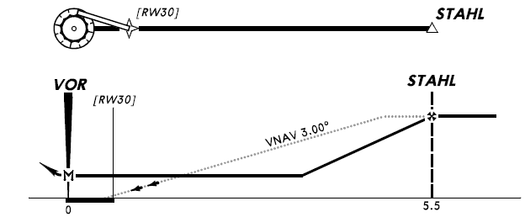
Inserted Runway FEP Coding:
APP  ID | SEQ  NR | FIX ID | P/T | WAYPOINT  DESCRIPTION |  |  |  | MAG  COURSE | DIST | ALT DESC/ALT | VERT ANGLE | ARINC 424 REF.
D30 | 020 | STAHL | IF | E |  |  | F |  |  | At or Above  Procedure Altitude |  | Attachment 5,  Rule 8.1.1
D30 | 030 | RW30 | CF | G |  |  | E | Published  FAC | 4.7 | At LTP + published  TCH (if no  procedure TCH is  specified by source  use 40 or 50 feet) | -3.00 | Attachment 5,  Rule 8.1.2 Rule  6.2.9.3 Rule  6.2.10.2.d
D30 | 040 | VOR | CF | V | Y |  | M | Published  FAC | 0.8 |  |  | Attachment 5,  Rule 6.2.10.2.d  Rule 9.2.3
D30 | 050 |  | CA |  |  | M |  | Published  FAC |  | At or Above Airport  Plus 400 feet |  | Attachment 5,  Rule 9.3.1.5
D30 | 060 | STAHL | DF | E | E |  |  |  |  | At or Above  Procedure Altitude
Waypoint Description:
Column One – Fix Type: E = Waypoint, G = Runway, V = VHF Navaid
Column Two – E = End of Final Approach Coding, Y = Flyover waypoint
Column Three – M = First Leg of Missed Approach Procedure
Column Four – Fix Function in Coding: F = FAF, E = Final End Point, M = Missed Approach Fix
Note: FAF Altitude Description may be at when this is prescribed
by source documentation. The altitude in sequence 050
may be a source provided value for the first leg of a missed
approach or may be regionally adjusted to 500 feet above
the airport. The At or Above Airport Plus 400 feet is the
minimum requirement.

    - Update VNAV coding example B:
CODING EXAMPLE B
VNAV APPROACH CODING EXAMPLE
Inserted Waypoint Final End Point as VNAV anchor point (Rule 8.10.2)

This example shows a procedure published as Final Approach Fix (FAF) to a Missed Approach Point (MAP) beyond the Landing Threshold Point (LTP). The Final Approach Course (FAC) does not cross over the landing threshold. The landing alignment is straight-in. As the MAP is located beyond the landing threshold, a database supplier created waypoint [EP30] is inserted as the Final End Point (FEP) to serve as the VNAV anchor point in the Final Approach Coding of this example. The VNAV Path angle is calculated from the LTP elevation + TCH (if no procedure TCH is specified by source use 40 or 50 feet [see Section 5.67 of this specification]) using the FEP and the FAF to determine the distance used in the calculation, to the FAF altitude and is coded in the FEP Fix sequence. The missed approach path is not included in the graphic. It is included in the coding sequence example. The inserted FEP Fix is coded with its designated unique code in the last position of the Waypoint Description on the FEP sequence. The coded first leg of the missed approach path is a continuation of the FAC to the officially published MAP where the flyover code is set in position 2 of the waypoint description field. The first leg of the published missed approach path is on the FAC to an altitude of airport elevation plus 400 feet, or as specified by source, followed by a direct to a fix at the FAF.
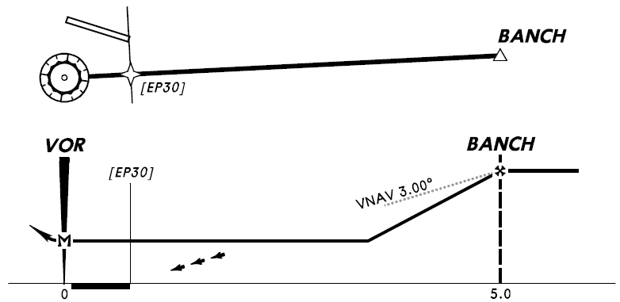
Inserted Waypoint FEP Coding:
APP  ID | SEQ  NR | FIX ID | P/T | WAYPOINT  DESCRIPTION |  |  |  | MAG  COURSE | DIST | ALT DESC/ALT | VERT ANGLE | ARINC 424 REF.
D30 | 020 | BANCH | IF | E |  |  | F |  |  | At or Above  Procedure Altitude |  | Attachment 5,  Rule 8.1.1
D30 | 030 | EP30 | CF | E |  |  | E | Published  FAC | 4.1 | At LTP + published  TCH (if no  procedure TCH is  specified by source  use 40 or 50 feet) | -3.00 | Attachment 5  Rule 8.1.2,  Rule 6.2.9.4,  Rule 6.2.10.2.d
D30 | 040 | VOR | CF | V | Y |  | M | Published  FAC | 0.9 | At or Above Airport  Plus 400 feet |  | Attachment 5  Rule 6.2.10.2.d,  Rule 9.2.3
D30 | 050 |  | CA |  |  | M |  | Published  FAC |  | At or Above Airport  Plus 400 feet |  | Attachment 5  Rule 9.4.1.4
D30 | 060 | BANCH | DF | E | E |  |  |  |  | At or Above  Procedure Altitude
Waypoint Description:
Column One – Fix Type: E = Waypoint, V = VHF Navaid
Column Two – E = End of Final Approach Coding, Y = Flyover waypoint
Column Three – M = First Leg of Missed Approach Procedure
Column Four – Fix Function in Coding: F = FAF, E = Final End Point Fix, M = Missed Approach Fix
Note: FAF Altitude Description may be at when this is prescribed by source documentation. The altitude in sequence 040 and 050 may be a source provided value for the first leg of a missed approach or may be regionally adjusted to 500 feet above the airport. The At or Above Airport Plus 400 feet is the minimum requirement.

    - Update FEP commentary section
COMMENTARY
Final End Point (FEP)
Output File Delivery Options
The purpose of all of the rules on vertical navigation coding for non-precision approach procedures contained in the Attachment 5 to ARINC 424 is to ensure that standards are established that will allow for the provision of a VNAV Path Angle for every approach. These standards have been broken into four groups that are the result of the location of the missed approach point for the procedures as published in official government source documentation. These groups are defined in Rule 8.10 of this attachment and are illustrated as Non-Precision Approach Coding Examples 1 through 15 following that paragraph. The primary group is Missed Approach Point (MAP) at Landing Threshold Point (LTP) and MAP Prior to LTP.
The remaining three coding examples cover the situations when the published MAP is beyond the LTP. These examples are illustrated in Coding Examples A, B and C associated with Rule 8.10:
- Coding Example A: Inserted Runway Final End Point (FEP) as VNAV anchor point
- Coding Example B: Inserted Waypoint Final End Point (FEP) as VNAV anchor point
- Coding Example C: MAP is Navaid within 0.1 NM of LTP
The runway and waypoint FEPs in
Coding Example A & B represents the best possible solution for providing the intent of the government source procedure and encoding the data necessary for execution of the procedure within the avionics. During the iterations required for the development of this encoding standard and its rules, it was identified that not all existing avionics would be able to process this new data in a manner compatible with their operational software. The required modifications to that operational software would more than likely result in a need to re-certify that software. As it is not within the scope of ARINC 424 to refine new avionics requirements or impose data configurations that would result in new avionics requirements; methods were reviewed that would ensure that the vertical navigation benefits of FEP Coding could be made available to the broadest possible user base.
This review effort resulted in identifying four data encoding versions for non-precision approach procedures that are designed such that they would make FEP data available to the largest number of users and negate the impacts of a single solution on operational software. FEP Delivery Format Zero is specified as the ARINC 424 default option. The other four options may be used when specified between avionics supplier and data provider. To ensure that the process and result of any option specification would result in an identical implementation by all data providers to any given supplier, it was agreed that all four encoding versions would be incorporated into ARINC 424 as Delivery Format Options One through Four. An illustration of the four FEP Format Delivery Options is provided on the pages that follow this Commentary.
The table below summarizes the differences between the ARINC 424 default option and the four FEP delivery options.
FEP Delivery Format | Runway (PG/HH) FEPs | Waypoint (EA/HC/PC) FEPs
Zero  (ARINC 424 default) | FEP coded as VNAV anchor with FEP indication of Wpt Desc Code 4 = "E". The published MAP is the coded MAP.
One | Runway FEP coded as MAP with no indication it is a FEP and not the published MAP. | Same as Option Zero (ARINC 424 default)
Two |  | Waypoint FEP coded as the MAP with no indication it is a FEP and not the published MAP.
Three |  | Waypoint FEP coded as VNAV anchor with FEP indication of Wpt Desc Code 1 = “F”. The published MAP is the coded MAP.
Four |  | Waypoint FEP is not coded and no VNAV Angle. The published MAP is the coded MAP.

    - Update FEP Delivery Format One
FEP Delivery Format One – ARINC 424 Standard Coding

Inserted Runway FEP – Differences from Coding Example A

There is no indication that the runway in sequence 030 is a FEP or that the fix in sequence 040 is the officially published MAP. Also, the first leg of the missed approach path is coded as starting at the the runway instead of from the published missed approach point.
Updated coding table from Coding Example A table (orange highlights the differences):
APP  ID | SEQ  NR | FIX ID | P/T | WAYPOINT  DESCRIPTION |  |  |  | MAG  COURSE | DIST | ALT DESC/ALT | VERT ANGLE | ARINC 424 REF.
D30 | 020 | STAHL | IF | E |  |  | F |  |  | At or Above  Procedure Altitude |  | Attachment 5,  Rule 8.1.1
D30 | 030 | RW30 | CF | G | Y |  | M | Published  FAC | 4.7 | At LTP + published  TCH (if no  procedure TCH is  specified by source  use 40 or 50 feet) | -3.00 | Attachment 5,  Rule 8.1.2,  Rule 6.2.9.3,  Rule 6.2.10.2.d
D30 | 040 | VOR | CF | V |  | M |  | Published  FAC | 0.8 |  |  | Attachment 5,  Rule 6.2.10.2.d  Rule 9.2.3
D30 | 050 |  | CA |  |  |  |  | Published  FAC |  | At or Above Airport  Plus 400 feet |  | Attachment 5,  Rule 9.3.1.5
D30 | 060 | STAHL | DF | E | E |  |  |  |  | At or Above  Procedure Altitude
Inserted Waypoint FEP – Differences from Coding Example B

There are no differences from Coding Example B above.

    - Update FEP Delivery Format Two
FEP Delivery Format Two – FEP Coded as MAP

Inserted Runway FEP – Differences from Coding Example A

There is no indication that the runway in sequence 030 is a FEP or that the fix in sequence 040 is the officially published MAP. Also, the first leg of the missed approach path is coded as starting at the runway FEP instead of from the published missed approach point.
Updated coding table from Coding Example A table (orange highlights the differences):
APP  ID | SEQ  NR | FIX ID | P/T | WAYPOINT  DESCRIPTION |  |  |  | MAG  COURSE | DIST | ALT DESC/ALT | VERT ANGLE | ARINC 424 REF.
D30 | 020 | STAHL | IF | E |  |  | F |  |  | At or Above  Procedure Altitude |  | Attachment 5,  Rule 8.1.1
D30 | 030 | RW30 | CF | G | Y |  | M | Published  FAC | 4.7 | At LTP + published  TCH (if no  procedure TCH is  specified by source  use 40 or 50 feet) | -3.00 | Attachment 5,  Rule 8.1.2,  Rule 6.2.9.3,  Rule 6.2.10.2.d
D30 | 040 | VOR | CF | V |  | M |  | Published  FAC | 0.8 |  |  | Attachment 5,  Rule 6.2.10.2.d  Rule 9.2.3
D30 | 050 |  | CA |  |  |  |  | Published  FAC |  | At or Above Airport  Plus 400 feet |  | Attachment 5,  Rule 9.3.1.5
D30 | 060 | STAHL | DF | E | E |  |  |  |  | At or Above  Procedure Altitude
Inserted Waypoint FEP – Differences from Coding Example B

There is no indication that the waypoint in sequence 030 is a FEP or that the fix in sequence 040 is the officially published MAP. Also, the first leg of the missed approach path is coded as starting at the waypoint FEP instead of from the published missed approach point.

Updated coding table from Coding Example B (orange highlights the differences):
APP  ID | SEQ  NR | FIX ID | P/T | WAYPOINT  DESCRIPTION |  |  |  | MAG  COURSE | DIST | ALT  DESC/ALT | VERT ANGLE | ARINC 424  REF.
D30 | 020 | BANCH | IF | E |  |  | F |  |  | At or Above Procedure  Altitude |  | Attachment 5,  Rule 8.1.1
D30 | 030 | EP30 | CF | E |  |  | M | Published FAC | 4.1 | At LTP + published TCH (if no procedure TCH is specified by source use 40 or 50 feet) | -3.00 | Attachment 5,  Rule 8.1.2 Rule 6.2.9.4 Rule 6.2.10.2.d
D30 | 040 | VOR | CF | V | Y | M |  | Published FAC | 0.9 | At or Above  Airport Plus 400 feet |  | Attachment 5,  Rule 6.2.10.2.d  Rule 9.2.3
D30 | 050 |  | CA |  |  |  |  | Published FAC |  | At or Above Airport Plus  400 feet |  | Attachment  5,  Rule 9.4.1.4
D30 | 060 | BANCH | DF | E | E |  |  |  |  | At or Above Procedure  Altitude

Waypoint Description:
Column One - | Fix Type: E = Waypoint, V = VHF Navaid
Column Two - | E = End of Final Approach Coding, Y = Flyover Waypoint
Column Three - | M = First Leg of Missed Approach Procedure
Column Four - | Fix Function in Coding: F = FAF, M = Missed Approach Point
Note: | FAF Altitude Description may be at when this is prescribed by source documentation. The altitude in sequence 040 and 050 may be a source provided value for the first leg of a missed approach or may be regionally adjusted to 500 feet above the airport. The At or Above Airport Plus 400 feet is the minimum requirement.

    - Update FEP Delivery Format Three
FEP Delivery Format Three – FEP Coded as MAP

Inserted Runway FEP – Differences from Coding Example A

There is no indication that the runway in sequence 030 is a FEP or that the fix in sequence 040 is the officially published MAP. Also, the first leg of the missed approach path is coded as starting at the runway FEP instead of from the published missed approach point.
Updated coding table from Coding Example A table (orange highlights the differences):
APP  ID | SEQ  NR | FIX ID | P/T | WAYPOINT  DESCRIPTION |  |  |  | MAG  COURSE | DIST | ALT DESC/ALT | VERT ANGLE | ARINC 424 REF.
D30 | 020 | STAHL | IF | E |  |  | F |  |  | At or Above  Procedure Altitude |  | Attachment 5,  Rule 8.1.1
D30 | 030 | RW30 | CF | G | Y |  | M | Published  FAC | 4.7 | At LTP + published  TCH (if no  procedure TCH is  specified by source  use 40 or 50 feet) | -3.00 | Attachment 5,  Rule 8.1.2,  Rule 6.2.9.3,  Rule 6.2.10.2.d
D30 | 040 | VOR | CF | V |  | M |  | Published  FAC | 0.8 |  |  | Attachment 5,  Rule 6.2.10.2.d  Rule 9.2.3
D30 | 050 |  | CA |  |  |  |  | Published  FAC |  | At or Above Airport  Plus 400 feet |  | Attachment 5,  Rule 9.3.1.5
D30 | 060 | STAHL | DF | E | E |  |  |  |  | At or Above  Procedure Altitude
Inserted Waypoint FEP – Differences from Coding Example B

The Waypoint Description Code column 1 value of “F” in sequence 030 indicates the waypoint is a FEP but there is no indication that the fix in sequence 040 is the officially published MAP. Also, the first leg of the published missed approach path is coded as starting at the waypoint FEP instead of from the published missed approach point.

Updated coding table from Coding Example B (orange highlights the differences):
APP  ID | SEQ  NR | FIX ID | P/T | WAYPOINT  DESCRIPTION |  |  |  | MAG  COURSE | DIST | ALT  DESC/ALT | VERT ANGLE | ARINC 424 REF.
D30 | 020 | BANCH | IF | E |  |  | F |  |  | At or Above  Procedure  Altitude |  | Attachment 5,  Rule 8.1.1
D30 | 030 | EP30 | CF | F |  |  | M | Published FAC | 4.1 | At LTP +  published TCH (if no procedure TCH is specified by source use 40 or 50 feet) | -3.00 | Attachment 5  Rule 8.1.2  Rule 6.2.9.4  Rule 6.2.10.2.d
D30 | 040 | VOR | CF | V | Y | M |  | Published  FAC | 0.9 | At or Above  Airport Plus 400 feet |  | Attachment 5,  Rule 6.2.10.2.d  Rule 9.2.3
D30 | 050 |  | CA |  |  |  |  | Published  FAC |  | At or Above  Airport Plus 400 feet |  | Attachment 5,  Rule 9.4.1.4
D30 | 060 | BANCH | DF | E | E |  |  |  |  | At or Above  Procedure  Altitude

Waypoint Description:
Column One - | Fix Type: E = Waypoint, V = VHF Navaid, F = FEP Waypoint
Column Two - | E = End of Final Approach Coding, Y = Flyover Waypoint
Column Three - | M = First Leg of Missed Approach Procedure
Column Four - | Fix Function in Coding: F = FAF, M = Missed Approach Point
Note: | FAF Altitude Description may be at when this is prescribed by source documentation. The altitude in sequence 040 and 050 may be a source provided value for the first leg of a missed approach or may be regionally adjusted to 500 feet above the airport. The At or Above Airport Plus 400 feet is the minimum requirement.
Note: | The Waypoint Description code #1 value of “F” for FEP Waypoint is not included in the Section 5.17 field definition as a valid code. It is used only in the FEP Delivery Format Three to indicate that the fix coded as the MAP is not the officially published MAP but rather an inserted FEP waypoint serving as the VNAV anvhor point.

    - Update FEP Delivery Format Four
FEP Delivery Format Four – No Waypoint FEP Provided

Inserted Runway FEP – Differences from Coding Example A

There is no indication that the runway in sequence 030 is a FEP or that the fix in sequence 040 is the officially published MAP. Also, the first leg of the missed approach path is coded as starting at the runway FEP instead of from the published missed approach point.
Updated coding table from Coding Example A table (orange highlights the differences):
APP  ID | SEQ  NR | FIX ID | P/T | WAYPOINT  DESCRIPTION |  |  |  | MAG  COURSE | DIST | ALT DESC/ALT | VERT ANGLE | ARINC 424 REF.
D30 | 020 | STAHL | IF | E |  |  | F |  |  | At or Above  Procedure Altitude |  | Attachment 5,  Rule 8.1.1
D30 | 030 | RW30 | CF | G | Y |  | M | Published  FAC | 4.7 | At LTP + published  TCH (if no  procedure TCH is  specified by source  use 40 or 50 feet) | -3.00 | Attachment 5,  Rule 8.1.2,  Rule 6.2.9.3,  Rule 6.2.10.2.d
D30 | 040 | VOR | CF | V |  | M |  | Published  FAC | 0.8 |  |  | Attachment 5,  Rule 6.2.10.2.d  Rule 9.2.3
D30 | 050 |  | CA |  |  |  |  | Published  FAC |  | At or Above Airport  Plus 400 feet |  | Attachment 5,  Rule 9.3.1.5
D30 | 060 | STAHL | DF | E | E |  |  |  |  | At or Above  Procedure Altitude
Inserted Waypoint FEP – Differences from Coding Example B

There is no FEP fix inserted as the VNAV anchor point and therefore no coded Vertical Angle on the Final Approach Coding.

The officially published MAP is provided with the appropriate code in the last position of the Waypoint Description. The coded first leg of the missed approach path is the officially published missed approach path and is from the published missed approach point. It is a climb on the FAC to an altitude of airport elevation plus 400 feet, but never lower that the altitude coded in previous leg or as specified by source, followed by a direct to a fix at the FAF.

Updated coding table from Coding Example B table (orange highlights the differences):
APP  ID | SEQ  NR | FIX ID | P/T | WAYPOINT  DESCRIPTION |  |  |  | MAG  COURSE | DIST | ALT  DESC/ALT | VERT ANGLE | ARINC 424 REF.
D30 | 020 | BANCH | IF | E |  |  | F |  |  | At or Above  Procedure  Altitude |  | Attachment 5,  Rule 8.1.1
D30 | 030 | VOR | CF | V | Y |  | M | Published  FAC | 5.0 | Note 1 | 0.00 | Attachment 5,  Rule 8.1.2
D30 | 040 |  | CA |  |  | M |  | Published  FAC |  | At or Above  Airport Plus  400 feet  Note 2 |  | Attachment 5,  Rule 9.3.1.5
D30 | 050 | BANCH | DF | E | E |  |  |  |  | At or Above  Procedure  Altitude

Waypoint Description:
Column One - | Fix Type: E = Waypoint, V = VHF Navaid
Column Two - | E = End of Final Approach Coding
Column Three - | M = First Leg of Missed Approach Procedure
Column Four - | Fix Function in Coding: F = FAF, M = Missed Approach Point
Note: | FAF Altitude Description may be at when this is prescribed by source documentation. The altitude in sequence 040 may be a source provided value for the first leg of a missed approach or may be regionally adjusted to 500 feet above the airport. The At or Above Airport Plus 400 feet is the  minimum requirement.
Note One: | For a published Missed Approach Point beyond the landing threshold and no Landing Threshold Fix or Final End Point Fix has been include in the lateral path, the altitude in the MAP sequence will be an at altitude equal to the lowest MDA published for the procedure. The Vertical Angle for this Delivery Option will be provided on the MAP sequence and will be 0.00.
Note Two: | The altitude coded will be the airport elevation plus 400 feet or the FEP MDA from previous leg whichever is higher, or a source provided altitude.
Note: | Add Y to column two on the MAP Fix sequence to indicate flyover required and update the Waypoint Description information to include the Y = Flyover Waypoint

    - Replace coding table for VOR Coding Example 1:
APP  ID | SEQ  NR | FIX  ID | P/T | RECD  NAV | Waypoint  Description |  |  |  |  | RHO |  | MAG  CRS |  | DIST |  | ALT |  | VERT  ANG
V04 | 020 | ADR | IF | ADR | V |  |  | F | 0000 |  |  |  |  |  | 01460
V04 | 030 | RW04 | CF | ADR | G | Y |  | M | 0017 |  | 2330 |  | 0063 |  | 00965 |  | -300
V04 | 040 |  | VA |  |  |  | M |  |  |  | 0440 |  |  |  | 02900
V04 | 050 | ADR | DF |  | V | E
    - Replace coding table for VOR Coding Example 2:
APP  ID | SEQ  NR | FIX  ID | P/T | RECD  NAV | Waypoint  Description |  |  |  |  | RHO |  | MAG  CRS |  | DIST |  | ALT |  | VERT  ANG
S28 | 010 | CV28 | IF | AGD | E |  |  | I | 0076 |  |  |  |  |  | 02400
S28 | 020 | AGD | CF | AGD | V |  |  | F | 0000 |  | 2840 |  | 0076 |  | 00486
S28 | 030 | RW28 | CF | AGD | G | Y |  | M | 0011 |  | 2840 |  | 0011 |  | 00135 |  | -300
S28 | 040 |  | VM |  |  | E | M |  |  |  | 2840
    - Replace coding table for VOR Coding Example 3:
APP  ID | SEQ  NR | FIX  ID | P/T | RECD  NAV | Waypoint  Description |  |  |  |  | RHO |  | MAG  CRS |  | DIST |  | ALT |  | VERT  ANG
V23 | 020 | FF23 | IF | ANB | E |  |  | F | 0080 |  |  |  |  |  | 02000
V23 | 030 | RW23 | CF | ANB | G |  |  | E | 0017 |  | 2330 |  | 0063 |  | 00066 |  | -301
V23 | 040 | ANB | CF | ANB | V | Y |  | M | 0000 |  | 2330 |  | 0017 |  | 00400
V23 | 050 |  | VM |  |  | E | M |  |  |  | 2330 |  |  |  | 05000
    - Replace coding table for VOR Coding Example 4:
APP  ID | SEQ  NR | FIX  ID | P/T | RECD  NAV | Waypoint  Description |  |  |  |  | RHO |  | MAG  CRS |  | DIST |  | ALT |  | VERT  ANG
S19 | 020 | FF19 | IF | ANB | E |  |  | F | 0080 |  |  |  |  |  | 02000
S19 | 030 | RW19 | CF | ANB | G |  |  | E | 0020 |  | 1990 |  | 0061 |  | 00066 |  | -300
S19 | 040 | ANB | CF | ANB | V | Y |  | M | 0000 |  | 1990 |  | 0020 |  | 00420
S19 | 050 |  | VM |  |  | E | M |  |  |  | 1990 |  |  |  | 05000

    - Replace coding table for VOR Coding Example 5:
APP  ID | SEQ  NR | FIX  ID | P/T | RECD  NAV | Waypoint  Description |  |  |  | RHO | MAG  CRS | DIST | ALT | VERT  ANG
S29 | 020 | FF29 | IF | ALT | E |  |  | F | 0070 |  |  | 01600
S29 | 030 | EP29 | CF | ALT | E |  |  | E | 0026 | 2630 | 0061 | 00066 | -315
S29 | 040 | ANB | CF | ANB | V | Y |  | M | 0000 | 2630 | 0026 | 00420
S29 | 050 |  | CA |  |  |  | M |  |  | 2630 |  | 00542
S29 | 060 |  | CA |  |  |  |  |  |  | 0830 |  | 04000
S29 | 070 | ALT | DF |  | V |  |  |  |  |  |  | 04500
S29 | 080 | ALT | HM |  | V | E |  |  |  | 1040 | 001T | 04500
    - Replace coding table for VOR Coding Example 6:
APP  ID | SEQ  NR | FIX  ID | P/T | RECD  NAV | Waypoint  Description |  |  |  |  | RHO |  | MAG  CRS |  | DIST |  | ALT |  | VERT  ANG
S11 | 020 | FF11 | IF | BAL | E |  |  | F | 0060 |  |  |  |  |  | 01830
S11 | 030 | EP11 | CF | BAL | E |  |  | E | 0015 |  | 1130 |  | 0035 |  | 00974 |  | -300
S11 | 040 | BAL | CF | BAL | V | Y |  | M | 0000 |  | 1130 |  | 0015 |  | 00980
S11 | 050 |  | VM |  |  | E | M |  |  |  | 2700 |  |  |  | 01490
    - Replace coding table for VOR Coding Example 7:
APP  ID | SEQ  NR | FIX  ID | P/T | RECD  NAV | Waypoint  Description |  |  |  | RHO | MAG  CRS | DIST | ALT | VERT  ANG
D27 | 020 | FF27 | IF | ALE | E |  |  | F | 0064 |  |  | 02280
D27 | 030 | MA27 | CF | ALE | E | Y |  | M | 0024 | 2710 | 0040 | 01800 | -300
D27 | 040 |  | VA |  |  |  | M |  |  | 2710 |  | 03500
D27 | 050 | ALE | DF | ALE | V |  |  |  | 0000
D27 | 060 | ALE | HM | ALE |  | E | M |  | 0000 | 2710 | 001T | 03500
    - Replace coding table for VOR Coding Example 8:
APP  ID | SEQ  NR | FIX  ID | P/T | RECD  NAV | W/P  DESC |  |  |  |  | RHO |  | MAG  CRS |  | DIST |  | ALT |  | VERT  ANG
V18 | 020 | FF18 | IF | ALM | E |  |  | F | 0070 |  |  |  |  |  | 02170
V18 | 030 | ALM | CF | ALM | V | Y |  | M | 0000 |  | 1840 |  | 0070 |  | 00390 |  | -300
V18 | 040 |  | VA |  |  |  | M |  |  |  | 1840 |  |  |  | 00489
V18 | 050 |  | VM |  |  | E |  |  | 0000 |  | 0050

    - Replace coding table for VOR Coding Example 9:
APP  ID | SEQ  NR | FIX  ID | P/T | RECD  NAV | Waypoint  Description |  |  |  | RHO | MAG  CRS | DIST | ALT | VERT  ANG
T01 | 010 | TUFER | IF | DWG | E |  |  | I | 0120 |  |  | 02500
T01 | 020 | FF01 | CF | DWG | E |  |  | F | 0050 | 3600 | 0070 | 01500
T01 | 030 | RW01 | CF | DWG | G | Y |  | M | 0008 | 3600 | 0042 | 00111 | -300
T01 | 040 |  | VA |  |  |  | M |  |  | 3600 |  | 00500
T01 | 050 | TUFER | DF |  | E |  |  |  |  |  |  | 02500
T01 | 060 | TUFER | HM | DWG | E | E |  |  | 0120 | 3600 | 001T | 02500
    - Replace coding table for NDB Coding Example 1:
APP  ID | SEQ  NR | FIX  ID | P/T | RECD  NAV | Waypoint  Description |  |  |  |  | RHO |  | MAG  CRS |  | DIST |  | ALT |  | VERT  ANG
N25 | 020 | MAJ | IF | MAJ | N |  |  | F | 0000 |  |  |  |  |  | 00700
N25 | 030 | RW25 | CF | MAJ | G | Y |  | M | 0035 |  | 2470 |  | 0035 |  | 00111 |  | -300
N25 | 040 |  | VA |  |  |  | M |  |  |  | 2470 |  |  |  | 01200
N25 | 050 | MAJ | DF |  | N
N25 | 060 | MAJ | HM |  | N | E |  |  |  |  | 2470 |  | 001T
    - Replace coding table for NDB Coding Example 2:
APP  ID | SEQ  NR | FIX  ID | P/T | RECD  NAV | Waypoint  Description |  |  |  |  | RHO |  | MAG  CRS |  | DIST |  | ALT |  | VERT  ANG
N11 | 020 | FF11 | IF | EB | E |  |  | F |  |  |  |  |  |  | 03600
N11 | 030 | RW11 | CF | EB | G |  |  | E |  |  | 1220 |  | 0055 |  | 02298 |  | -300
N11 | 040 | EB | CF | EB | N | Y |  | M | 0325 |  | 1220 |  | 0015 |  | 02657
N11 | 050 | EB | FA | EB | N |  | M |  | 0000 |  | 1220 |  |  |  | 04400
N11 | 060 | EB | DF |  | N | E
    - Replace coding table for NDB Coding Example 3:
APP  ID | SEQ  NR | FIX  ID | P/T | RECD  NAV | Waypoint  Description |  |  |  | RHO | MAG  CRS | DIST | ALT | VERT  ANG
N34 | 020 | FF34 | IF | YXL | E |  |  | F | 0060 |  |  | 02600
N34 | 030 | EP34 | CF | YXL | E |  |  | E | 0015 | 3530 | 0045 | 01621 | -301
N34 | 040 | YXL | CF | YXL | N | Y |  | M | 0000 | 3530 | 0015 | 01800
N34 | 050 |  | CA |  |  |  | M |  |  | 3530 |  | 03000
N34 | 060 | YXL | DF |  | N | E
    - Replace coding table for NDB Coding Example 4:
APP  ID | SEQ  NR | FIX  ID | P/T | RECD  NAV | Waypoint  Description |  |  |  | RHO | MAG  CRS | DIST | ALT | VERT  ANG
Q05 | 020 | FF05 | IF | BX | E |  |  | F | 0036 |  |  | 00580
Q05 | 030 | BX | CF | BX | N | Y |  | M | 0000 | 0530 | 0036 | 00448 | -300
Q05 | 040 |  | CA |  |  |  | M |  |  | 0530 |  | 01100
Q05 | 050 | BX | DF |  | N | E

- XML ARINC 424 changes as depicted (Track Changes is Helpful)
- Jira Ticket: N/A
- Git Feature Branch: N/A
- Summary of changes: N/A

