**ARINC 424 NDB**

**Draft 1 of Supplement 24**

**Discussion/Proposal**

**Location Atlanta, Georgia**

**April 16-18, 2024**

|  |  |  |
| --- | --- | --- |
|  |  |  |

vertical angles coded between faf and mapT

**V.0**

Al Toledo, The Boeing Company

|  |
| --- |
| **SUMMARY** |
| Ensure that Data Suppliers are allowed to code vertical angles with different numeric values within the Final Approach segment thus between the FAF and the MAPt. |

1. **INTRODUCTION/ BACKGROUND**

The Boeing FMS team has recently encountered a non-precision approach procedure at VNKT RW02 for VOR and LOC route types. The issue is that the final approach segment (FAF-to-MAPt) published in the AIP from the Civil Aviation Authority of Nepal defined two different vertical angle values from the FAF to the MAPt. At the FAF the vertical angle was defined at 5.34 degs to approx. 3nm from MAPt where the vertical angle is 3.0 degs to reduce the gradient.

However, per ARINC 424 Attachment 5, section 8.9 *VNAV Descent Gradient Considerations*; **If the government source provides, vertical path angle or other suitable information that can be used to determine a vertical path angle, it must be used. The only exception is when the source provides more than one angle for the Final Approach Coding segment FAF to MAP. If more than one angle is provided for this segment, the highest angle will be used.**

In addition, rule 8.1.2 in attachment 5 only talks about one Vertical Angle, and that it needs to be repeated on all fixes in the final approach segment. It does use the word “will”, so we could deviate from the rule, but it does neither allow nor encourage the coding of different angles.

1. **DISCUSSION and or ACTION**

Given the AIP for VNKT VOR02, see below. Note there is more than one vertical angle *value* defined within the Final Approach Coding Segment of FAF to MAP.

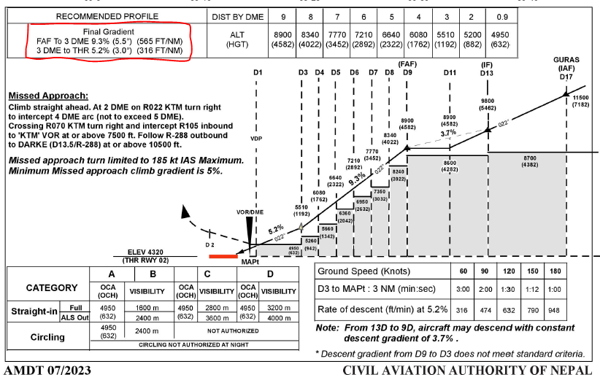

**DISCUSSION**: Should this guideline be required to apply to this Non-precision Procedure Coding of VNAV descent path? Thus, the highest vertical angle at VNKT VOR02 is 5.34 degs and this has been coded for the Final Approach segment from the FAF to MAP. Boeing 737s have received questions and complaints from Airline customers about this steep angle into the MAP when a recommend profile of 3.0 degs is stated in the AIP.

**ACTION**: Prompt a discussion and consider a revision to the Waypoint Description Code (5.17) and Attachment 5, sections 8.1.2 and 8.9 *VNAV Descent Gradient Considerations*

Thus section 8.9 needs to be modified to clarify that only one vertical angle can be applied to any path/terminator and that the “only one” rule is for the case where the government source data, for some reason, includes two vertical angles within a single path terminator (leg). Thus, the higher vertical angle value is used.

Note, it is not meant to specify that if there are multiple path terminators between FAF and MAPt, the higher vertical angle must be used on all path/terminators (legs) between FAF and MAPt.

However, there is a potential issue at the fix where the vertical angle changes (steeper/shallower) depending on whether the fix was designated as a stepdown fix since, vertical angles are expected to meet or satisfy the coded stepdown fix altitude. Thus, it is proposed to define a new Waypoint Description code (5.17) to indicate that such a fix, where the vertical path angle changes, be designated as mandatory and independent of the fix being a stepdown fix or not.

1. **Changes as depicted (Track Changes is Helpful)**

**Changes to Attachment 5:**

**5.17 Waypoint Description Code (DESC CODE)**

Definition/Description: The Waypoint Description field facilitates the designation of the type, function, and attributes of a specific waypoint in Enroute Airway or Terminal Procedure segment coding.

Source/Content: Valid contents for the Waypoint Description Code are contained in the following table:

**Table 5-16 – Waypoint Description**

|  |  |  |  |  |  |  |
| --- | --- | --- | --- | --- | --- | --- |
| **Waypoint Description Type/ Function/ Attribute** | **Used On Enroute, SID, STAR, APCH** | **Column** | **Column** | **Column** | **Column** | **Remarks** |
| 40 | 41 | 42 | 43 |
| … |  |  |  |  |  |  |
| Unnamed Stepdown Fix Final Approach Segment | APCH |  |  | A |  |  |
| Unnamed Stepdown Fix Intermediate Approach Segment | APCH |  |  | B |  |  |
| ATC Compulsory Reporting Point | Enroute, SID, STAR, APCH |  |  | C |  | Note 1 |
| Oceanic Gateway Waypoint | Enroute |  |  | G |  | Note 1 |
| First Leg of Missed Approach Procedure | APCH |  |  | M |  | Note 3 |
| Fix used for turning final approach or vertical path angle change | APCH |  |  | R |  | Note 4 |
| Named Stepdown Fix | APCH |  |  | S |  |  |
| … |  |  |  |  |  |  |

Note 4: Step-down fix on the final approach coding indicating a segment course change that is greater than or equal to one degree different than the next leg or a change in the vertical path angle. All RF non-procedure fixes on the final approach coding meet this requirement. This code will take precedence over a step-down fix code at the same fix.

**Alternative:** Define a new Waypoint Description code in column 42 of “V” with a description of “Fix Required for VNAV Path”

Note 11: The column 42 value of “V” indicates the fix is required to anchor a change in Vertical Path Angle within the Final Approach Coding.

**Changes to Attachment 5:**

**8.1.2** A Vertical Path Angle must be coded in the Missed Approach Point, Runway Threshold or Final End Point sequence, whichever occurs first, for each approach procedure. This Vertical Path Angle will be repeated on all fixes on the segment FAF to MAP, except when the vertical path requires a change in the Vertical Angle within this segment. In such cases, the fix at which the change in Vertical Path Angle occurs must be coded using the Waypoint Description Column 42 code “R”.

Vertical Angles will be from official government source or computed.See rules in section 8.9 for details on how to compute vertical path angles.

A Vertical Angle may be coded in the Final Approach Fix sequence if the approach includes a FACF and an Approach Transition segment. A Vertical Angle will be coded in the Final Approach Fix sequence if published in the official government source, or if the segment FACF to FAF includes one or more step-down fixes, see rule 8.9.9 for further details.

**8.9 Vertical Navigation Path (VNAV PATH) or Descent Gradient Considerations**

If the government source provides, vertical path angle or other suitable information that can be used to determine a vertical path angle, it must be used. The only exception is when the source provides more than one vertical angle for a single coded sequence for the Final Approach Coding segment FAF to MAP. If more than one vertical angle is provided for a single coded sequence, the highest published vertical path angle will be used.

The following guidelines have been developed for the coding of the vertical angles on the Final Approach Coding when vertical path information is not provided by the government sources. Rule 8.9.1 through 8.9.8 applies to the FAF to MAP segment only. Rule 8.9.9 applies to the FACF to FAF segment only.