**ARINC 424 NDB**

**Draft 1 of Supplement 24**

**Discussion/Proposal**

**Location Atlanta, Georgia**

**April 16-18, 2024**

|  |  |  |
| --- | --- | --- |
|  |  |  |

CLARIFICATION ON INTERCEPT LEGS

**V.0**

Lee Powers, Honeywell

|  |
| --- |
| **SUMMARY** |
| The purpose of this paper is to provide clarification to the definition of intercept legs to ensure flight management systems implement in the way expected by the ARINC 424 standard. |

1. **INTRODUCTION/ BACKGROUND**

## Problem Statement

The current ARINC 424 specification does not clearly define where the intercept point should be for a CI or VI leg, relative to the termination point of the following leg. The current specification only defines crossing the subsequent leg.

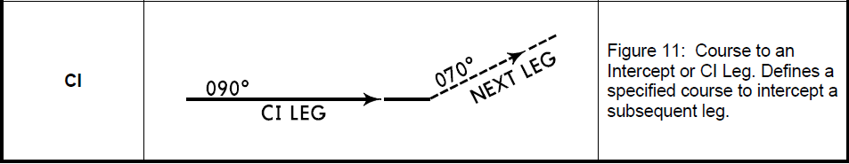

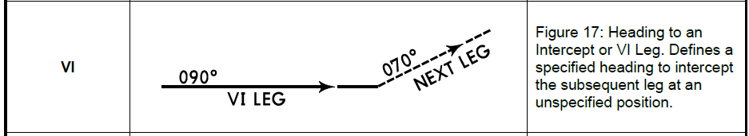

**Figure 1 – 1.4 Leg Type Descriptions for Intercept Legs**

## Problem Use Case

The ambiguity in the description allows for a flight management system to plot the intercept point beyond the termination point of the next leg. The ILS and LOC approaches for VLLB RW23 demonstrate a fundamental problem when the intercept is misplaced.

In this case, an FD-CI-CF leg combination exists on the LPB transition to the final approach path. In some FMS designs, after sequencing the FD leg the FMS immediately turns to intercept the 285° of the CI leg, which then intercepts the 230° final approach path. The problem with this operation is that immediately turning to the intercept path causes the aircraft to fly very close to terrain (Figure 2‑1).

Alternatively, other FMS designs do limit the placement of the intercept leg to the termination point of the following leg (Figure 2‑2).

|  |  |
| --- | --- |
|  |  |
| **Figure 2‑1 Gulfstream G650 FMS CI Path Determination** | **Figure 2‑2 Gulfstream G550 FMS CI Path Determination** |

NOTE: Yellow dashed line depicts each FMS’s planned path for the CI leg’s 285° path and intercept point. When there is a gap between legs, FMS will compute a 045° intercept course to the next leg as shown in Figure 2‑2.

Similar inconsistencies are present between other airframes and flight management systems.

1. **DISCUSSION and or ACTION**

Honeywell recommends that ARINC 424 be updated to clearly define that the CI/VI intercept point should be limited to the TO side of next leg’s path terminator.

1. **Changes as depicted (Track Changes is Helpful)**

