ARINC Project Initiation/Modification (APIM)

# Name of Proposed ProjectAPIM **16-xxx**

**ARINC Project Paper 848:** Broadband IP System Functional Interface Standard

Note: This APIM supersedes APIM 14-008 on the same subject.

## Name of Originator and/or Organization

KSAT and NIS Subcommittee participants

# Subcommittee Assignment and Project Support

## Suggested AEEC Group and Chairman

NIS Subcommittee

Steve Arentz, Chairman

## Support for the Activity (as verified)

Airlines: Delta, United

Airframe Manufacturers: Boeing, Airbus

Service Providers: Gogo, Panasonic, ViaSat, Global Eagle

Suppliers: Cobham, Honeywell, Intelsat, Rockwell Collins, Tecom, Teledyne, Thales, others TBD

## Commitment for Drafting and Meeting Participation (as verified)

Airlines: Delta, United

Airframe Manufacturers: Boeing, Airbus

Service Providers: Gogo, Panasonic, ViaSat, Global Eagle

Suppliers: Cobham, Honeywell, Intelsat, Rockwell Collins, Tecom, Teledyne, Thales, Kymeta, Zodiac Inflight,

## Recommended Coordination with other groups

Air/Ground Communications Systems (AGCS) Subcommittee

Cabin Systems Subcommittee (CSS)

Electronic Flight Bag (EFB) Subcommittee

Systems Architecture and Interfaces (SAI) Subcommittee

Ku-Band and Ka-Band Satcom (KSAT) Subcommittee

Internet Protocol Suite for Aeronautical Safety Services (IPS) Subcommittee

# Project Scope (why and when standard is needed)

The purpose of this project is to provide requirements for interoperability of aircraft and ground IP-based networks for non-safety end-to-end communication between on-board and off-board systems. Initially, this standard is expected to support Ku-Band and Ka-Band Systems. Ultimately, this standard should be more widely compatible with other systems such as cellular, commercial air-to-ground, and T-W LAN. The following areas will be addressed:

* Support for systems that service one or more network domains over a single carrier. This effort will be limited to non-safety applications.
* Provide link parameters to enable upper-layer communications carrier selection
* A coordinated, layered approach to network security that is compliant with existing aviation industry guidance and IT industry networking and security best practices.
* Use of end-to-end Quality of Service (QoS) and precedence definitions for differentiation of traffic and communication of level of service
* Architectural and design considerations, taking both forward-fit and retrofit configurations into account

Note: This project is not intended to define either (a) data exchange protocols between end-system applications, as specified in ARINC Specification 830, or (b) communication management services, as specified in ARINC Specification 839. Rather, this standard will complement those services when they are available.

## Description

The primary objective is to enable secure communication between each onboard LAN providing non-safety services and Enterprise LANs on the ground. This sets the foundation for secure segregation between onboard LANs.

This project would standardize the broadband IP network interface between the airplane LAN and the Enterprise LAN as shown in the figure below. The following figure illustrates the network security and segregation provisions of Project Paper 848 supplementing existing application (end-system) and link (radio) security measures in a layered approach to security.

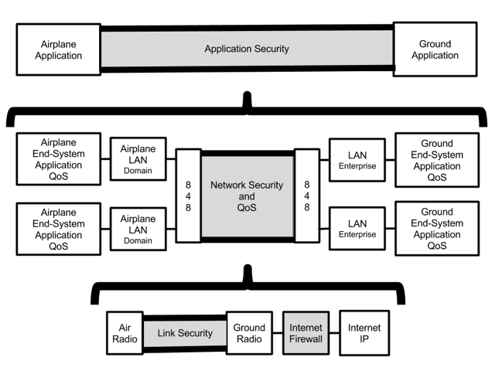

## Planned usage of the envisioned specification

Note: New airplane programs must be confirmed by manufacturer prior to completing this section.

New aircraft developments planned to use this specification yes ⌧ no 

Airbus: (aircraft & date) – [to be considered]

Boeing: 777X, 2020

Other: (manufacturer, aircraft & date)

Modification/retrofit requirement yes ⌧ no 

Airbus:

Boeing:

Needed for airframe manufacturer or airline project yes ⌧ no 

Airbus: A320, during 2017

Boeing: 777X

Mandate/regulatory requirement yes  no ⌧

Program and date: (program & date)

Is the activity defining/changing an infrastructure standard? yes ⌧ no 

Specify: Network infrastructure, non-safety services

When is the ARINC standard required? 2018

What is driving this date? Continued Implementation in forward fit and retrofit applications.

Are 18 months (min) available for standardization work? yes ⌧ no 

If No, please specify solution: _________________

Are Patent(s) involved? yes 

If YES please describe, identify patent holder: _________________

## Issues to be worked

Definition of generic IP network protocols for non-safety broadband communication services.

* End-to-end IP network security, including:
  + Secure channel detailed specification (e.g. based on IPsec) in order to guarantee end-to-end interoperability
  + Support for isolation of end-points of different service tunnels to prevent cross-domain traffic.
  + Preventing unauthorized traffic from entering the LAN.
  + Strong authentication.
* End-to-end Quality of Service (QoS) based on inputs from developers and related systems.
* Means to identify which QoS classes can be supported by the network.
* Means to tag\identify which specific QoS to apply to traffic in real time (if the traffic QoS is not profile-defined).
* Guidance for QoS application and traffic prioritization per tunnel, as applicable for specific carriers.
* As applicable, support hardware segregation, e.g., as established by the port definitions in ARINC 791 Part 2 for traffic flows in AISD and PIESD.
* Avoid changes to COTS communications components and minimize impact on intermediate networks.

# Benefits

The goal is to reduce airplane design and installation costs, reduce system design cost for multiple airplanes, and reduce airline operation and support costs.

## Basic benefits

Operational enhancements yes  no ⌧

For equipment standards:

a. Is this a hardware characteristic? yes  no ⌧

b. Is this a software characteristic? yes ⌧ no 

c. Interchangeable interface definition? yes  no ⌧

d. Interchangeable function definition? yes  no ⌧

If not fully interchangeable, please explain: Interoperable IP network interface definition

Is this a software interface and protocol standard? yes ⌧ no 

Specify: _________________

Product offered by more than one supplier? yes ⌧ no 

Identify: TBD

## Specific Project Benefits

### Benefits for Airlines

Contain acquisition cost of non-safety broadband systems for new airplanes and retrofit. Standardized interfaces have the potential to reduce maintenance and communications cost/support across the airlines multiple airplane models.

### Benefits for Airframe Manufacturers

The goal is to simplify the deployment of IP non-safety end-to-end communication solution through a standard air-ground IP network definition.

### Benefits for Avionics Equipment Suppliers

Avionics suppliers are able to design standardize equipment applicable to multiple airplane manufacturers and models.

# Documents to be Produced and Date of Expected Result

ARINC Project Paper 848 is expected to define common broadband network protocols and interfaces. A mature document is desired in 2017.

## Meetings and Expected Document Completion

The following table identifies the number of meetings and proposed meeting days needed to produce the document described above.

|  |  |  |  |  |
| --- | --- | --- | --- | --- |
| **Activity** | **Mtgs** | **Mtg-Days**  **(Total)** | **Expected**  **Start Date** | **Expected Completion Date** |
| ARINC  Project Paper 848 | 8** | 9* | October 2016 | October 2018 |

* In addition, monthly web conferences will be scheduled, as needed.

** Although the number of meetings is set for 8, only 1 to 1 ½ meeting days will be allocated per meeting.

# Comments

(Insert any other information deemed useful to the committee for managing this work.)

## Expiration Date for this APIM

April 2019

***Completed forms should be submitted to the AEEC Executive Secretary.***