Introduction

Purpose of this Document
The purpose of this document is to provide guidance for the assignment, accomplishment, and reporting of Investigations for components which exceeds the regular workshop analysis and repair process.
The operator repair shop and the OEM will use this guideline for aircraft components where additional attention has to be taken to fulfill reliability and authority requirements. This includes the process of assignment, the scope of accomplishment, and the content/style of final report.

Term refinement

Standard Work Scope
If a component fails to operate properly, it is removed from the aircraft and replaced by one that does operate properly. The removed component is then maintained. This maintenance consists of determining the cause of the failure (ref. to 1.2.1.2 Troubleshooting) and replacing those internal parts that failed (ref. to 1.2.1.3 Repair). The component usually is disassembled, cleaned, inspected, repaired, reassembled, tested and returned to service (ref. to 1.2.1.5 Test). These procedures are accomplished in accordance with the component manufacturer’s maintenance manuals (CMM) and may be supplemented by approved processes based on industry practices and workshop experiences.

Troubleshooting
Troubleshooting is a logical, systematic search for the source of a problem. It is needed to maintain components where the symptoms of a problem may have several different possible causes. This fault isolation process usually bases on approved data like CMMs or standard procedures as well as industry practices and experiences.
Goal of the troubleshooting process is to determine the root cause of the components failure.

Repair
A Repair is the rectification of defects by using an applicable standard, means a manufacturing / design / maintenance / quality standard, method, technique or practice approved by or acceptable to the Competent Authority. Component repairs range from simple part replacements to an entire overhaul.
Goal of the repair is to fix any sort of failure to ensure the component is in complete conformity with the certification holder’s specification.

Restoration/Overhaul
A Restoration and an Overhaul describe maintenance processes where a component at least will be disassembled, cleaned, inspected, repaired as necessary, reassembled, and tested in accordance with approved or accepted data. Partly overhaul can also be described as preventive maintenance.
Goal of a Restoration or an Overhaul is to ensure the component is in complete conformity with the applicable service tolerance specified in the type certificate holder’s or equipment manufacturer’s instruction for continued airworthiness, or in the data approved or accepted by the authority.

Visual Inspection
A Visual Inspection is a common method to inspect components or their subassemblies by using all important human senses like hearing, touch, smell and especially vision, but without usage of any additional T&E.
Goal of a Visual Inspection is to identify and evaluate obvious damages.

Test
A Test is the examination or measurement in accordance with an applicable standard, means a manufacturing / design / maintenance / quality standard, method, technique or practice approved by or acceptable to the Competent Authority.
Several kinds of tests are known in the aviation industry, for instance Acceptance Tests, Return to Service (RTS) Tests, Diagnostic Tests or Built-In Tests (BIT). For further information about those tests refer to ARINC Report 847: Product Development Guidance for Maintainability and Testability (PDMaT).
In the context of a Special Investigation the term Test shall be understood as RTS Test which is described in approved documents like CMMs.
Goal of the test is to prove the component’s airworthiness and to recertify the component after removal.

Extended Work Scope
Activities of the extended work scope are usually not defined within OEM published documents like CMMs. They rather base on a comprehensive empirical knowledge and a specific expertise about the system or the component design. Typically also the engineering of the maintenance organization acc. to e.g. FAA or EASA Part 145 is involved in those tasks. Wherever necessary also the engineering of the design and/or certification organization acc. to e.g. FAA Part 121 or EASA Part 21.J is involved for approving data and/or procedures.

Special Investigation
A Special Investigation is an event where in particular an engineering attention is necessary. This in turn can be the case because e.g.
- A customer justifiably complains about the component’s reliability,
- An authority introduces an obligatory requirement,
- An incident or rather an accident has happened.
It usually includes the following process steps:
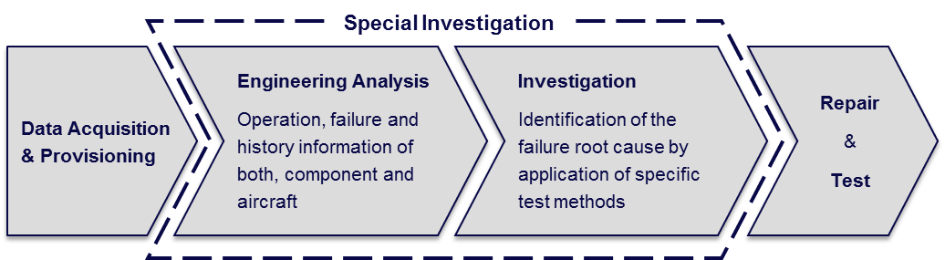
There is no specific recommendation which test methods should be applied for identifying the root cause of the failure. The set of necessary measures should rather be the result of the suppliers engineering analysis, the comprehensive empirical knowledge and the specific expertise about the system’s or the component’s design.
Typical elements of such set of measures are:
- Environmental Stress Screening (ESS): Those tests typically include temperature variations and vibration tests, as well as a combination of both.
- Wide-ranging test applications like RTS test, loop test, burn-in test, power cut test, specific SRU test, flying probe tests, etc.
- Visual inspection by using highly magnifying equipment and/or X-ray systems
- Installation, operation and observation of the component in an aircraft or an aircraft system mock-up.

Related Documents
The latest version of the following documents applies:
ARINC Report 625: Industry Guide for Component Test Development and Management
ARINC Report 663: Data Requirements for Avionics Component Maintenance
ARINC Report 668: Guidance for Tool and Test Equipment (TTE) Equivalency
ARINC Report 670: Guidance for Materials, Processes, and Parts Equivalencies
ARINC Report 847: Product Development Guidance for Maintainability and Testability (PDMaT).

Document Conventions
ARINC reports are voluntary standards intended to ensure interchangeability and interoperability between equipment, independent of manufacturer or host airframe. The recommendation reflected in this standard is provided to offer the necessary foundation to develop superior products through design philosophy.
In this standard, the following terms carry key significance:
Term | Usage
shall | Identifies features and structures required to meet the minimum level of compatibility intended by this standard.
should/must | Used to recommend approaches to optimize the process
will/is/does | Used to express a statement of fact based on other requirements.
may | Used to express an optional capability or choice.

Roles and Responsibilities

Introduction
Airline operators, airframe manufacturers, engine manufacturers, component manufacturers, and repair facilities all have a vested interest in the effective functioning, reliability and safety of commercial aircraft components and therefore the special investigation process.
This section describes the expected roles and responsibilities of each group throughout the investigation process.

Operator/Airline
Each airline operator is ultimately responsible for the airworthiness and reliability of their aircraft. As such they are a primary user and beneficiary of the special investigation process.
The airline operator will define criteria within their organization, using these guidelines, for initiating a special investigation. The system for identifying and evaluating criteria should include items such as: 1) identifying “events” such as RTOs (rejected take-off), ATB (air turn-backs), etc.; 2) identification of “rogue” units or NFF issues; cost and reliability tracking.
The airline operator will initiate a request for special investigation by contacting the appropriate Component Manufacturer or organization responsible for performing the investigation. It is recommended that the airline operator notify the airframe/engine manufacturer when a special investigation has been requested on a component on the airframe or engine.
The airline operator will provide all pertinent data to the Component Manufacturer or organization responsible for performing the investigation as defined in this document. This includes acting as an agent to collect data, such as maintenance records, from Repair Facilities it contracts with other than the Component Manufacturer.
The Airline Operator will review the investigation plan submitted by the Component Manufacturer or organization responsible for performing the investigation and provide appropriate feedback. The Airline Operator will specify any specific tests per this document it would like the investigator to perform.
The airline operator will review the investigation report written by the investigator and provide appropriate feedback.
The airline operator will evaluate and consider for implementation any recommended changes to operations made in the investigation report.

Airframe/Engine Manufacturer/
As the primary producer of the aircraft and engine. The Airframe/Engine Manufacturer is interested in enhancing the safety and reliability of their product and is therefore a critical participant in the investigation process.
The Airframe/Engine Manufacturer may initiate a request for special investigation by contacting the appropriate Component Manufacturer or organization responsible for performing the investigation.
The Airframe/Engine Manufacturer will provide all pertinent data to the Component Manufacturer or organization responsible for performing the investigation as defined in this document.
The Airframe/Engine Manufacturer may be asked to review the investigation report written by the investigator. If so the Airframe/Engine Manufacturer will provide appropriate feedback.
The Airframe/Engine Manufacturer will evaluate and consider for implementation any recommended changes to aircraft systems, airframe or recommended maintenance procedures made in the investigation report.

MRO/Repair Facilities
For the purposes of a special investigation, Repair Facilities can be considered as an extension of the Component Manufacturer. A repair facility may have maintenance data on a serial number of interest or general maintenance or reliability data on a part family, which may be pertinent to a given investigation. In some cases a Repair Facility might perform tests in addition to what the Component Manufacturer performs, or may even be the prime organization to perform the special investigation as requested by the Airline Operator.
The Repair Facility will provide data pertinent to the investigation to the Component Manufacturer, Airframe/Engine Manufacturer, or Airline Operator as requested by the Airline Operator.
The Repair Facility will participate with the Component Manufacturer in developing an investigation plan as requested by the Component Manufacturer.
The Repair Facility will participate with the Component Manufacturer in preparing an investigation report as requested by the Component Manufacturer.
The Repair Facility will perform a special investigation fulfilling the responsibilities listed in the “Component Manufacturer” section above, when requested to do so by an Airline Operator.

Component Manufacturer
The Component Manufacturer, as the design and build authority of the investigation hardware, is the organization who will typically coordinate and conduct the special investigation. They have a vested interest in understanding the cause of events and improving the safety and reliability of their hardware.
The Component Manufacturer will provide contact information to the Customer for the person within their organization responsible for coordinating special investigations and provide instructions for returning investigation hardware to the appropriate location.
The Component Manufacturer will review the data provided by the Airline operator, Airframe/Engine Manufacturer, Repair Facility or other to ensure that all data required to conduct the investigation is available.
The Component Manufacturer will provide an investigation plan with proposed testing to the Airline Operator or other customer.
The Component Manufacturer will perform the special investigation in accordance with the requirements of this document.
The Component Manufacturer will prepare an investigation report in accordance with the requirements of this document and provide a copy to the Airline Operator or other customer.
The Component Manufacturer will implement corrective action as identified in the investigation report including releasing documentation such as component service bulletins (CSBs), component maintenance manual (CMM) updates, service letters (SLs), etc.

Investigation Authority (e.g. NTSB, BEA)?
A goal, and with some Investigation Authority organizations the only goal, is to advance the safety of commercial aviation. As such these national organizations are prime instigators of special investigations, and will often require that a special investigation be performed on hardware involved in an aircraft accident or incident over which they have oversight.
The Investigation Authority will work with the Airline Operator and Airframe/Engine Manufacturer to identify components which bear on their investigation and warrant a special investigation.
The Investigation Authority will contact and work with the Component Manufacturer to prepare an investigation plan for the affected hardware.
The Investigation Authority may send a representative from their organization or related organization to oversee the special investigation. When present the representative will participate in preparing field notes documenting the investigation.
The Investigation Authority will prepare a final report according to their own national or other requirements.

Reasons for Special Investigations (Guy Air Canada)

Reliability caused Special Investigations
The component inherent reliability is based on the failure rate of its piece part. Initial TDSP is also based on the same data.
A degradation in reliability will have a negative economic impact on the operator. Special investigation on the component will help identify the specific root cause of the degradation and generate a better restoration level to achieve acceptable reliability.

Authority caused Special Investigations (include 3.2 and 3.3)
Incident and accidents, although undesirable, are part of our industry.
Root cause failure analysis helps identify and prevent such occurrences from repeating. In order to re-create the conditions that led to the event, beyond CMM testing can be required to isolate the piece part(s).

FAA order 8020.11C states:
16. Airworthiness Investigations. An FAA airworthiness investigation will be conducted whenever:
a. Preliminary data indicate an in-flight structural failure or designor manufacturing-induced malfunction of a powerplant, aircraft system, or component.

Incident caused Special Investigation (to be deleted)

Others (to be deleted)
Special investigation can be used to address high NFF rate or specific component serial number deemed chronic offender (rogue).

Processing Special Investigations

Durable Communication Process
The effectiveness and efficiency of a special investigation event is directly related to the cooperation of both sides, the customer and the supplier. The event should be understood as temporary alliance which in turn necessitates an open and regular communication over the entire process. This helps to increase understanding and to foster the mutual confidence of the cooperating industry partners.
The supplier needs as much as possible information about and around the error which has occurred to better understand the failure of the component (refer to chapter 4.2 for details). This enables to start focused analyses and troubleshooting tests to efficiently identify possible error causes.
Since a special investigation needs significantly more time compared to a normal repair event the customer in turn expects to be involved over the complete process, especially detailed information describing troubleshooting and corrective actions are expected.
Picture 4-1 depicts the recommended communication concept especially between the customer and the supplier for special investigations:
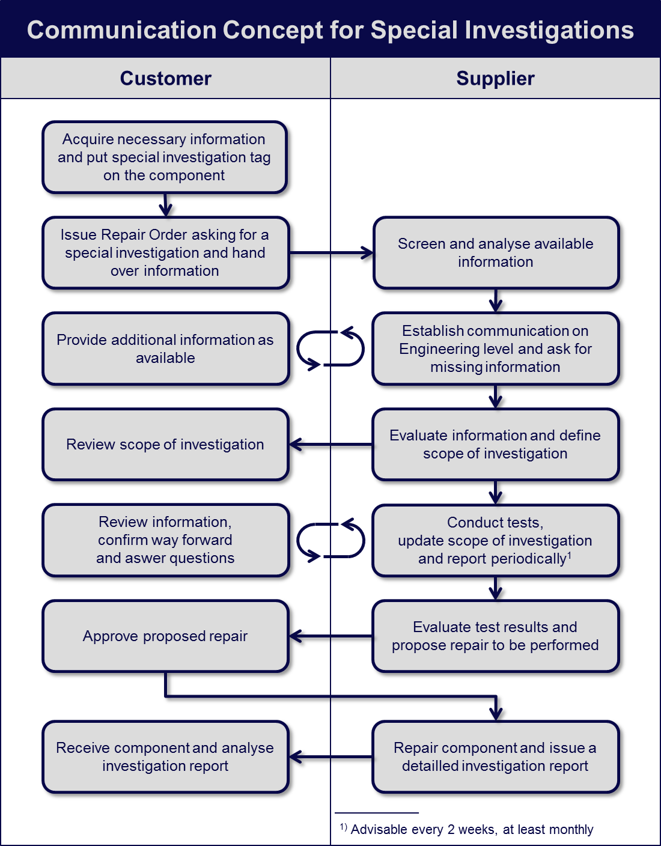
Picture 4-1: Communication Concept for Special Investigations

Necessary Information for Assignments

Description and Context of Event

Flight parameters

Maintenance messages

Troubleshooting Information

Pilot/Maintenance logs

Applicable FIM section

LRU including NVM

History Information

Aircraft

Affected aircraft system

LRU

Accomplishment (Jack (BAE)

Result of standard CMM testing

Extended Diagnostic Testing

Hardware and Software Investigations

Disposition of hardware (LRU)

Corrective Actions

Service Bulletin information

CMM Update

Production incorporation

Principle Implications (Preventative Actions)

Special Investigation Reports (steps may be omitted as appropriate)

Introduction

Background

Investigation Objective

LRU/Aircraft System Functional Description

Assumptions

Logic and Circuit Analyses

Standard Workscope (Testing) and results

Exended Workscope (Testing) and results

Conclusions

Corrective Action Taken

Further steps if applicable

Examples

We have reviewed on live, comments sent by Delta Airbus and AF.

Communication
Technical focus point needs to be defined between the both technical staff
Commercial conditions will be clearly defined for the primary investigation /evaluation and when the final investigation. Quote will contain appropriate work agreed by the both parties and will include at the minimum following data:
- Turnaround Time
- For the evaluation: to indicate conclusions that can, or cannot be ascertained from the results of each test procedure performed.
- Loan proposal if available during the investigation
- Report structure on specific investigation with nomenclature example.
It is important to provide Informational updates or periodic updates while unit is at vendor facilities
In the target to facilitate the kind of investigation requested, justification can be given by Operator:
- Unable to duplicate failure, description of test performed
- Vendor replace something and returns for same problem, generate a special investigation
- Deep engineering evaluation due to several failures, operational issues.

Technical:
Report should be provided to the operator (customer), and will show the results of a special investigation, and will include:
- Data formatted into a readable format with explanations, graphs, and conclusions as appropriate.
- Root-cause Failure analysis and if there is success or NOT
- A list of all test procedures performed with a comprehensive description, including when environmental and Vibration tests are to be complied with.
- Report all data/results collected during the execution of each procedure.
- If Root-cause of failure has been found:
  - Teardown findings and give part(s) involved
  - To tell if it is a failure already encountered.
  - To Determine and tell why a normal test or trouble shooting as related in CMM could not be appropriate.
  - To tell if an update/upgrade (CMM/Test Fixture/Tools/Software) will be launched to prevent same failure
  - To tell if an SB or SIL will be launched to prevent same failure

- If Root- cause of failure has not been found:
  - To give the recommended action, including preventive work or standard exchange proposal if unit is considered as Rogue unit

  - To tell if OAM action needs to be implemented to go further

Points need to review , do we consider that nomenclature & investigation is already included in expectations above :
SUGGESTIONS FOR NOMENCLATURE
- Root cause
- Discrepancy
- Rogue
- Scrap
- Defective
- Engineering Review
- Justification
- Engineering Evaluation
- Special evaluation
- Defect
- Unit under test (UUT)
INVESTIGATION CONTENT
- Manual reference if any
- Description of problem
- Description of solution
- Initial findings (Exterior condition)
- Initial Findings ( Testing on arrival)
- Teardown findings
- Testing results
- Final testing results
- Additional Technical or Engineering comments. (what, where, why)
  - Lead Time for return or results

Possible criteria for bad reliability are: - 3 times TSI < 500h (unscheduled removal) - 2 times TSI < 50h (unscheduled removal) - 3 unscheduled removals within 18 months

